**Introduction to AWS (Amazon Web Services)**

AWS is 6 times bigger than all the service providers currently. AWS currently has a market share of 90%. It is a Graphical User Interface (GUI). 99.9% your data will be secure with AWS. It is a secure cloud service platform offering content delivery. Data will be replicated from one location to another location. Globally you can access your data. It takes out the snapshots of your data and make it available to other locations. If you want to create a virtual machine, it will have a very quick response which will start in within 2-3 seconds time.

**What is cloud computing?**

Cloud computing is the on demand delivery of compute power, database storage, applications, and other IT resources through a cloud services platform via the internet with pay-as-you-go pricing concept. In a day Facebook does 19,000 releases and Amazon it does around 5,000-8000 deployments in a day. So, they are many deployments in a day, you need to do it through automation. Manually it’s not possible. They need immediate provisioning of their servers. They need tools to build their applications fast.

If the builds/software are sitting on the same hardware, it will take a longer time to execute and the performance will also suffer. That’s why it’s not done on the local system. We can have any kind of data by using cloud – structured and unstructured data.

Structured data – which follows a particular format.

Unstructured data – like Facebook images, posts, raw data, etc.

**Waterfall method –**

It is a method in a Software Development Lifecycle (SDLC) which they used to follow in the previous days. They used to take the requirements from the client. A team would analyze it. Then they would design for the desired project. Developers would code the related task as per the design, then testing would be performed and it will go for maintenance.

**Service-models**

1. IAAS (Infrastructure as a Service), eg., Virtual Machines, Operating Systems. Virtual machines uses your hardware of your software in a fast manner. It will not sit on your hardware directly. You’ll get them on a pay as you go basis.
2. PAAS (Platform as a Service), eg., Google App Engine. It is for testing, allocation of your resources, etc.
3. SAAS (Software as a Service), eg., Salesforce, AWS. It is for delivering software applications over the internet on demand and typically on a subscription basis.

**Cloud Deployment Models**

1. Private Cloud – The cloud infrastructure is held by one organization and hosted and operated internally. A private cloud can physically be located on a company’s onsite data center. Some companies also pay 3rd party service provided to host their private clouds.
2. Public Cloud – Computing resources are provided publicly over the internet based on a pay per use method. They are owned and operated by 3rd party services which deliver the company’s computing resources like server and storages over the internet.
3. Hybrid Cloud – Computing resources are provided by a composition of private and public clouds. This way they provide more flexibility in business and greater deployable options.

**Benefits of cloud computing**

1. **Self-service provisioning** – any type of workload which is on demand.
2. **Elasticity** – Amazon has to scale up as computing needs depending on the demand (eg., Amazon puts sale in the weekend). It eliminates the need for local investment. You are increasing your services with an estimation.
3. **Scalability** – Scale on demand to support fluctuating workloads. It will increase and decrease automatically.
4. **Pay for use** – You’ll pay on hourly basis.
5. **Reliability** – Disaster recovery, business continuity is easier and less expansive.
6. **Performance** – Secure data centers which are upgraded regularly.

**Why hardware services are so fast as compared to local machines?**

They use SSD (solid state drive). It uses the concept of IOPS (Input Output Per Second) technology –It is an ultra-fast technology, the data will be transferred in a fraction of a second.

HDD (Hard disk drive) – we use this in our local system.

1TB of hard disk costs around $60 in HDD. If you take 1TB of same size in SDD, it’s going to cost $350-$400.

1. **Automatic Software Updates –** We don’t have to worry about maintaining the system ourselves.
2. **Security –** Data will be more secure on cloud computing.

**Benefits of AWS**

* Easy to use
* Cost effective
* Scalable
* High performance
* Global leader
* Secure

**AWS Free Tier Account**

1. **EC2 –** It isfree for new customers for 750 hours. You can use multiple systems or it will be available for 12 months of time. It is for both Linux and Windows.
2. 30 GB EBS, 1GB snapshot, if you use the service beyond 750 hours, it will start charging without notifying.

EBS – Elastic Block Storage

5GB Amazon S3

**How AWS works?**

Some are designed to work with RestAPIs.

Steps to create an account (New AWS account)

**Step 1** -> <https://aws.amazon.com>

**Step 2** –> Create an AWS account – fill the credentials

**Step 3** –> Click create and continue

**Step 4** –> Enter your card details – which has very less amount in your card

**Step 5** –> Check AWS service tab. Click on services

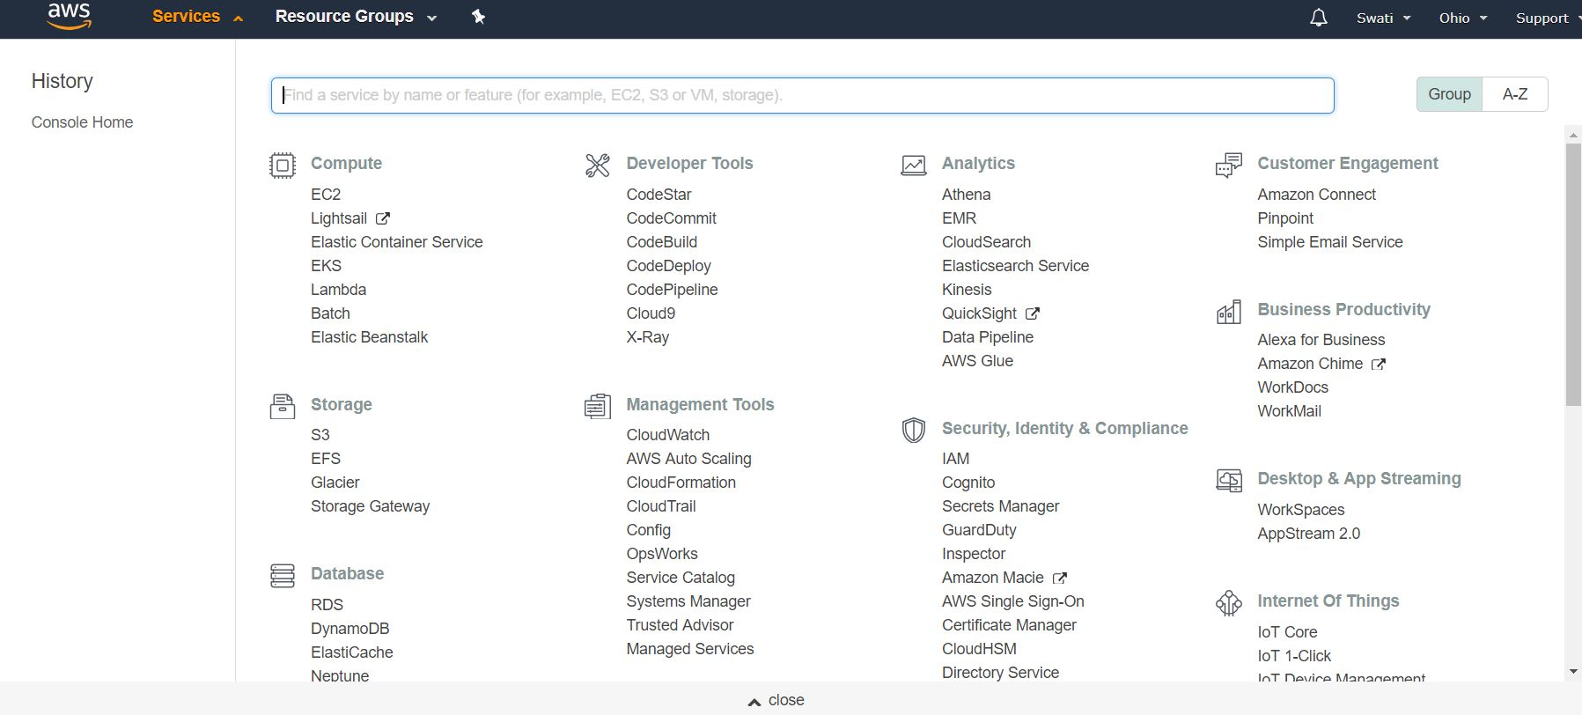

**Step 6** –> Click EC2

In Resources, click Running Instances

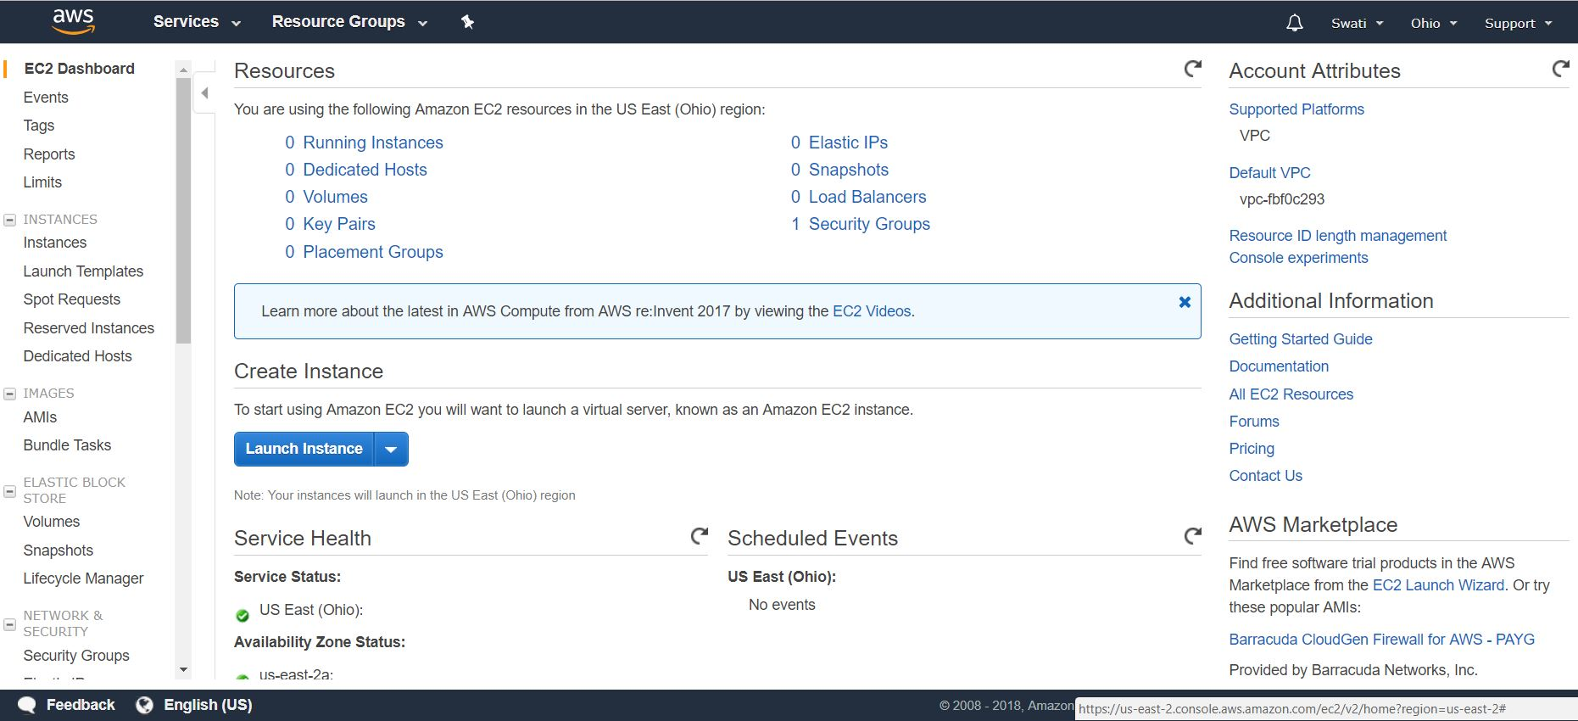

If you have created any instances that will be visible here.

Go back-> Click Volumes

You can see the OS there.

If 30 GB size, Windows Operating System

* Can we change the 10PS given in the table?

Yes

* Remember snapshot ID if you want to create a snapshot.

Go back

If you are running out of space, you will create one more volume.

If your phone is 16GB and you are running out of memory, you can add extra memory storage media and add it to your hardware. Same goes with application.

Go back

Elastic IPS – When you launch once instance, it will get one private (can create/define yourself) and 1 public idea – It will be provided by client computing provider.

When Dynamic IP is converted into static IP – its called elastic IPs.

Click launch instance

There are 7 tabs that we must complete:

**Step 1**: Choose AMI – click it. AMI – pre-configured software configuration. You are supposed to have instances in fraction of seconds. You can take anyone below. Click select. Click only one.

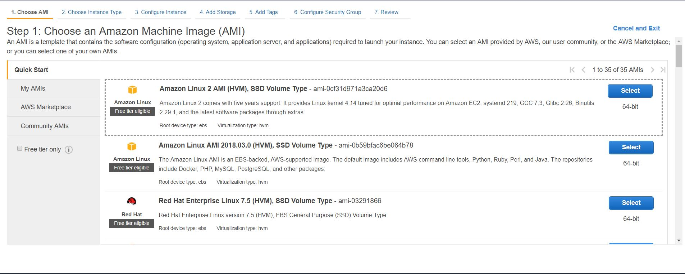

Community AMI – AMIs provided by communities. We choose the first AMI here.

Step 2: Select General purpose t2.micro

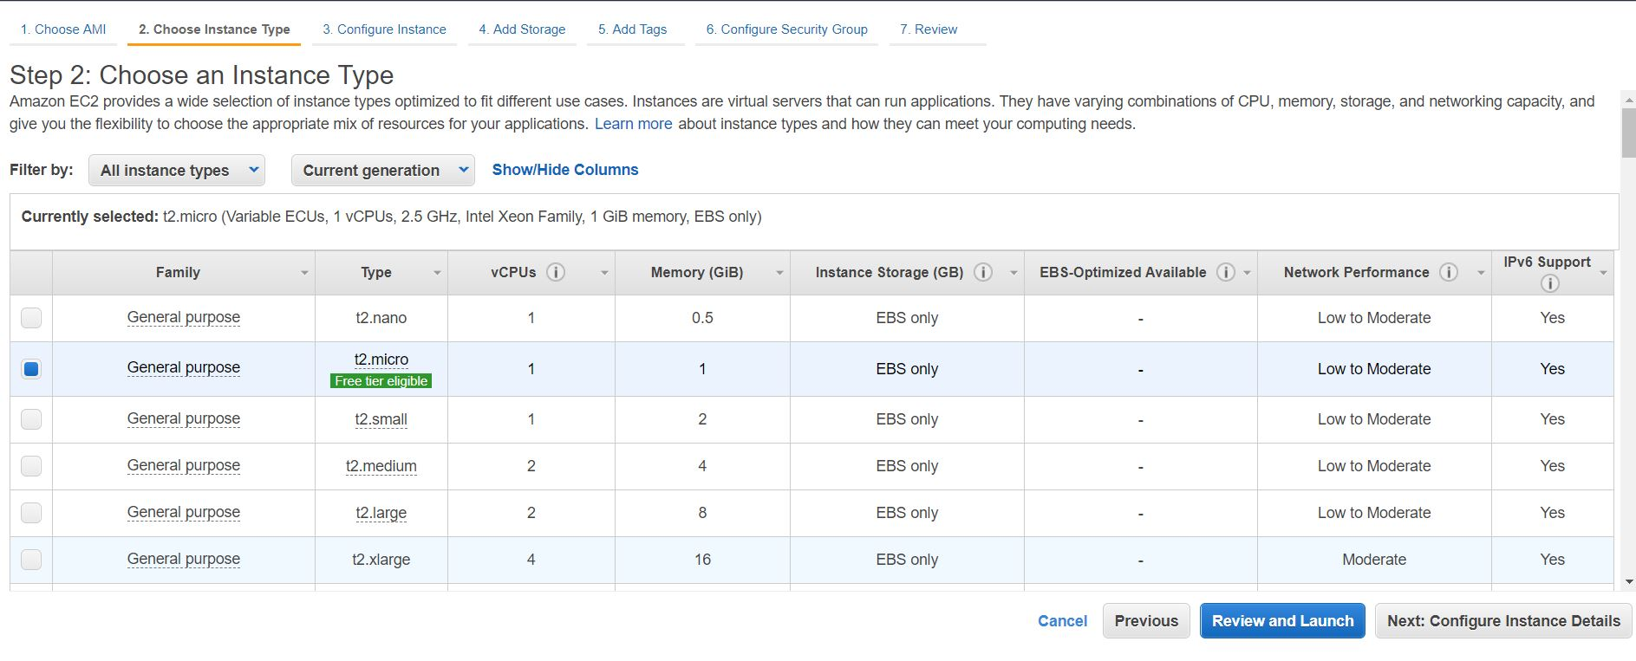

Step 3: Number of Instance – If we put 3 number here, 3 instances with the same configurations and everything will be created. It is used for the purpose of auto scaling.

Network – VPC – Virtual Private Cloud

You will be having security on your instances Amazon provides 1 default VPC which runs in background. You can create your own subnet (zone) under **Create New VPC**.

IAM role – when you are creating users under you, you are creating instances, give access to the tools department wise, give cloud resources to only specific departments that actually require. It’s like restriction, manage your app properly.

Monitoring – Cloudwatch – sometimes instances will be running out of space which will not give the results to end users. To help in that Cloudwatch is used.

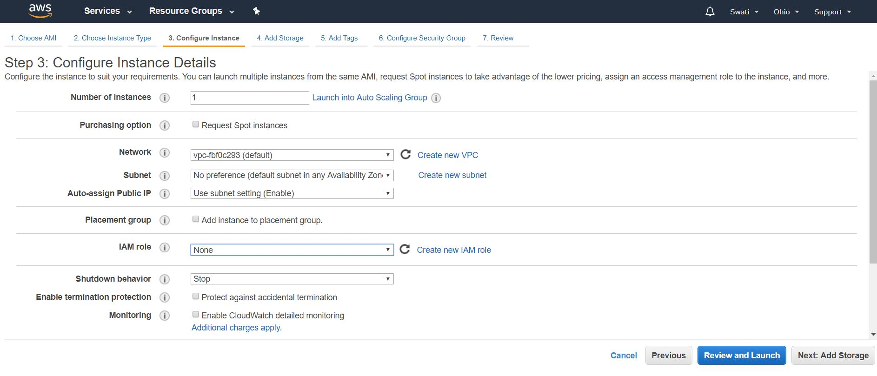

Step 4: Add Storage- Default given 8GB – If reduce it, your instance will not start.

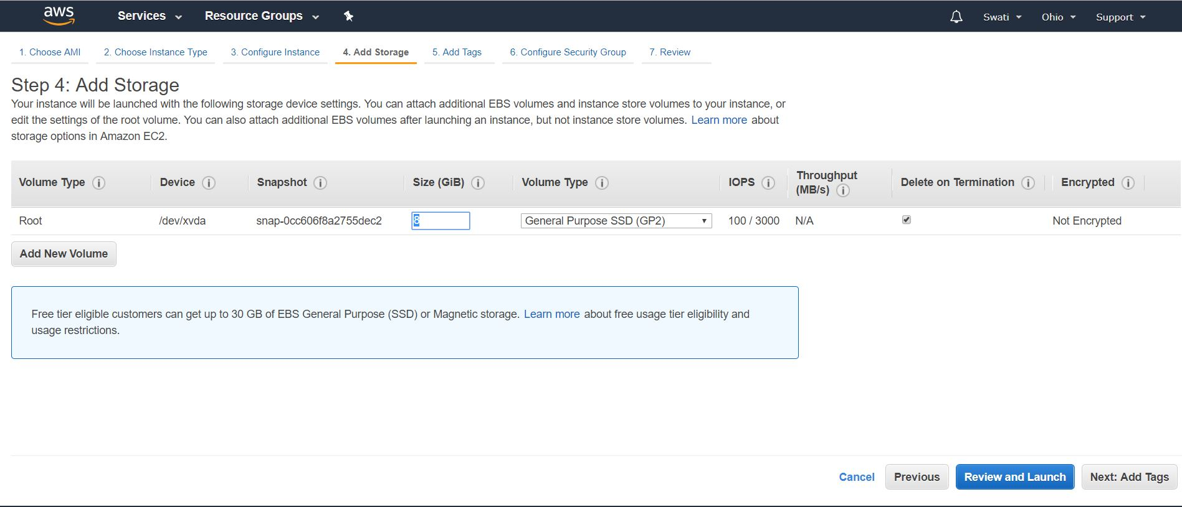

Click next

Step 5: Add Tags – key -EC2_Intro_B-2(can be anything)

Or key AWS – value – AWS (check instances and volumes)

Go to next page

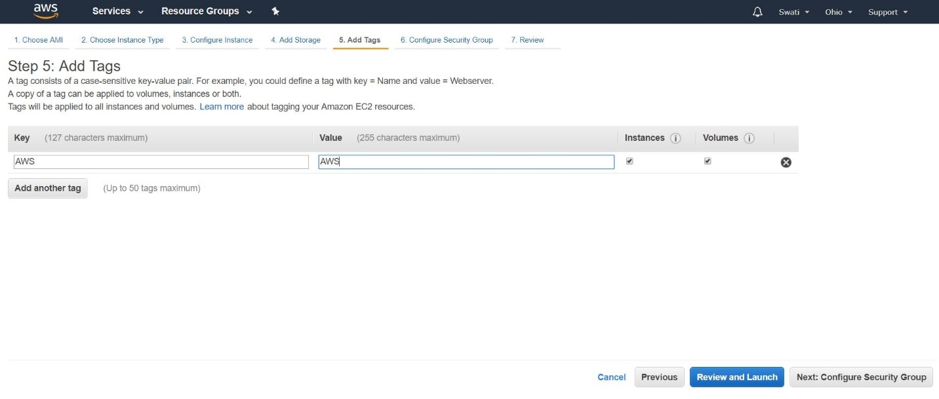

Step 6: Configure Security Group –

* Click create a new security group
* Security group name: Digi_Test
* Description: Creating this EC2 for webserver
* Click add rules
* SSH – SSH must be given – port range – 22
* Click HTTP – port range 80
* Click HTTPS – port range 443
* Source- anywhere in all
* Protocol-TCP anywhere
* Note down port numbers of all and at the end click on launch

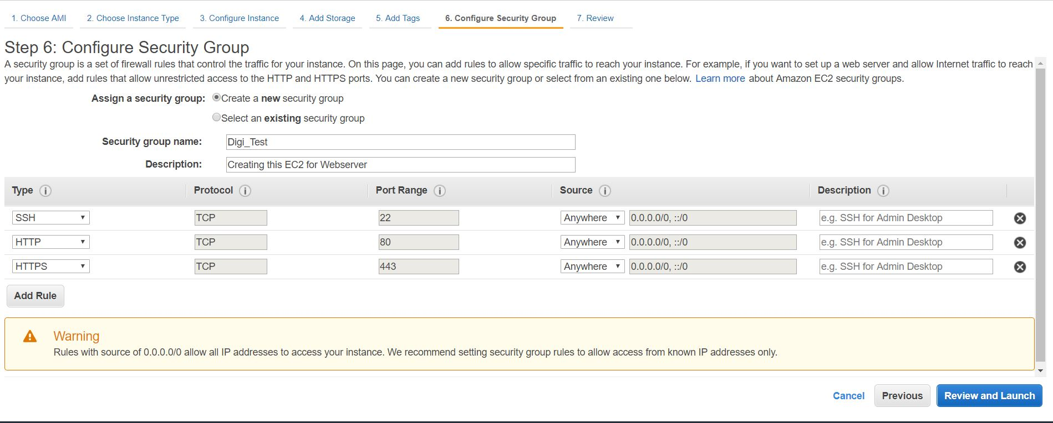

Step 7: Review –

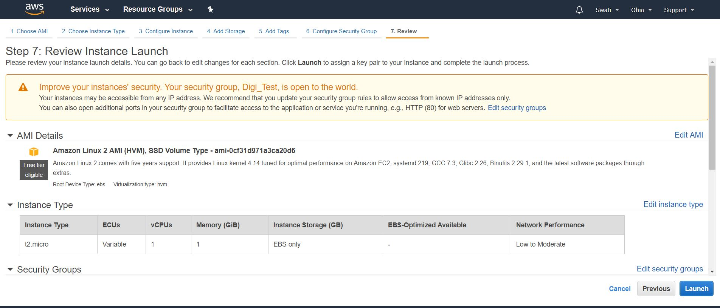

* Select Create a new key pair

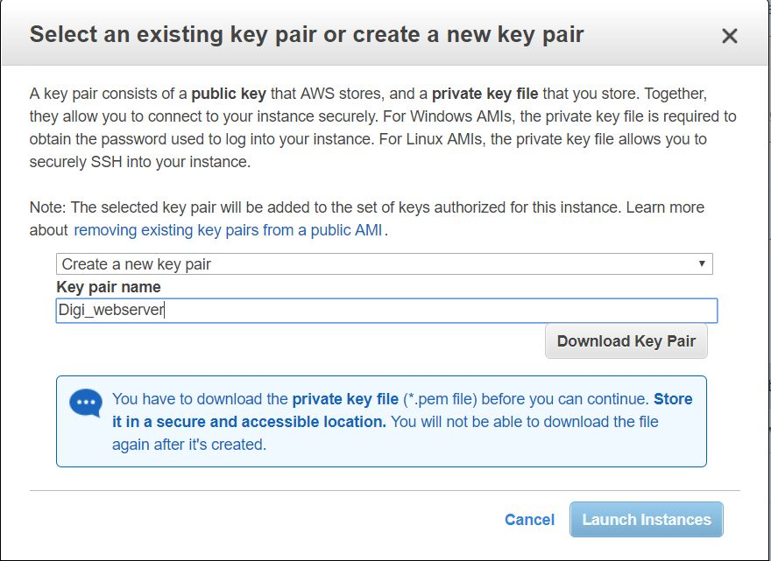

* Give Key pair name – Digi_webserver
* Click download key pair
* Click launch instances

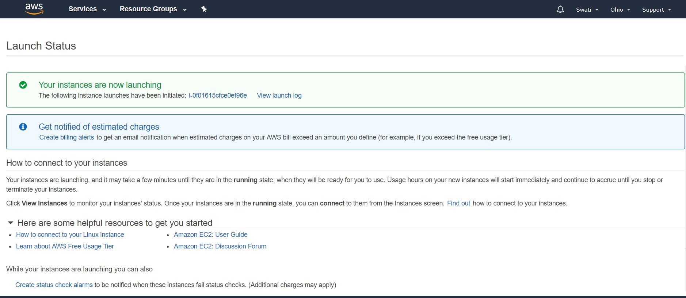

* Click view instances
* It will start in less than a minute time.
* Name it – Digi_webserver

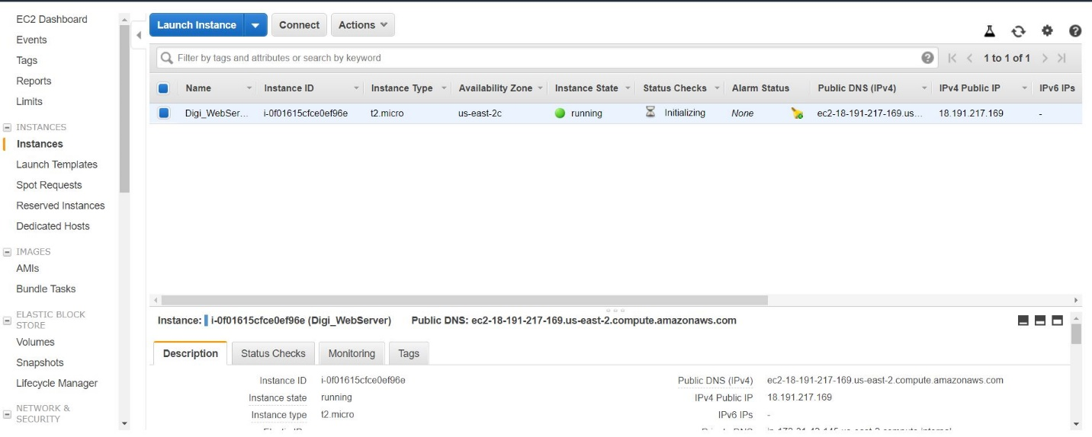

* If it runs successfully, a green tick will come in Status Checks. 2/2 checks – Services from AWS site is OK. Restart your instance if checks are not coming.

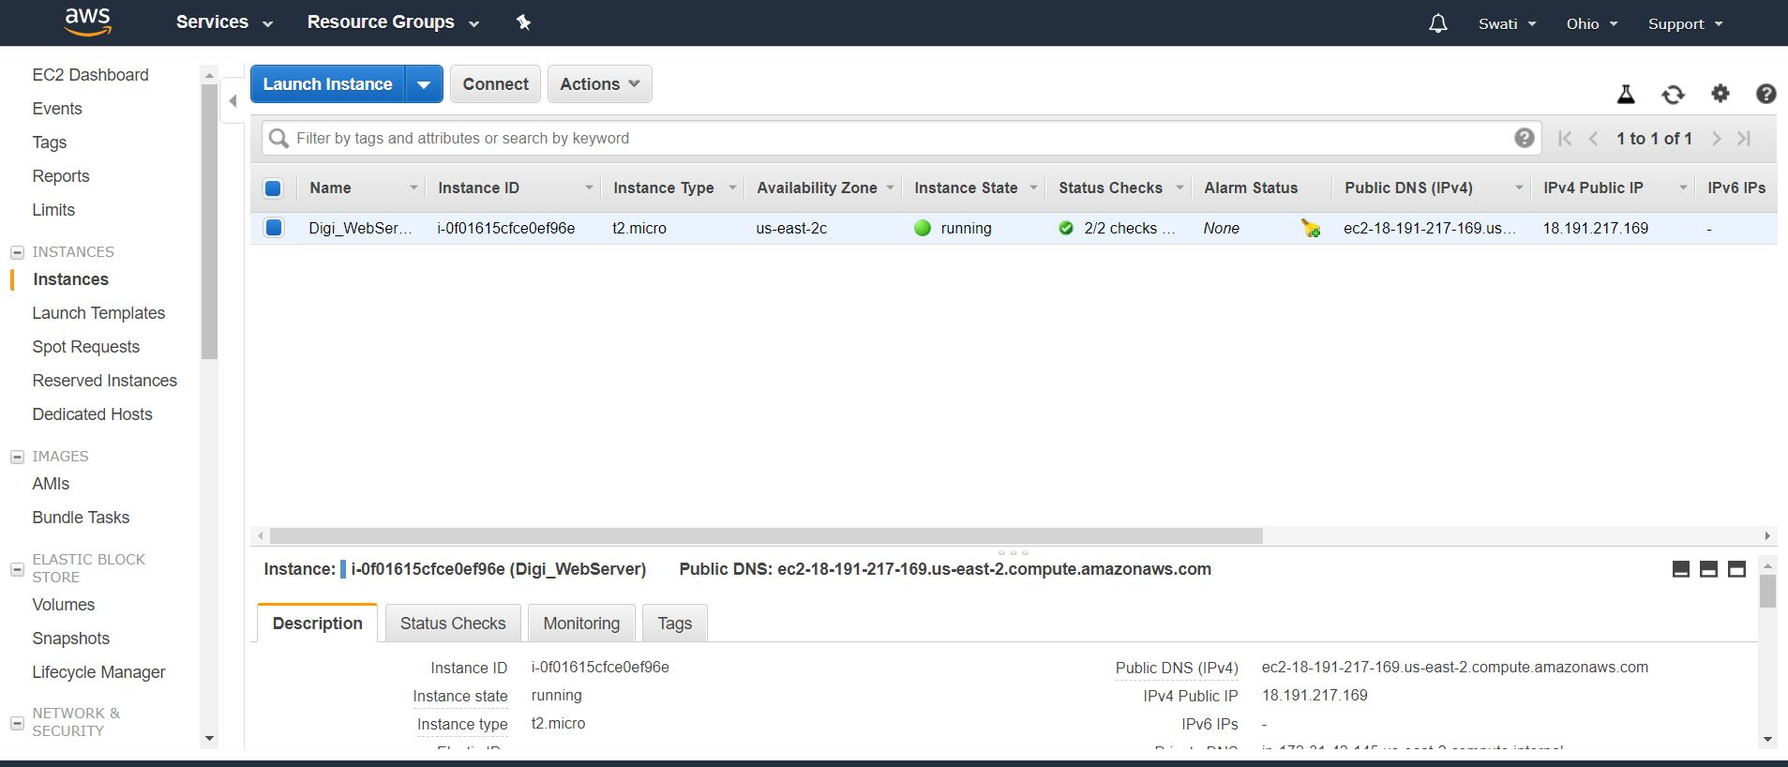

**How to connect to system?**

Download putty – Putty is a 3rd party software. .pem to .ppk conversion is required to connect with the EC2.

* Putty key generator – only one.
* Load
* Click all files to find the file in a dialog box
* Digi_webserver.pem
* Click OK
* Type yes
* Save as type putty private key files(*.ppk) Filename – Digi_webserver



**Putty configuration**

* Click on instance public IP in the browser under reviews -copy and click session in putty configuration and paste it in putty configuration (open putty configuration by typing putty on cortana and double clicking on it).

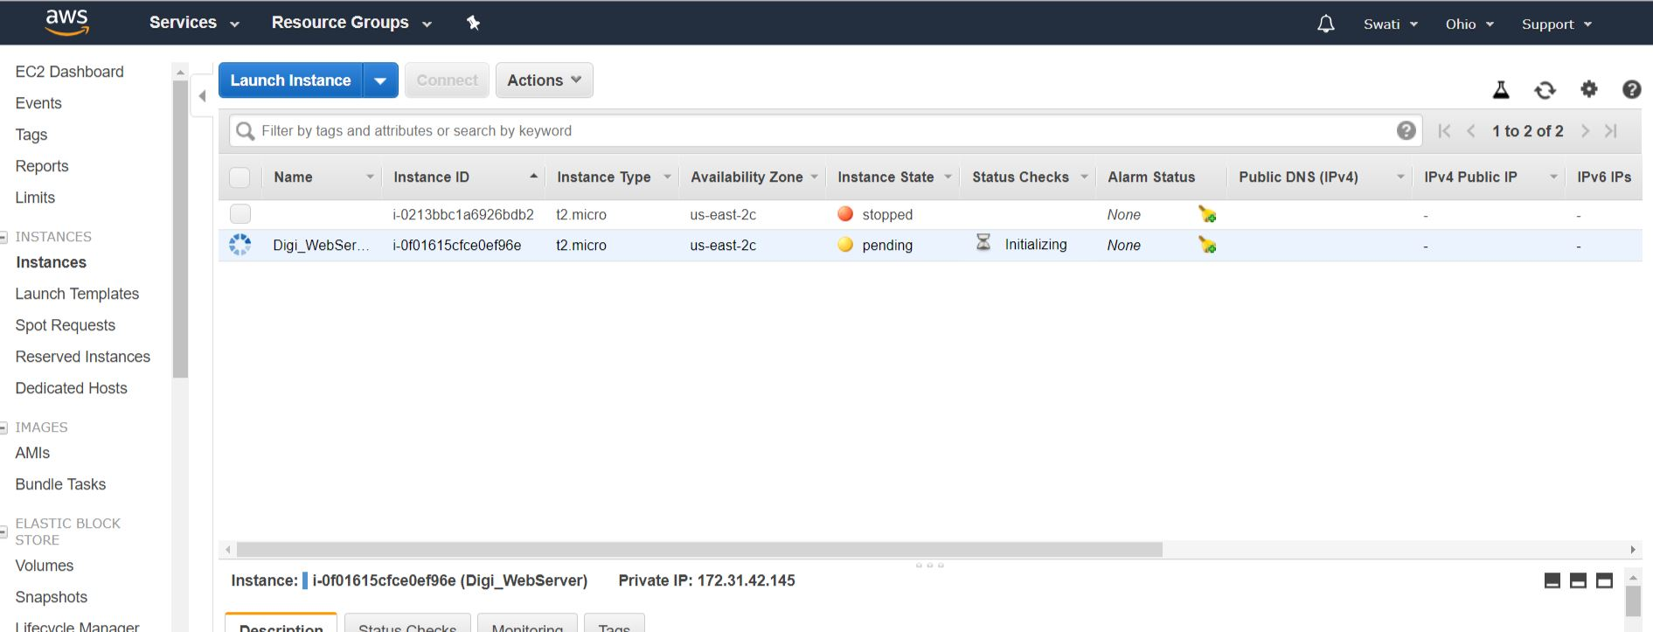

Paste the highlighted IP address in Putty Configuration

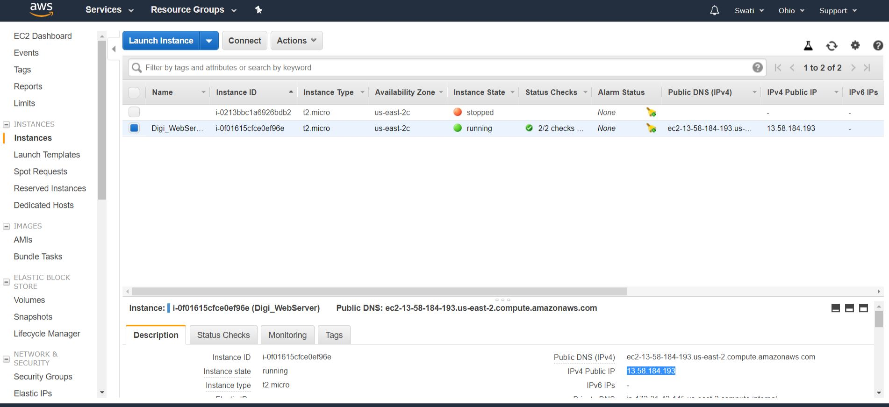

Paste that IP address here in sessions.

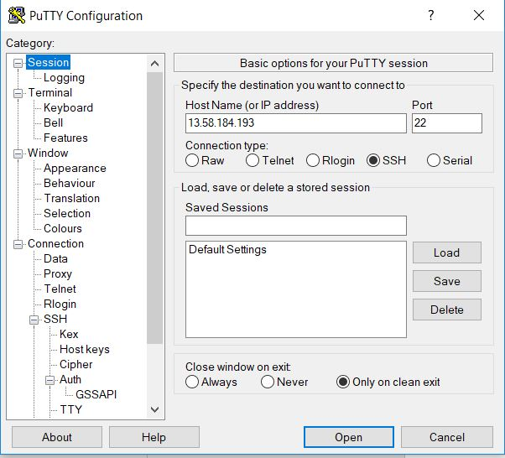

* SSH-Auth-click on browse to get Digi_webserver. That’s Your key and click open.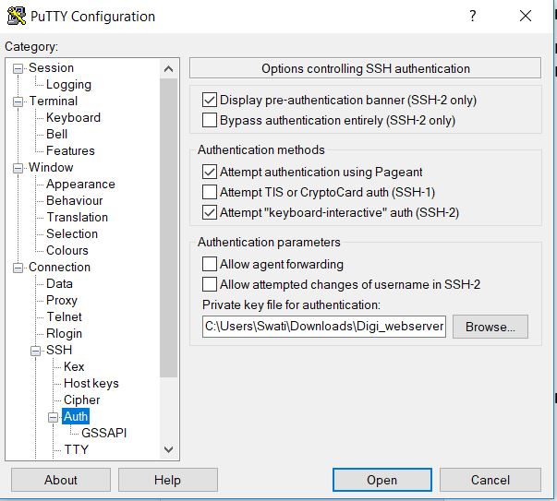
* In putty configuration, Connection – Make it 10 if 0.

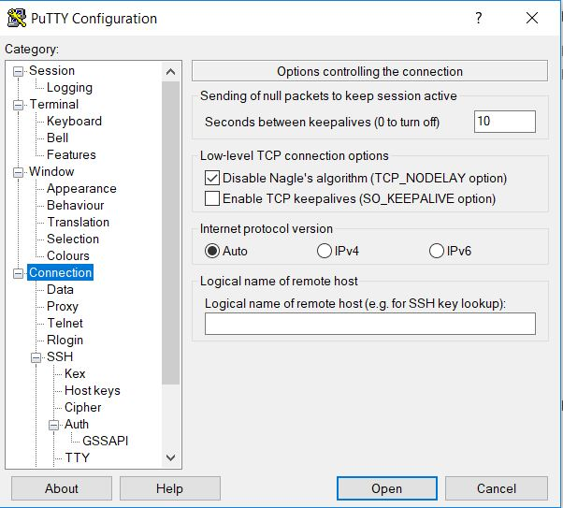

* Click open – Terminal (Amazon – Linux machine) will get opened

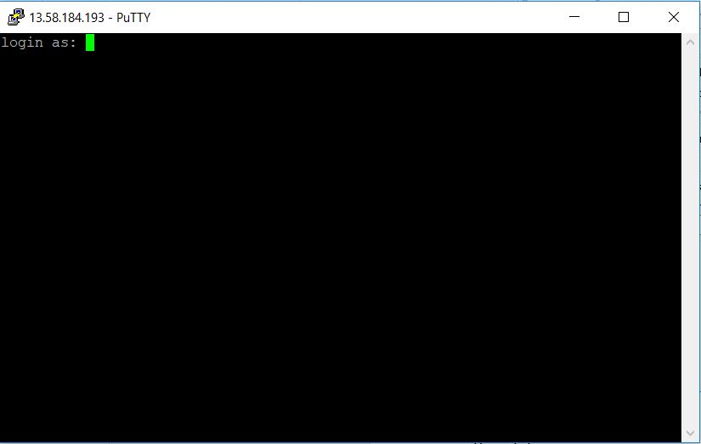

* Login as: ec2-user
* Yum update -y
* java –version
* date
* cal
* cal 15 08 1947
* logname
* click on Digi_webserver in review section in browser – on top- 3rd tab – action ----- stop. Otherwise they will charge you.

Can we edit the instance after launching the instance?

No. Only port can be edited.

IP address always changes every time you stop the server. Same steps after copying IP.

Go to terminal (Amazon – Linux machine)

Give the following commands –

* ec2-user
* sudo -i

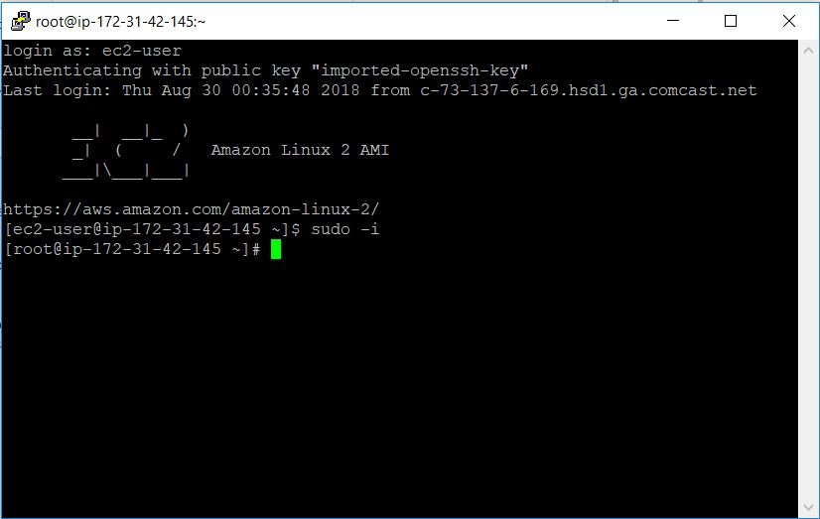

**Linux**

* Linux is a command line based operating system.
* Operating System
* Single user system -eg., DOS
* Multi -user system (can be used by more than one person) – Unix, Linux
* Features of Linux/Unix
* Multi user
* Multi-tasking
* Open system – The Unix is an aopen source code. Any user can modify the code.
* IBM+ additional features (took source code) = IBM -AIX
* HP+ additional features = HP-UX
* Santa Cruz+ additional features = Sco-unix
* Silicon graphics+ additional features = IRIX
* Microsoft+ additional features=Xenix

**How is Linux better than all of them?**

It is much faster in loading and access services faster and much secure.

* Distributions of Linux: Redhat, Suse, ubuntu, puppy, slakware, centos, OEL, Fedora, white box, Mandrake.
* Security: It ensures how security level

1. System Level Security – controlled by system administrator
2. File level Security - controlled by owner of the file

* Portability
* Communication process
* Programming language
* Help facility: #man <command name>

Or #info <command name>

Or <command name> --help

**Types of shells**

sh, bash, ksh, zsh, csh

kernel is the heart of the operating system. It will interact with the hardware and produces the output instantly. Linux is like a kernel.

**Difference between Unix and windows**

1. Unix Command Line Interface
2. Windows – Graphic User Interface
3. Unix-process based concept
4. Windows-thread based concept
5. Unix-unlimited users can work on the server
6. Windows-limited people can work on the server

1) Unix - If we want to reboot Linux machine we only need 2MB size of RAM

2) Windows – We need 12MB minimum RAM

1. Unix – no downturn
2. Windows-downturn is there
3. Unix-if you kill a process in your system it will not hurt others
4. Windows-it will affect all the other programs
5. Unix-it is an open system
6. Windows-it is not an open system
7. Unix-portable operating system
8. Windows-it is not a portable operating system

**File System**

It is a method of storing data in an organized fashion on the disk.

File Systems ->

* Disk File Systems – eg., FAT, FAT32, NTFS, CDFS, HFS, ext2, ext3, ISO9660
* Network – eg., DFS, NFS, SMB, FTP
* Virtual

File System Hierarchy System

* /(slash): Top level hierarchy. It is a parent directory for all other directories also. It is called as a root directory.
* root: It is a home directory for root user and provides a working environment for the root user.
* home: home directory of other users and their environment
* bin: binary file commands. It contains commands for all users
* sbin: contains only root user commands
* boot: it contains system bootable files, bootloader information
* /etc: it contains configuration files, eg., /etc/hosts, /etc/resolve.conf
* usr: by default softwares are installed in this usr directory. These are unix shareable resources
* opt: optional directory for users, which installs 3rd party softwares
* dev: device files
* var: variable files
* mnt: default removable media
* library: contains all libraries
* tmp: contains temporary files information
* media: removable media, link CD-ROM, pendrive
* proc-process files

**Commands on terminal**

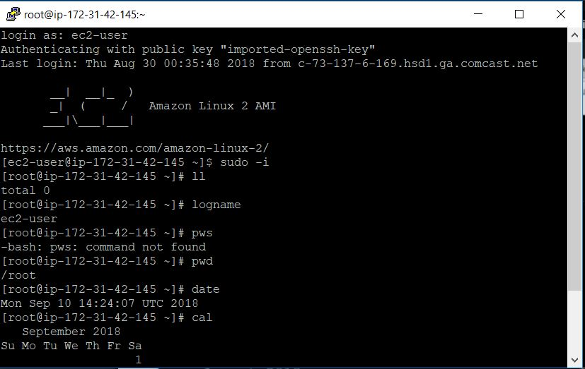

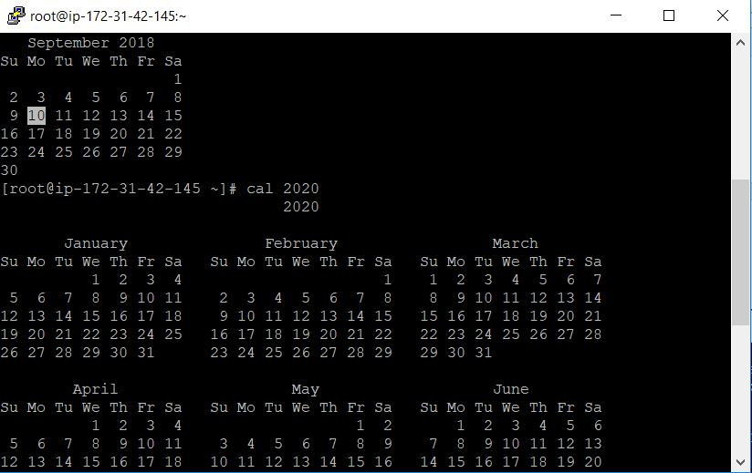

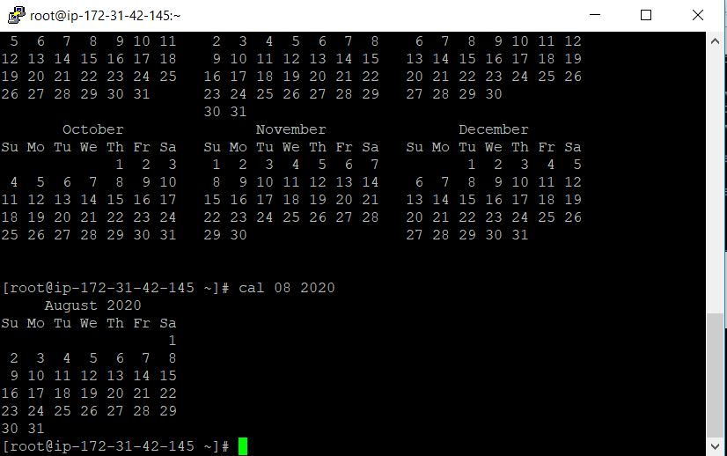



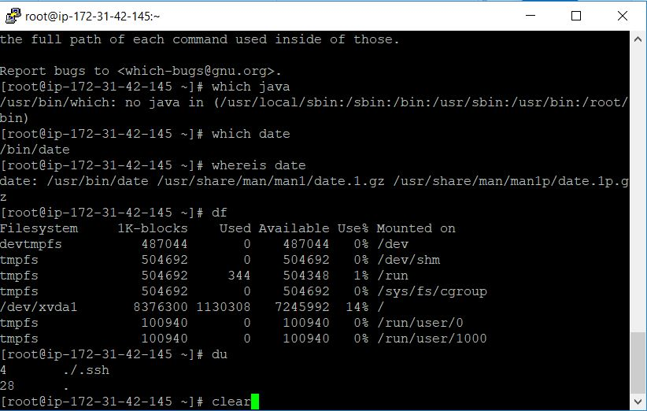

**Creating files**

|  |  |
| --- | --- |
| Command | Meaning |
|  |  |
| cat>digi1 | Creating a file named digi1 and entering data in it |
| Hello world.$$ Today is a very great day |  |
|  |  |
| ctrl + g | To come out of that line |
|  |  |
| ll | to check that file contents |
|  |  |
| cat digi1 | to append the file |
| cat >>digi1 |  |
| yes, I am here |  |
|  |  |
| clear | to clear the page |
|  |  |
| touch file1 file2 file3 file4 | to create multiple files in a directory |
|  |  |
| ls | list the contents of the file/folder |
|  |  |
| mkdir workspace | make a directory |
|  |  |
| mv digi1 digi2 digi3 digi4 digi5 workspace/ | move digi1, dig2, etc. To workspace |
|  |  |
| cd workspace | change directory to workspace |
|  |  |
| ls -r | list in reverse order |
|  |  |
| ls -i | list |
|  |  |
| ls -a | list all files including hidden files |
|  |  |
| ls -l | long list |
|  |  |
| ls -R | list recursively |
|  |  |
| ls -h | list human readable languages |
|  |  |
| cd .. | to come out of the directory - one step back |
|  |  |
| pwd | print working directory |
|  |  |
| cd ../.. | to go 2 levels back |
|  |  |
| cd ~ | home directory |
|  |  |
| cd | comes to the current directory |
|  |  |
| mkdir digi2 digi3 digi3 digi4 | create multiple directories |
|  |  |
| rm -I digi2 | remove interactive mode |
|  |  |
| rm -rf digi2 | forcefully remove digi2 |
|  |  |
| rm digi1 digi3 | remove digi1 and digi3 |
|  |  |
| cd digi4 | create a file digin in digi4 |
| cat>digin |  |
|  |  |
| mkdir digi5 | copy digi4 to digi5 |
| cp digi4 digi5 |  |

**Meta characters or wild characters**

**‘*’, ‘-‘, “()”**

**Vim editor –** it’s a text editor. Even if you give one dot(.)by mistake whole server will stop. vi or vim

emacs – similar to vi

nano

vi editor – It is most popular. It has 3 modes:

1. Command mode –

Syntax ->vim <argument> <filename>

Arguments

-R : opens a file in read only mode.

-O : opens 2 files at a time

+ : Starts at the end of the file

+ <num> : Starts with line <num>

Importance of cursor position: If we want to make changes at a specific location, and mouse is not working, only up and down keys, this helps (+<num>)

1. Insertion mode – In arguments place you will be passing :

vi sudo -ldap.conf

to escape: q

clear

i: begin insert mode at current cursor position

I: to insert at the beginning of current line

a: to append to next word’s letter

A: to append at the end of the line

o: to insert a new line below the cursor position

O: to insert a new line above the cursor pointer

1. Execution mode –

Arguments:

e: moves to the end of a word

b: moves to the beginning of a word

$: moves to the end of a line

^: moves to the beginning of a line

H: moves to the first line on screen

M: moves to the middle line on the screen

L: moves to the last line of the screen

x(nx->number you are passing): deletes the n character

dd(ndd): deletes the n character

dd(ndd): deletes the n position/current line

dw(ndw): deletes n word

yy(nyy): yanks(copies) the current line/n line

p: paste below the cursor line

P: paste above the cursor line

gg(ngg): go to the beginning of the line

G: end of the file

w(n): to move the cursor forward, word by word

b(n): to move the cursor backward, word by word

ctrl+f: to forward one page

ctrl+b: go backward one page

/: to search a word in the file

n: to find next occurrence of the search word

N: finds the previous occurrence of the search command

. : repeat the last command action

**Commands for the last line mode:**

:q : to quit without saving

:w : to save the changes

:wq : to save and quit

:wq! (or) x : save and quit forcefully

:set nu (or) se nu : to set line numbers

:set nano (or) se nano: to remove line numbers

:n : jumps to new line

$d : to delete the last line

!<unix command> : to execute unix command

:X : to give password to the file and remove the password

/string/ : to search a word in the file

**To find some words and replace it with new words**

:%s/root/dog/ - replace “dog” with the first instance in your line

:%s/root/dog/g – for each instance of the line

:%s/root/dog/gi – to ignore the case sensitive

:%s/root/dog/gc – ask for confirmation

**Executing unix commands in vi editor**

It can be done by simply typing ! before unix command

:!pwd

:r! date – read the result from the date command into a new line following the cursor

:r! cat file1 - Cat command will open the file

:1, 4 co 10 – from 1 to 4 copy to 10 (use escape for that; mouse won’t work). co is for copy

:3, 7 mo 8 – 3 to 7 lines move after the 8th line

:1, 30 w test 1 – take 1-30 lines and create a new file

:8, 20 w >> test1 – append the data with test in 8 to 20 lines

: r/etc/passwd

**Managing 2 files at a time**

$vim -o file1 file2 – open 2files and manage them

-o will open

Or

$vim file1 file2

options:

:n

:rew – revert to previous file

ctrl+w

**Input output redirection or I/O Redirection**

Sometimes you need output of a command more than once.

> - over rides

< - directs input from file/device

>> - append the data

|(pipe) – output of one command to another

&& - combining of 2 commands

**Cut**

Syntax: cut<option>file

-d specifies the delimeter

-f displays a particular field

C displays character

**Paste state capitals**

paste s1 s2 – joining 2 words

wc – word count or line count

Syntax: $wc <options> file

-l (lines)

-w (words)

-c (characters)

wc -c s1

wc -w s1-It will count the spaces also

diff – It will tell the difference between the files

Syntax:

$diff file1 file2 – tells the difference between file1 file2

cmp

$cmp file1 file2 – it will compare 2 files

tr

$tr “aeiou” “AEIOU” < s1 - file $tr “aeiou” transforms lower case aeiou to upper “AEIOU”

tr “a-z” “A-Z” < s1 – all upper case

tr “A-Z” “a-z” < s1

tr -d “aeiou” < s1 – delete aeiou

cat n

cat>n

check grammatical errors – aspellcheck s1

**Head command**

cat > new – pasted all data

head -4 new – here new is the filename. Whatever is there in this file (return number of lines from the top). Its use is that when we want to set the log files and find the 1st 10 visitors today or the offer is only for 1st 10 people, this is how we get 10 people’s data.

Tail new – to know the last person in the data.

Tail -5 new – to know the last 5 members

Piping – combining 2 or more commands in a single line

$ls – l|wc -l| -first command output is taken as second command input

&& - combine 2 commands

echo “this is a text file” > s2

cat s2

echo “good day” >> s1 && cat s1 – append good day to s1

more new

cat new more

less s1

sort

iuniq

sed

**Regular expressions or Regex (Grep)**

Meaning of Grep – Globally research a regular expression and print it out

To search a string or regular expression in a file(S)

Syntax: $grep<options>pattern file

grep root

grep workspace

grep “b[aeiou] ll” s1

cat s1

grep [0-6] s1

**Note: vmware makes your system slow**

yum install grep -y

grep “^g” s1

cat s1

**Notes related to grep**

history – displays everything; you can check which commands you have used

aliasname = “command” – syntax

alias u = useradd

or

alias c = cat

c > s3 – create a file, short cut names for regular commands file

alias cl = clear

cl = it will clear the screen

alias – to find the number of alias in our system

unalias c – to check if c is there

unalias d

alias

vim . bashrc – to remove permanently

**What is file permission?**

It is used to protect the files or directories on different parts of the system.

ll

//rw-r--r--- - middle r is group – it will be divided into 3 parts. Rw is user, last r is other.

User – person who owns the file

Group – group that owns the file

Other – all other users on the system

Permissions in Linux can be assigned in 1 or 2 ways

Operation Digit Mnemonic Description

Read r 4 view file contents (Read only)

Write w 2 write or change

Execute x (small) 1 run the file

umask : universal mask – default values for :

super user umask value : #022

normal user umask value : #002

maximum permission of a file : #666

umask : #022

to get default value permission #644 – default file permission

(subtract umask from max)

Max presentation of a file : #666

Umask for a normal user : #002

Normal user: #664

Max permission of a directory #777

Umask #022

Max permission default value #755

Max permission of a directory #777

Umask for normal user #002

Default permissions for a normal user #775

In command line type:

umask

ll

cd ..

digi

workspace

cd workspace

chmod – to change the permission of a file and directory. It can be used by the owner of the file (or) by root

+ - > add a permission

* -> Remove a permission

= -> override a permission

Syntax : chmod<options> <permissions>

-R (recursively)

-v (verbose)

chmod g+n, o+x new

Ll

chmod ugo = rn new – complete permissions for user group (for all)

ll

chmod u-w, g-w, o-w, new – remove write permissions for all

ll

cd ..

ll

digi

workspace

ll

digi

workspace

chmod 700 workspace1

digi

workspace

chmod 755 workspace

chown : change the owner of the file or change the owner of the group at any time

Syntax: chown<option> <user:group><file>

groupadd linux

usermod -g linux root

groups

useradd raj (create user)

usermod -g linux raj

groups

groupadd qa

groups

chow root digi/

you can also use chgrp(change group  
) in place of chown

vmware is your work station – AWS includes vmware, etc.

Create windows machine/system: storage will be min of 30GB. With Linux it’s only min of 8GB.

**Installation of vmware**

**Step 1** – Click vmware workstation from the link provided in the materials in Mydrive. Install it. Extract it.

**Step 2** – After installation, you’ll get the workstation created. Open it by double clicking it

**How to create a Linux system**

**Step 1** – Click on create a new virtual machine.

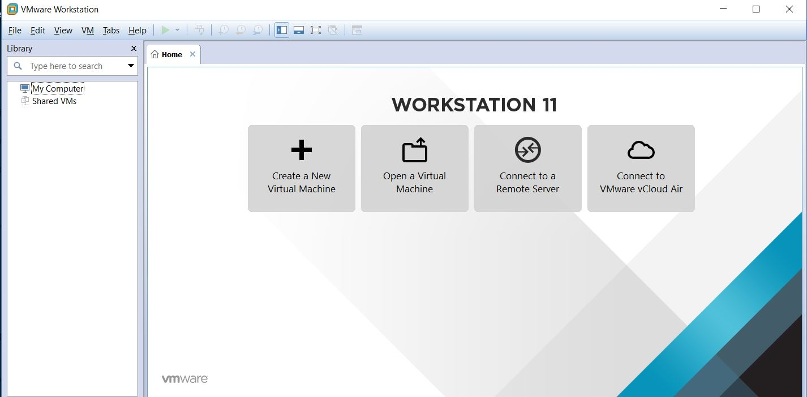

**Step 3** – A new window will open, click on next

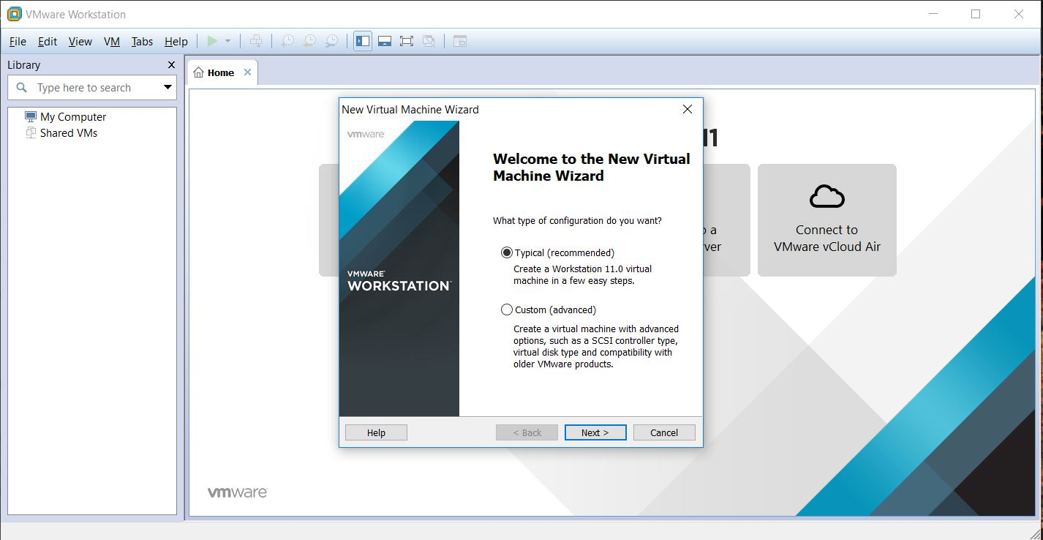

**Step 3** – In the next window, you’ll be asked for the path to the rhe16.iso which we received in materials in MyDrive. Copy its path and paste in that dialog box. Then click next.

**Step 4**– Give the credentials below:

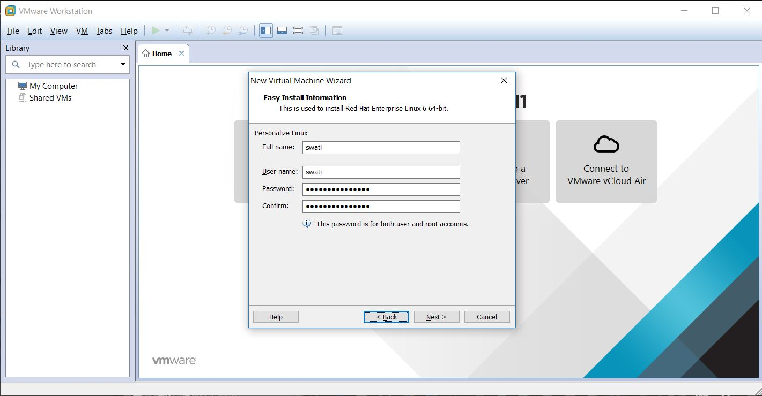

**Step 5** – Give your name to name the virtual machine and click next.

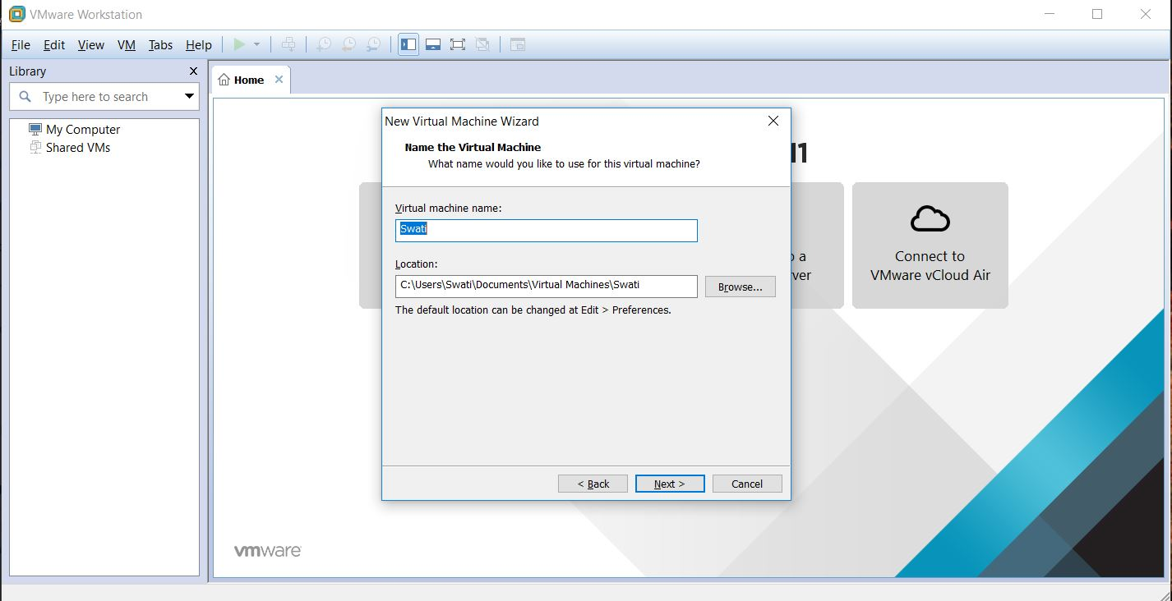

**Step 6** – After installation, you’ll get the workstation created. Open it by double clicking it

**Step 7** – Change the number from 20 to 40. Click next.

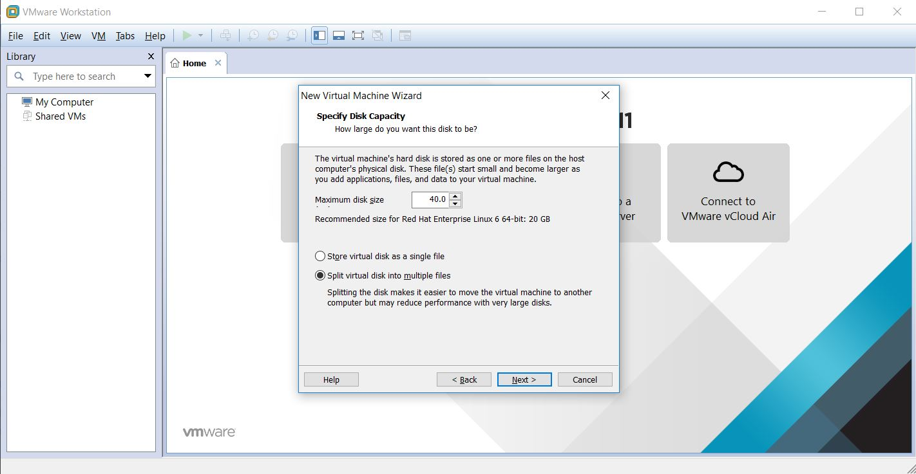

**Step 8** – Click finish.

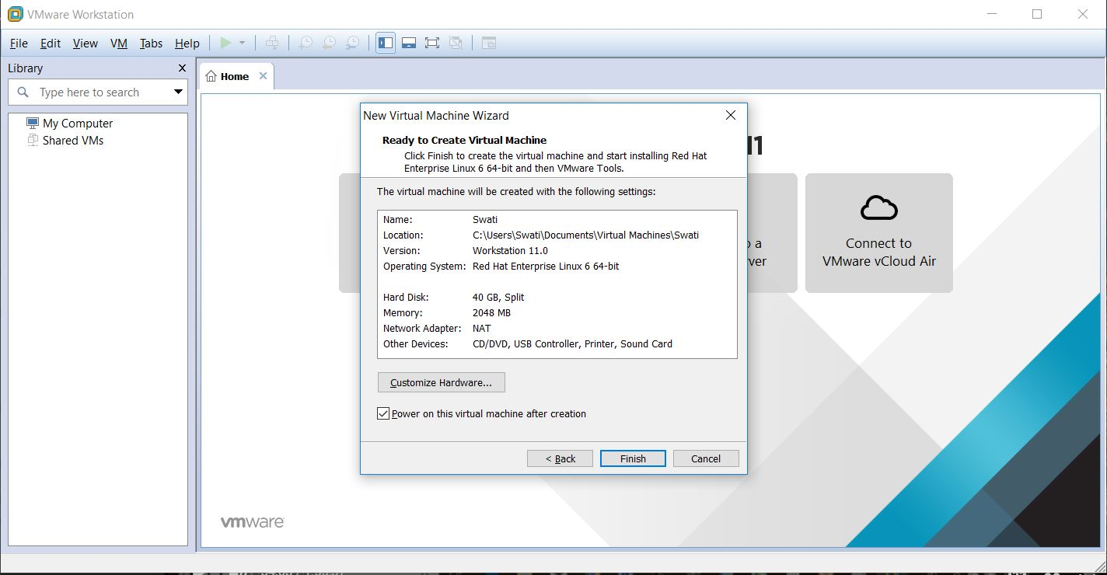

**Step 8** – New rhe16 is getting ready here.

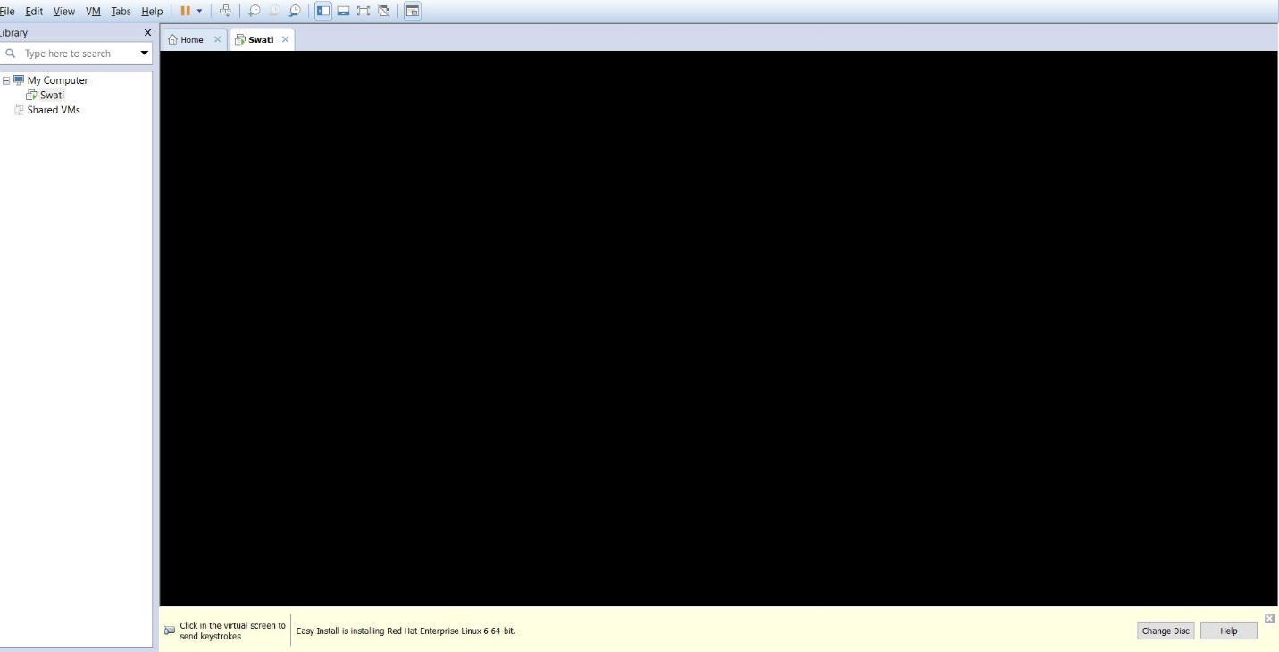

**Step 9** – VMware deals with very heavy files because of that c:\ data storage will get finished soon. People who want to access on multiple systems can use VMware. It is installing now.

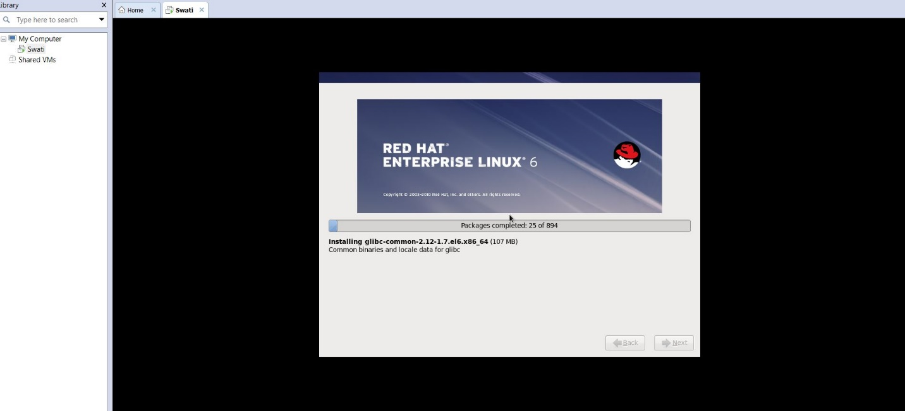

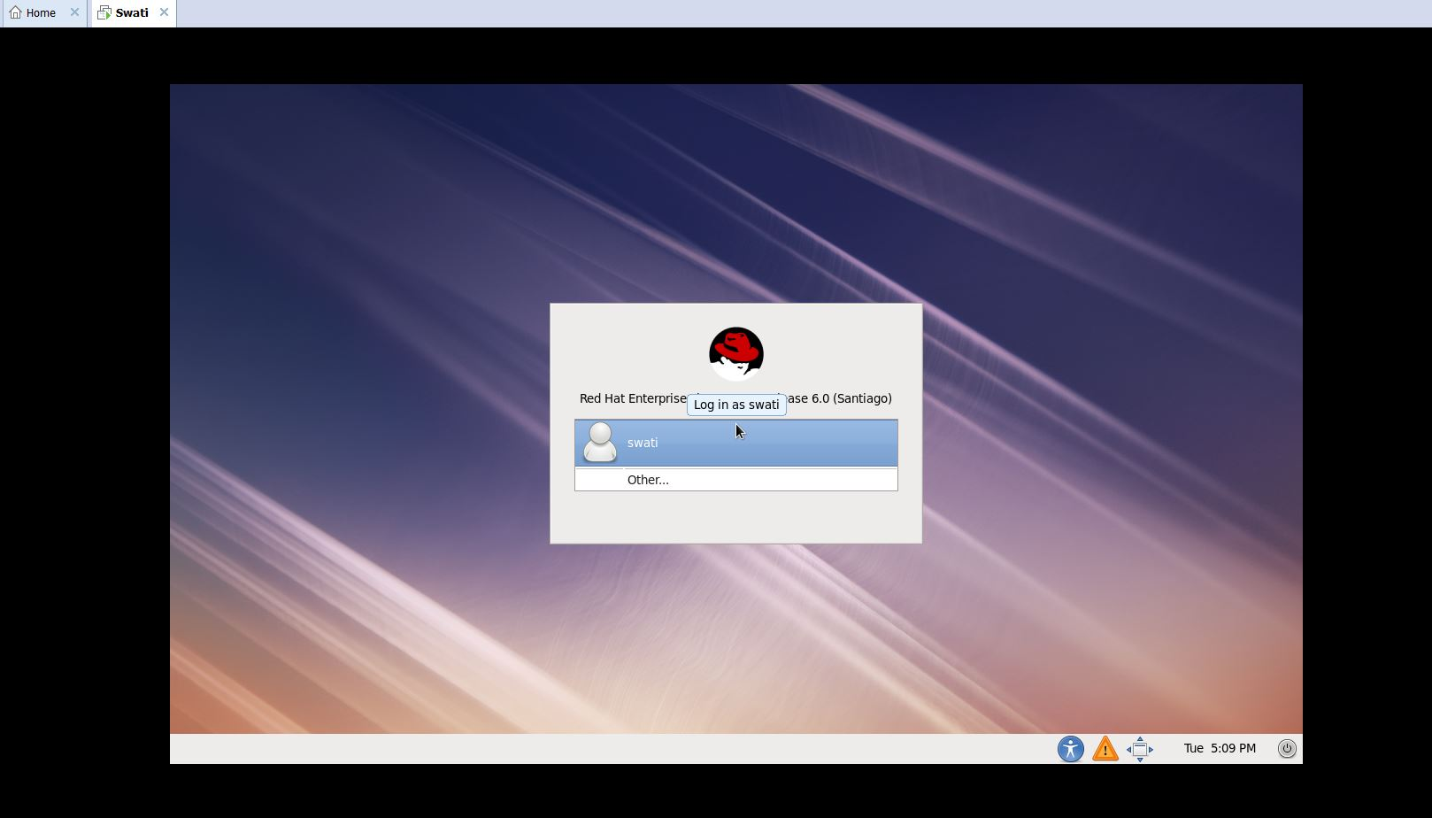

**Step 10** –Linux machine is installed

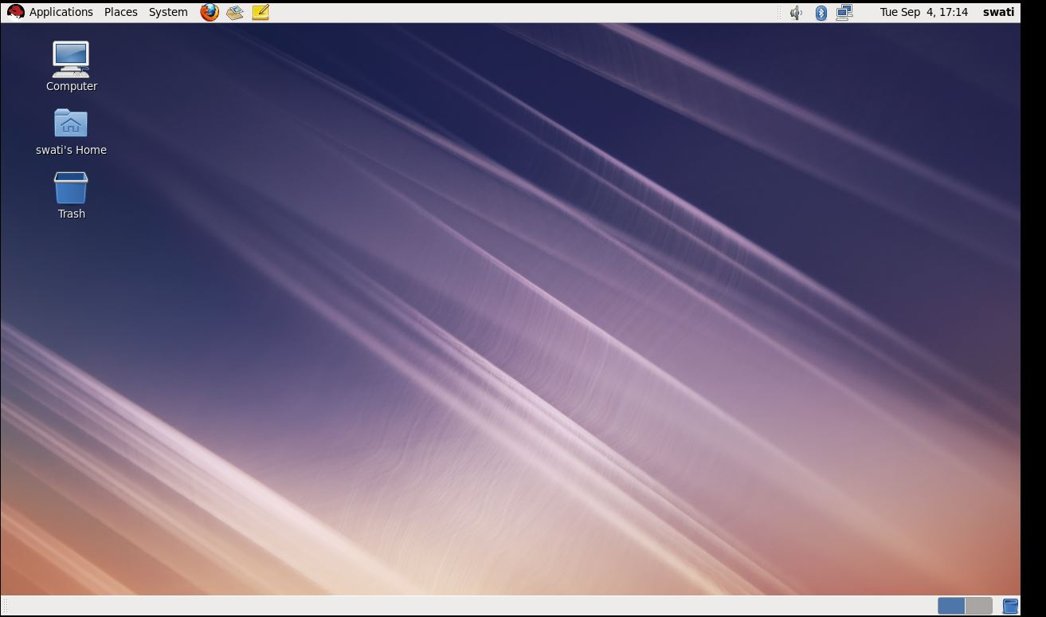

**Git**

- It is a widely used version controlling system

- It is very fast.

- no need to access the server

- most popular

- founded by Linux in 2005

- It is a distributor-based version control system

**Version control tools –**

Share codeamong team members and keep it stored safely, can backup the code so that it doesn’t get lost, can revert back to a previous version

**Steps to install Git**

* Git download or git-scm.com/download
* Click download for windows
* After completion of installation, always click on next and complete the installation.
* Go to the folder where you are working(where we created Git folder)
* Click finish when it’s installed.
* Now right click on Git folder and click git bash. To install Git, install few git packages on Linux and not windows. For windows it’s installed by default commands.
* To generate ssh – generate ssh for communication
* Ssh -keygen
* If you want to override click y
* Click y 3 times.
* Cd/c/users/Swati/.ssh/ - to check – Swati(first parameter in in of gitbash)
* To get ssh ->
* Cat id, rsa.pub – to get secure ssh key. Copy the key
* Go to setting in github
* Click ssh
* Title -> github-project
* Key- copy key and create
* Go to git
* cd ..
* cd .ssh/
* git init
* create a repo on Git
* add a name
* git remote add origin …. From Git to gitbash paste.
* Touch s1 s2 s3
* git add .
* mkdir work
* mv s1 s2 s3 work
* cd work

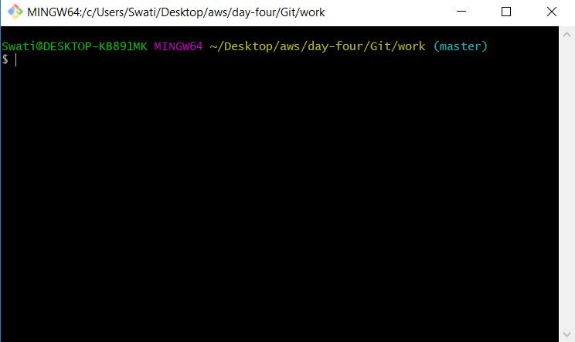

* git add .
* git commit -m “my code”

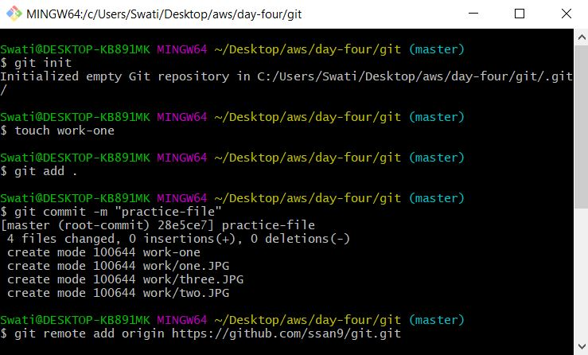

* git push -u origin master
* touch d1 d2
* git add . – add to local repo

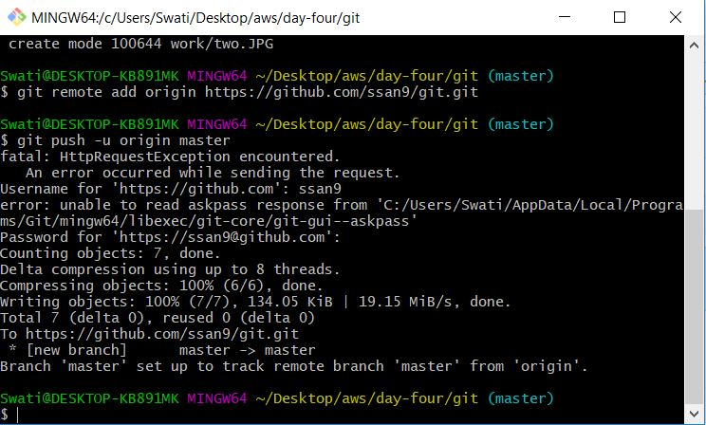

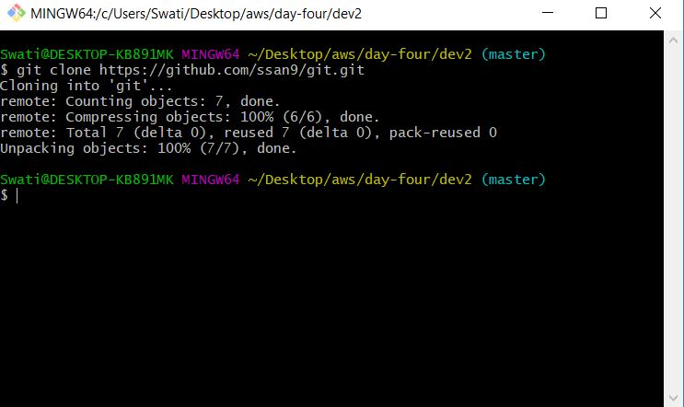

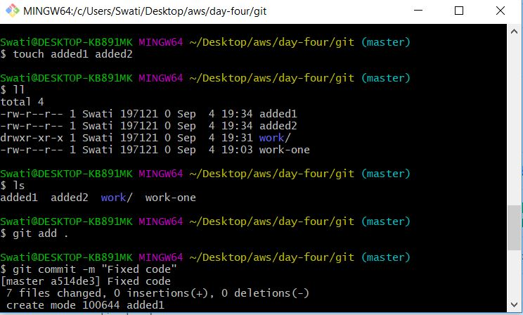

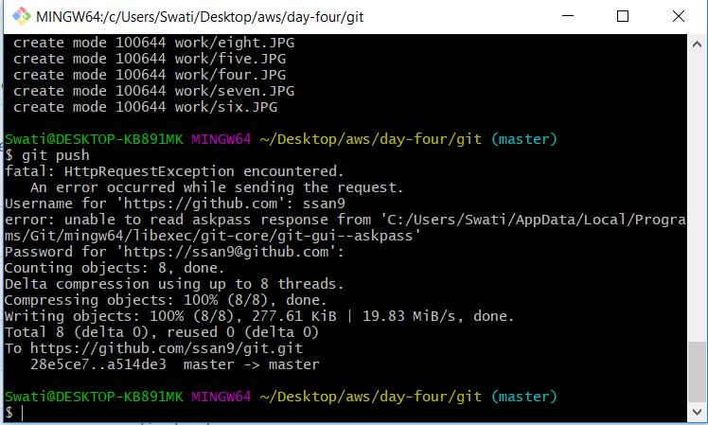

**Difference between distributor**

Push to local repo and then central repo-step-by-step-distributor

Connect with GitHub

**GitHub**

* Create an account on github.com
* Settings – find different options
* SSH and GPG keys
* Create a new repository on GitHub

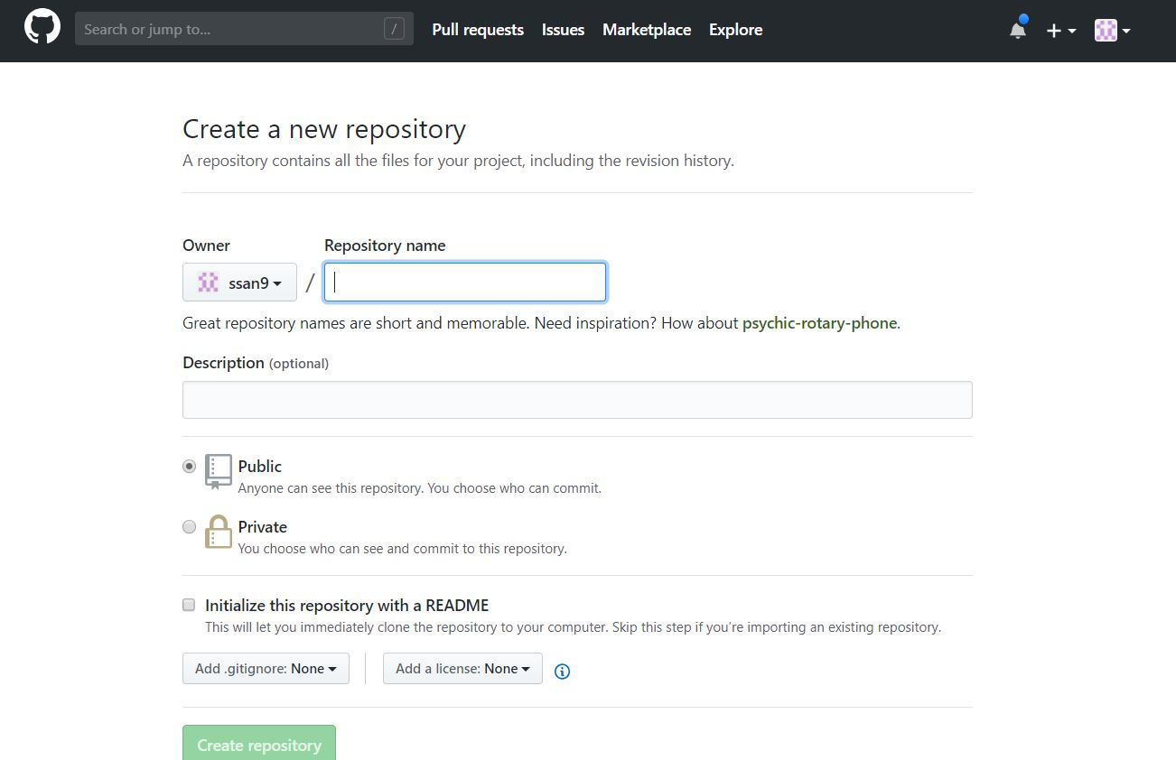

We’ll use the commands given below in Gitbash.

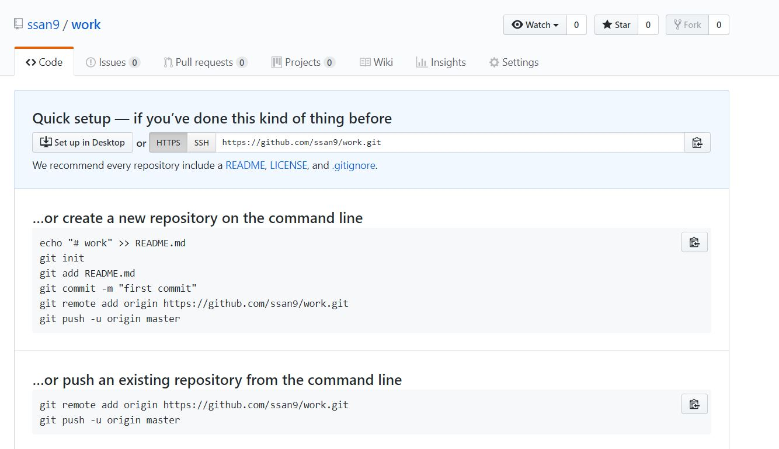

* Click refresh and you’ll see your files from the local system in the repository

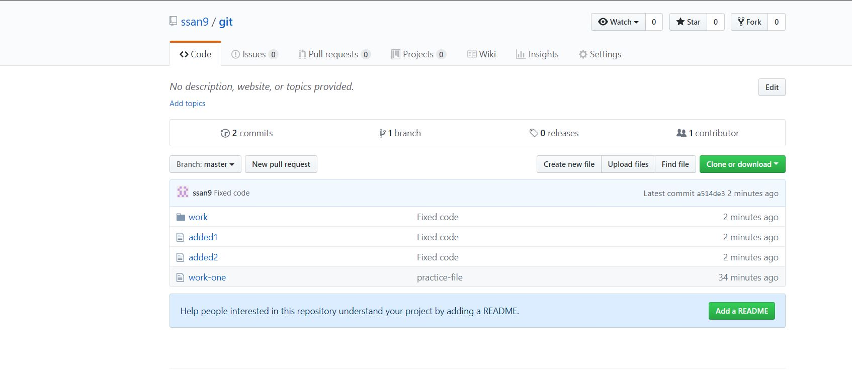

* Repositories – If you want to change the code on GitHub:
* Go to repo
* Click edit
* Make changes
* Click commit changes
* Notification will be intimated to the person who owns that code.
* Comparison option – with comparison option they’ll know what changed.
* In DevOps terminology it’s called continuous collaboration of teams.
* Fork – when we log into other person’s repository in github and want to copy it, we use fork.
* Git pull – get changes from remote repository to local repository.

In Settings – Default Branches – In master you can check branches. If you want to restrict branches, add rules by clicking on add rules, and then choose rules. Click create after that.

**How multiple people will be working on the same repository?**

In your Git, create a new folder and go to one of your repositories in your github, click clone, copy its url and clone it to your new folder using the command git clone along with the url you copied from github.

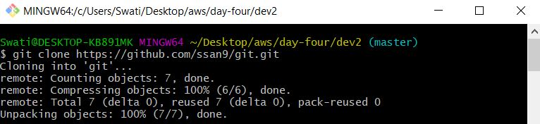

Parallel development:

When you do git log, it shows you what are the commits you did at your side.

Git config --list - To see all configuration files related to git

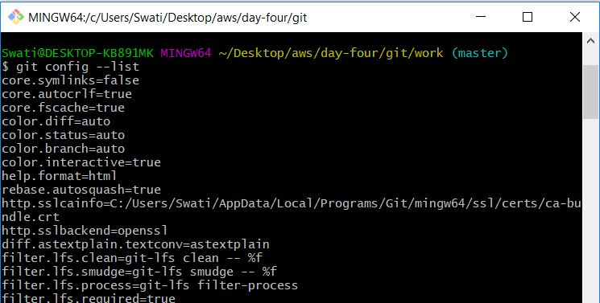

:q – to quit

Git status - to check the files you have uploaded in the current directory

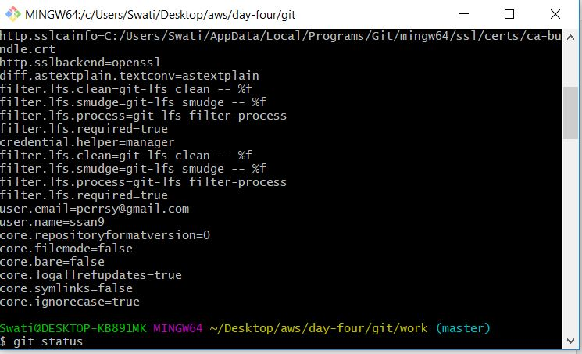

Directory structure in the Git

1. Master – It is the root directory and the default one. It contains the branches
2. Branches- They contain the major releases
3. Tags – they contain minor releases and are read only

Uses of parallel branching strategy –

1. No data lost in the production
2. Branch is a developer code where check in and check out before deployment no data loss overriding code in production environment. After deploying releasing branch.

To know the default branch

Command – git branch

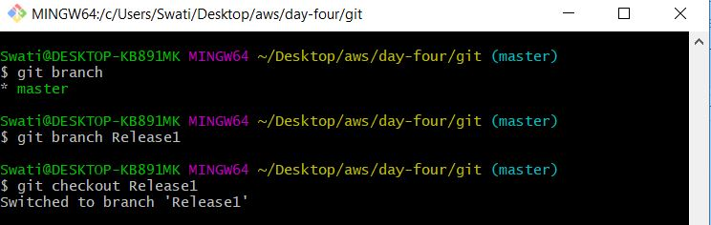

To create a new branch:

Git branch Release1

To switch to Release1 branch – git branch Release1.

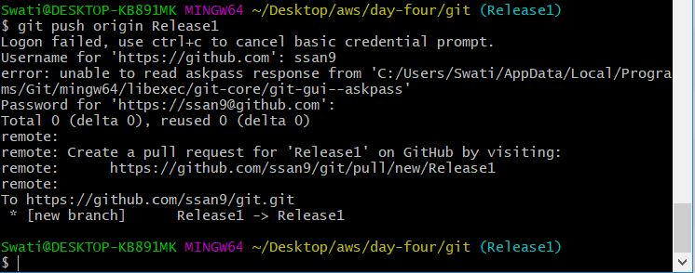

We can see in Github a new branch is created under master

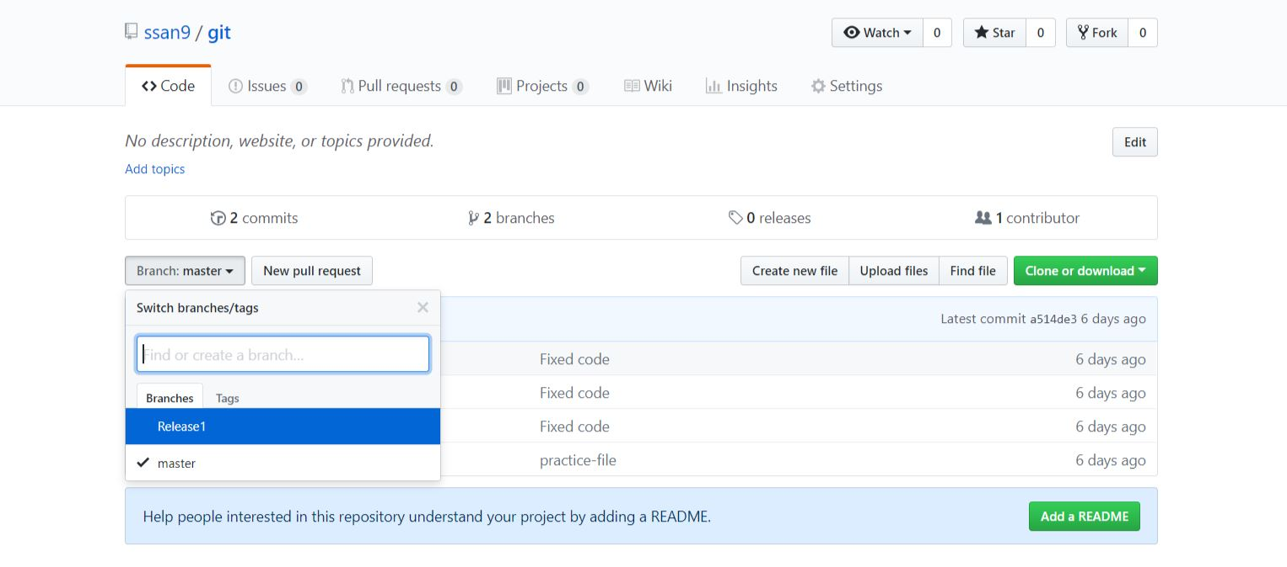

Close Gitbash. Go to folder Git and use gitbash here. We’ll see it will mention Release1 in brackets.

Create a branch and checkout in one command – git checkout -b Release2

Git push origin Release2.

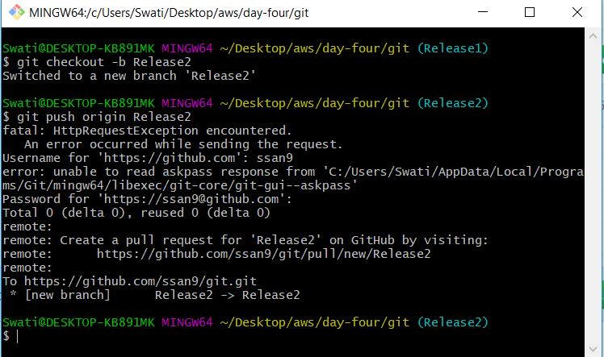

Check GitHub, you’ll see one more branch created under master.

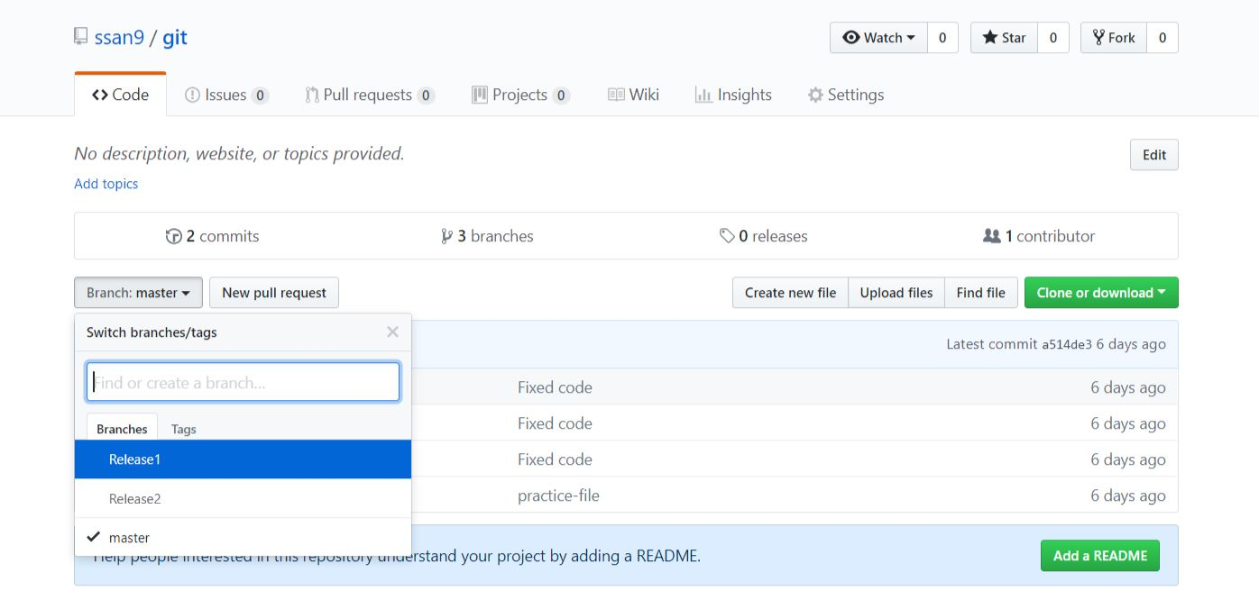

To get the display info of the branches – git branch -v

Rename a branch - git branch -m Release1 Newrelease

To check – git branch. This will show the list of branches with the latest change.

Delete a branch in a local repo – git branch -d Newrelease

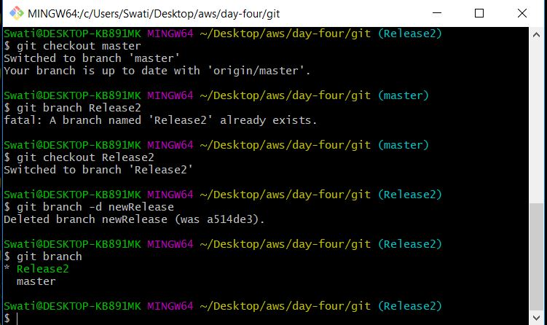

Git branch – to check the list of branches

Git branch -m Release1 New release changes the name of the branch

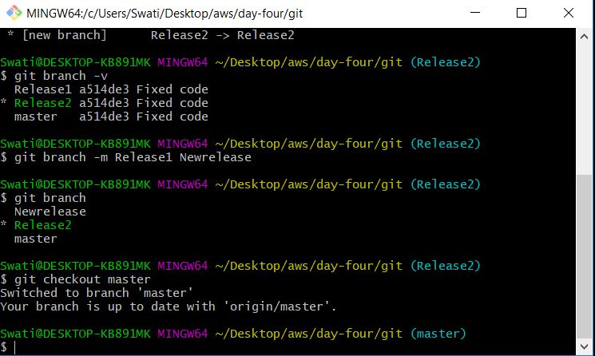

We need to push the changes to GitHub then only latest changes will be visible there in the remote repository, i.e., deleting changing the name of Release1 to New release and deleting it.

To see the remote branches – git branch -r

Git branch -D (small d deletes local branch if you have pushed them, it is for remote branch)

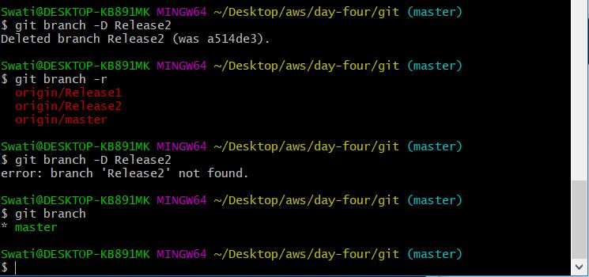

To remove the branch from remote repository we’ll give the command: git push origin :Release2

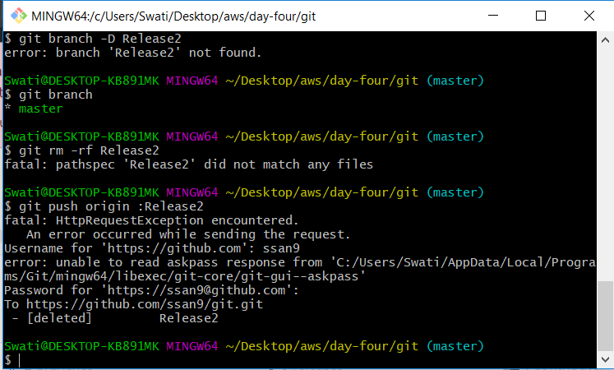

Similarly, we’ll remove Release 1 as well

This is how github repository looks like now

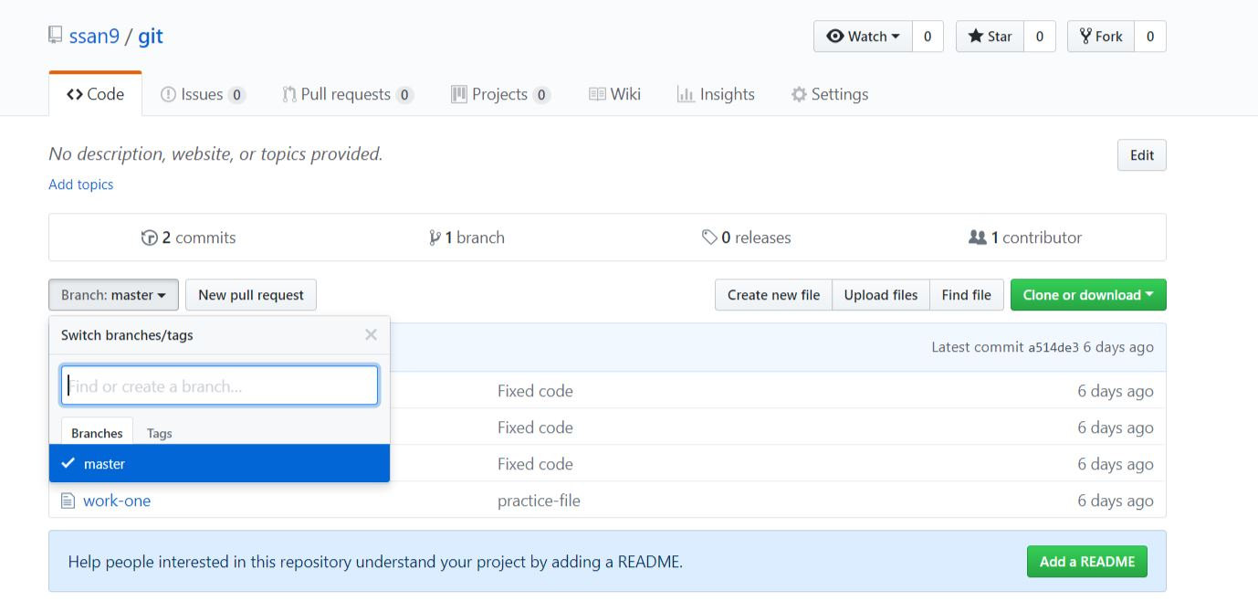

Give the command history to see the list of commands.

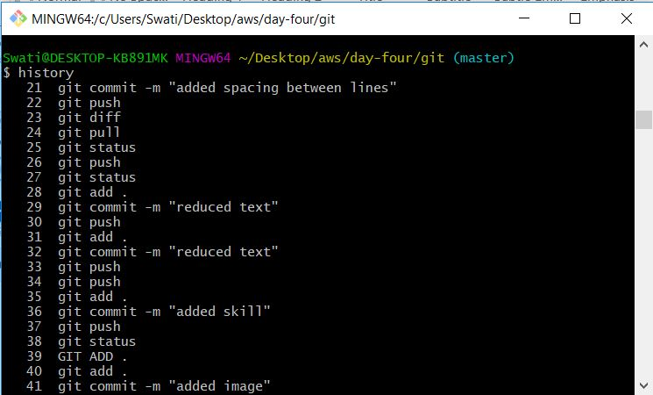

Git diff to check the difference between 2 branches

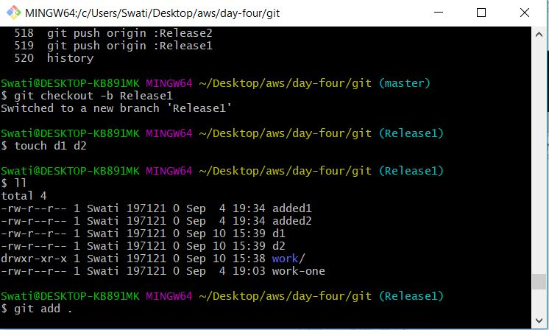

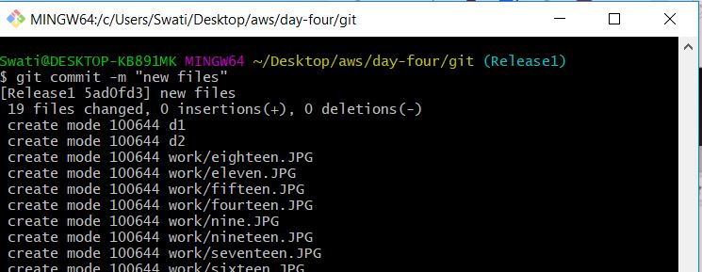

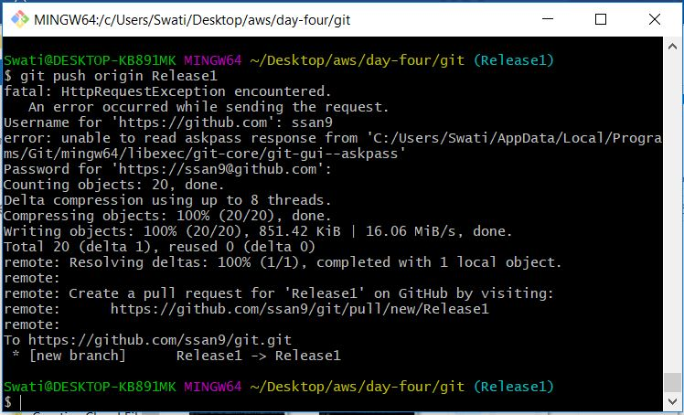

Create one more branch in the same manner as above called Release2.

Refresh and we’ll find the branches in github.  
Now when we give the command – git diff master Release1

We’ll get the differences between the 2 branches

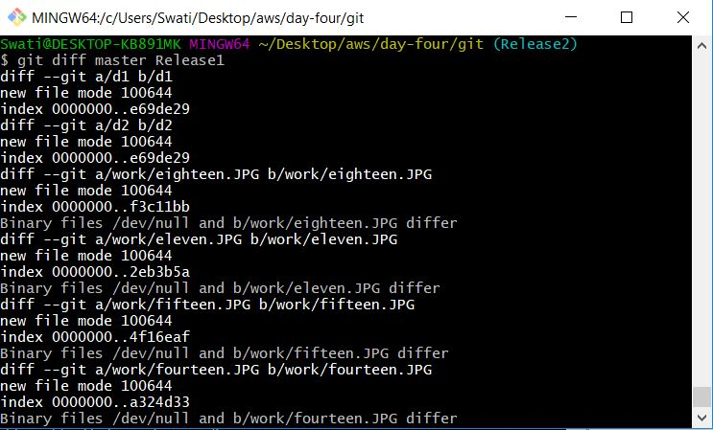

In gitbash, click branches(3), you’ll see the following

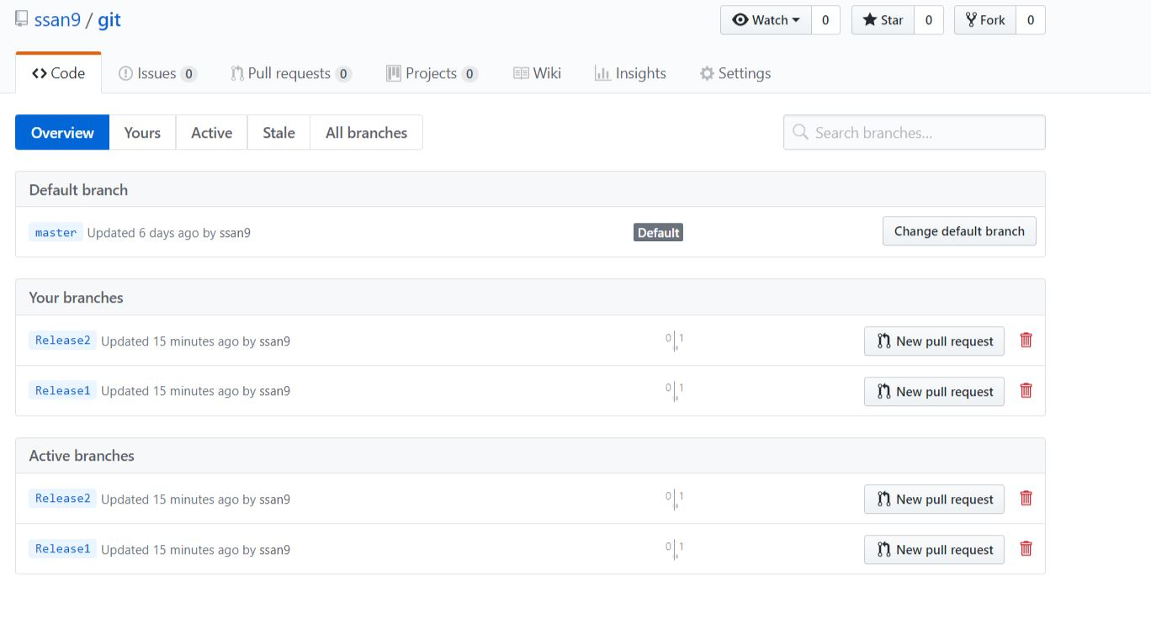

You can even directly delete the branches in Github as well.

Tags – They are additional mechanism to get a snapshot of a Git repo. It will create a identifiable tags which will correspond with Software Release Cycles. We can create, modify, delete

git tag tag_1.0



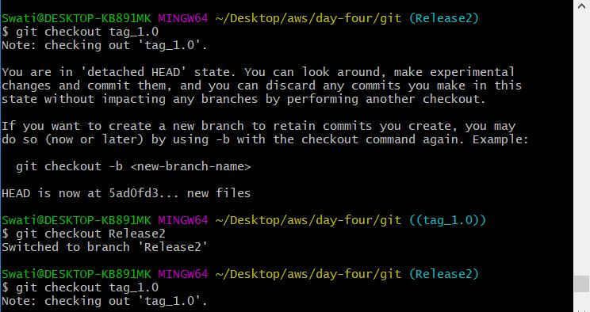

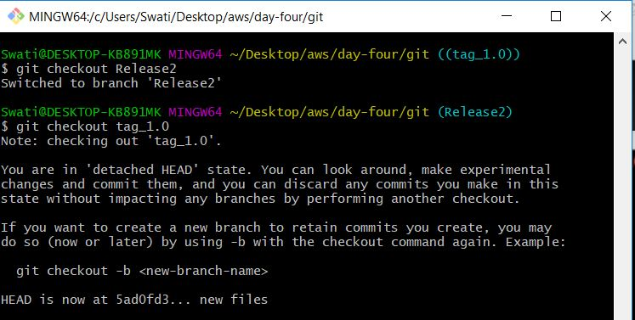

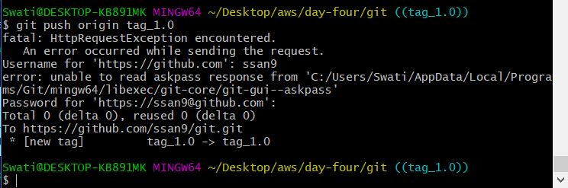

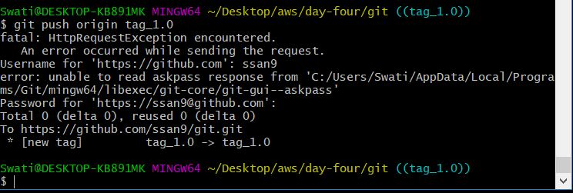

To get the details on the tag, to get its version – git show tag_1.0.

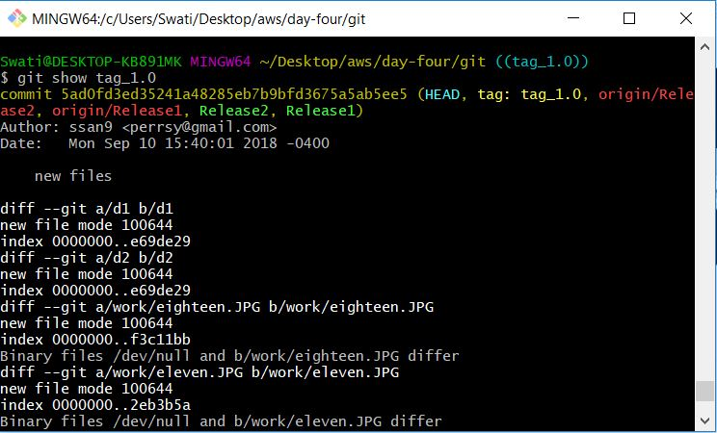

To see all the available tags in the branch

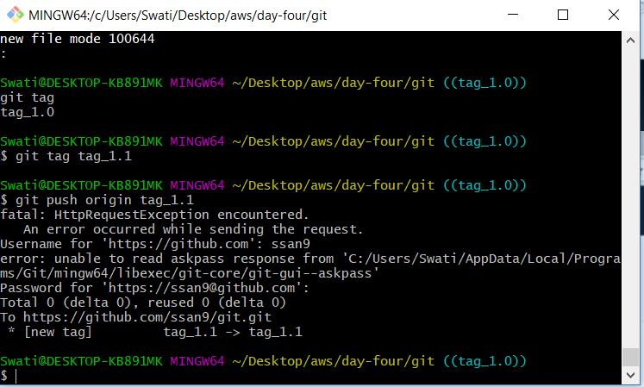

Tags created in github

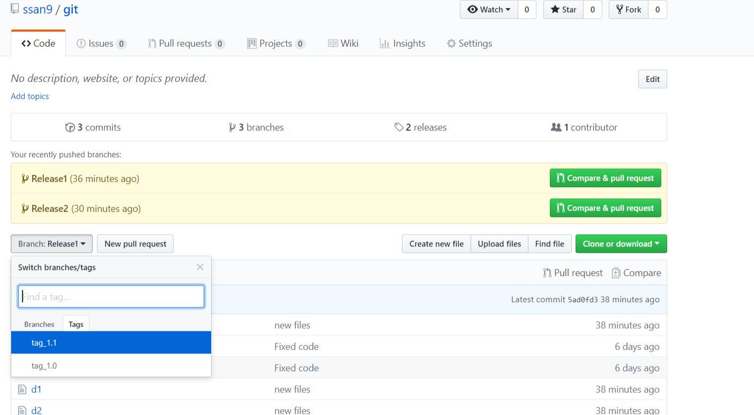

Delete the tag in the local repository –

$ git tag -d tag_1.1

Delete the tag in the remote repository –

$ git push origin : tag_1.1

**Directory and branching structure**

**Sequential Branching:** For each build master code will be copied to the tags. Working with different branches at the same time. Expected time will be more. Only after completion of one stage you go to another.

**Parallel Branching:** Master is always equal to the production environment

**Build tools**

They are used for documentation which includes unit tests, integration, etc. These are used by developers.

For java – ANT, Maven, Gradle

.NET framework – nAnt

C# - MS build

**Maven**

It is an advanced tool. Apache Maven is a java based project management and comprehension tool based on POM(project object model).

Build – covers all the steps required for delivering a software product -> src code,compiling, running, health, checks, packaging

Compilation and execution of a java program

Compile – Compiles src code and generates byte code. It is saved in the form of a jar class file.

jvm – java interpreter – takes .class as input and generates a byte code.

Byte code will be used for next steps of preparation.

ANT – can be used for C, C++ as wll. We nee to use xml. And will do the same thing as Maven but should be written in xml. It is a bit difficult to learn and understand as compared to Maven. You have to write the code on your own.

Maven – All dependencies, distribution management will be available. You don’t have to code anywhere, it will take care of itself.

Maven’s use

Maven signifies and gives solutions to problems

* Adding set of jars and dependencies in each project(not possible with other tools)
* Creating and maintaining right product structure otherwise it will not be written – with Maven its not a problem’
* Build and deploy the project – it’s easy
* Job to be done in quick response

Amazon performs 8000 builds/day

Facebook performs 16000/day

It is difficult to do everything manually and the results will be slow.

Maven will make the project easy to build.

Maven – we use as many project structures

-as build tool

-reporting, releases, distribution

**Installation of Java jdk**

* java jdk kit download – google search
* click on first link
* click on agreement button under Java SE development kit 8u 181 heading and then click on Windowx64 link

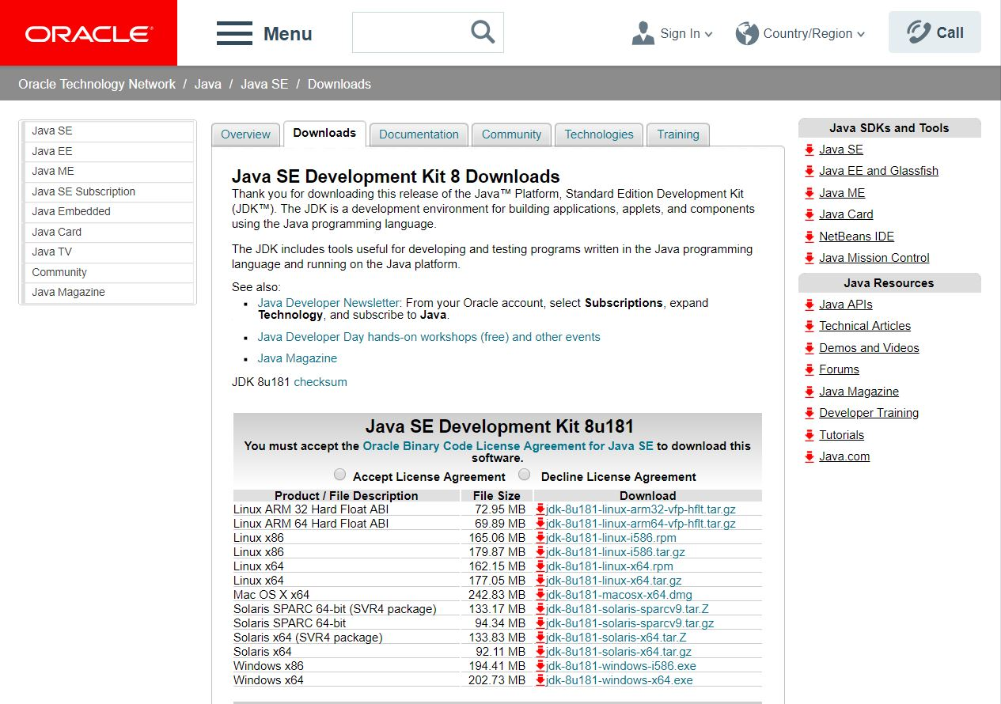

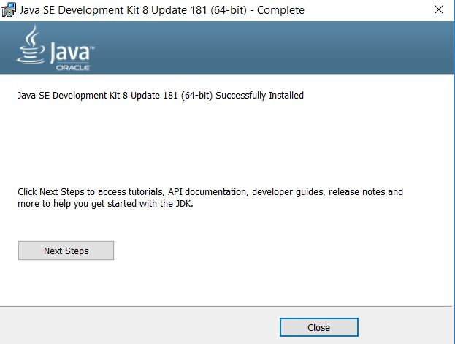

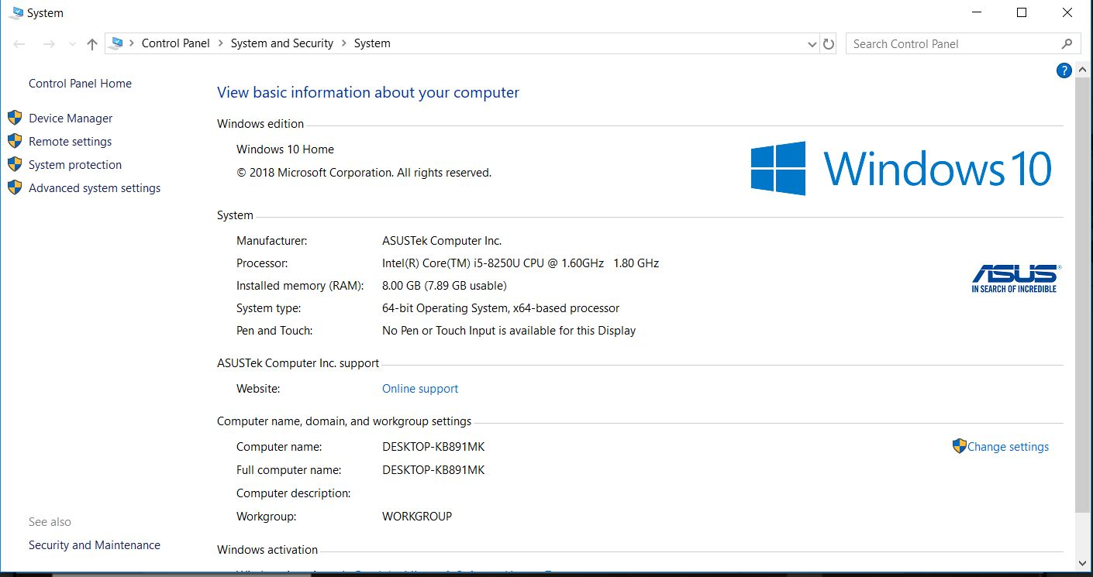

* Once you install you have to mention Java Environment variables setup

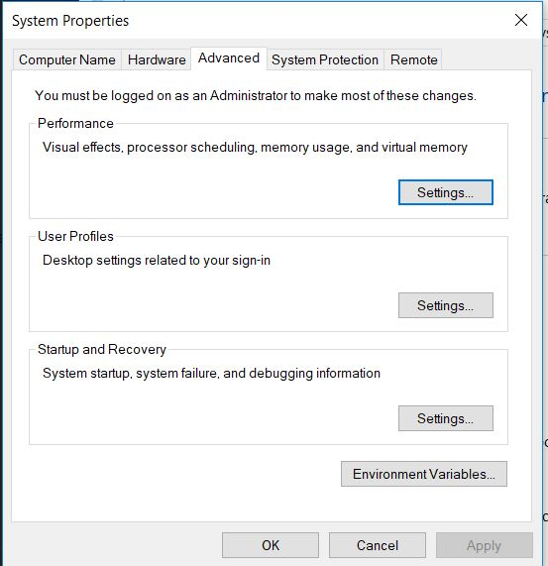

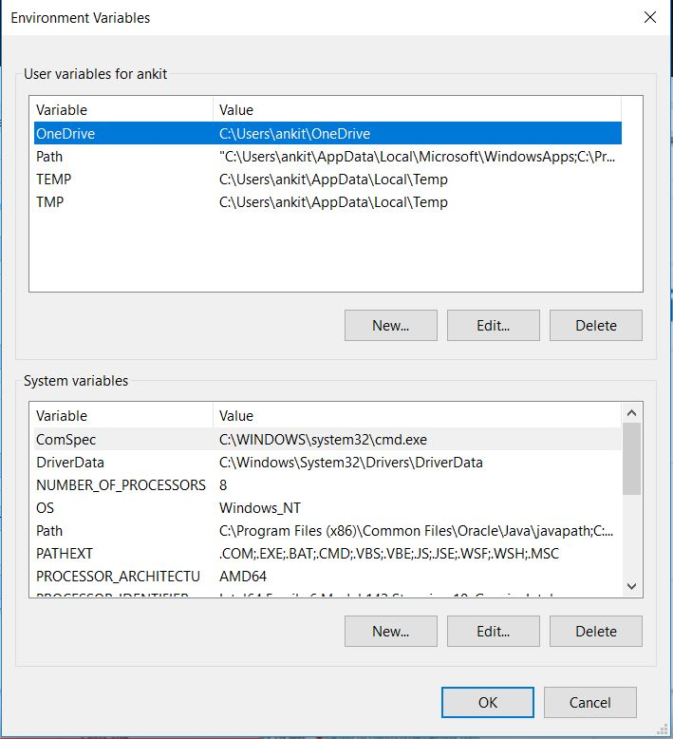

* Replace the below variables with
* JAVA_HOME = location of java
* PATH = location\bin(binary files)

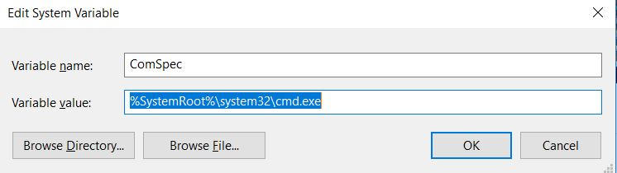

* After it gets downloaded double click and keep on clicking next and it will start installing.
* In cortana type this PC, right click on it, and click on properties
* In properties click on advanced system settings
* Click on environment variables
* Click new in the 2nd box to add Java_Home for Java_Home’s address (path), go to C: - program files – Java – double click – first jdk 1.8 …., double click and copy its path. Now paste it in the edit section of environmental variables.

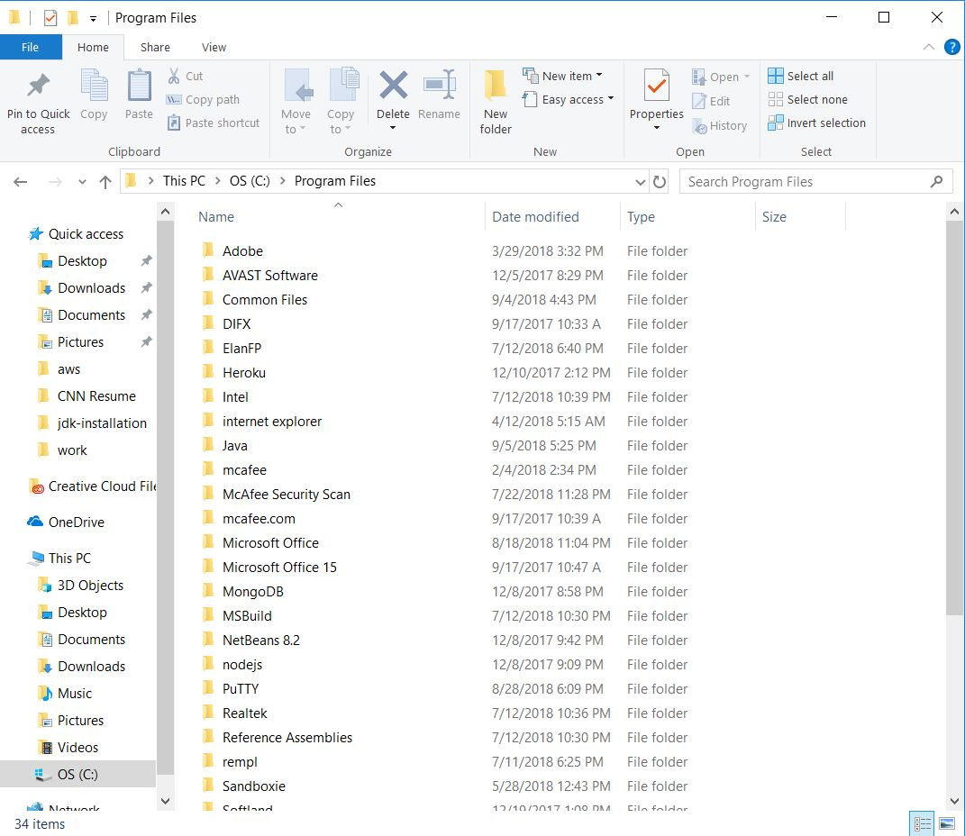

* Check java path

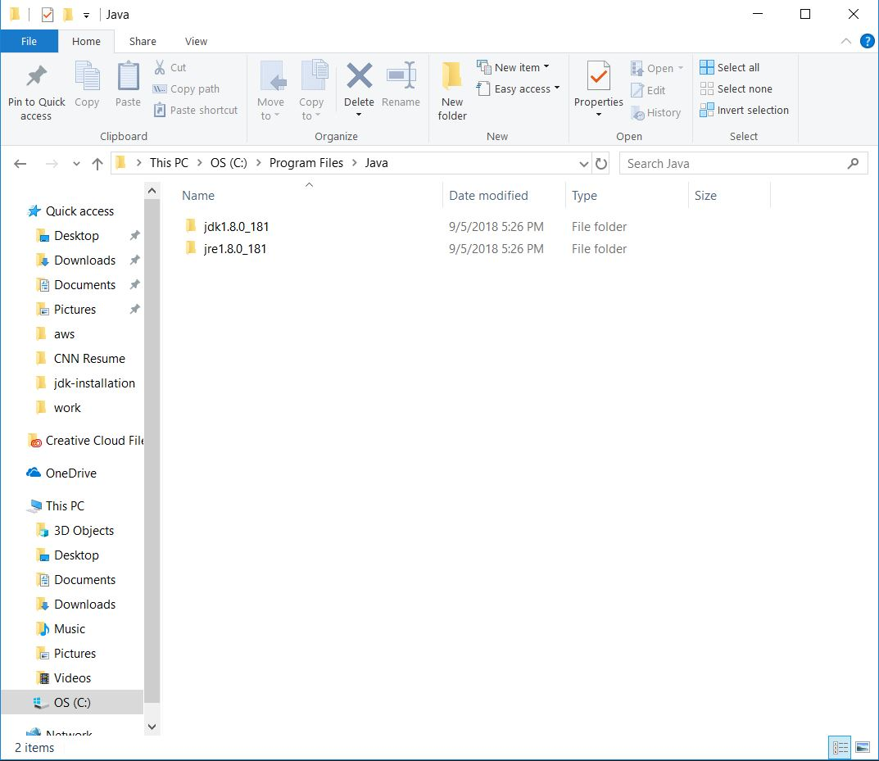

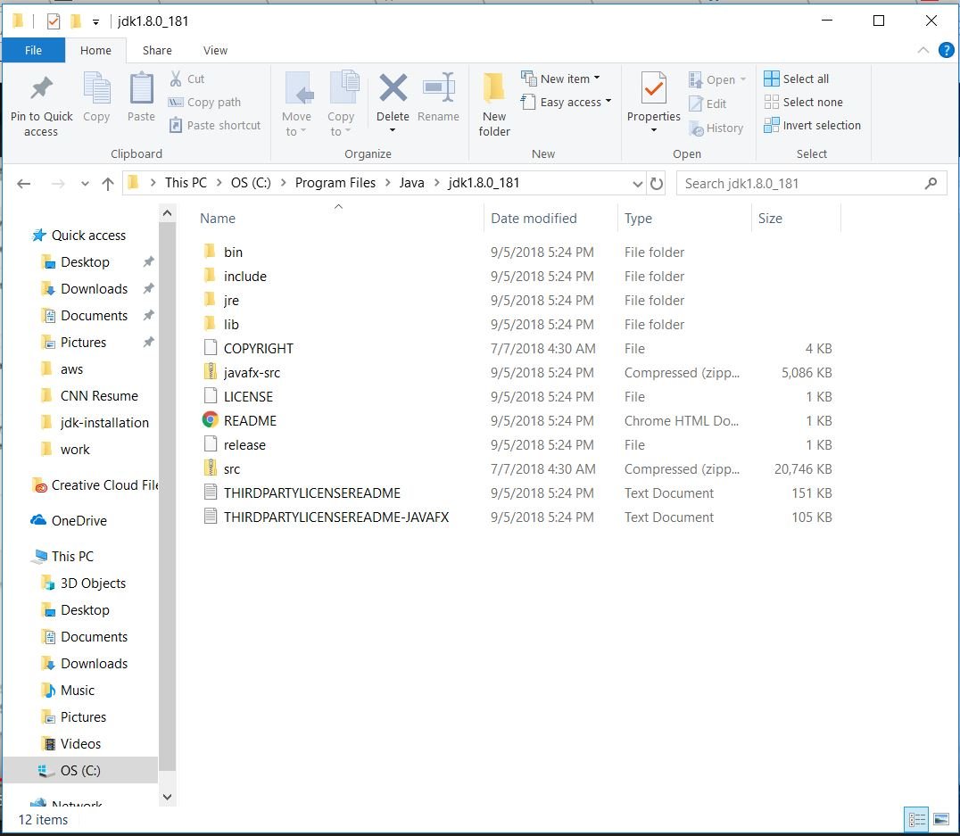

* Click new and add % JAVA_HOME%\bin

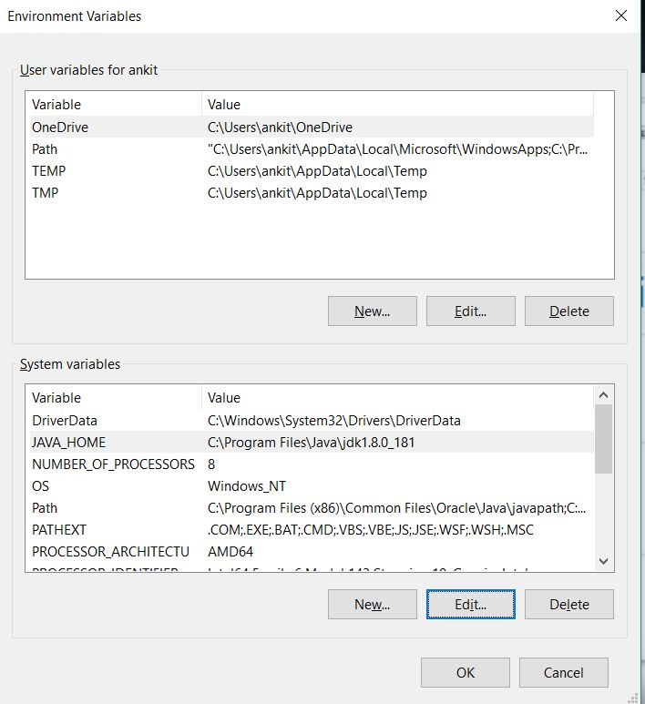

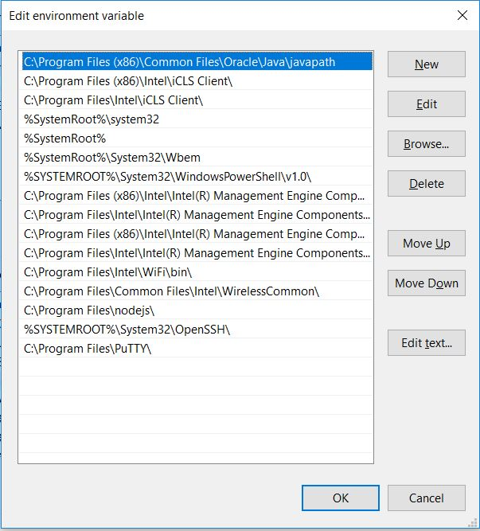

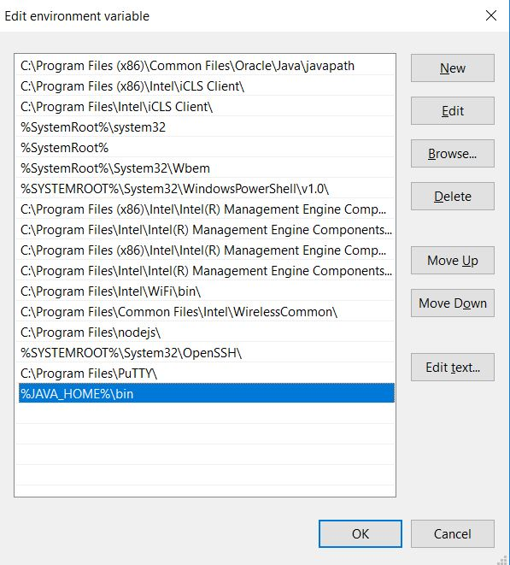

* Click OK
* Click OK in environment variables as well
* Click OK till the end ( to choose all dialog boxes)
* Check whether jdk is installed properly or not. Go to command prompt -> end in console type java -version

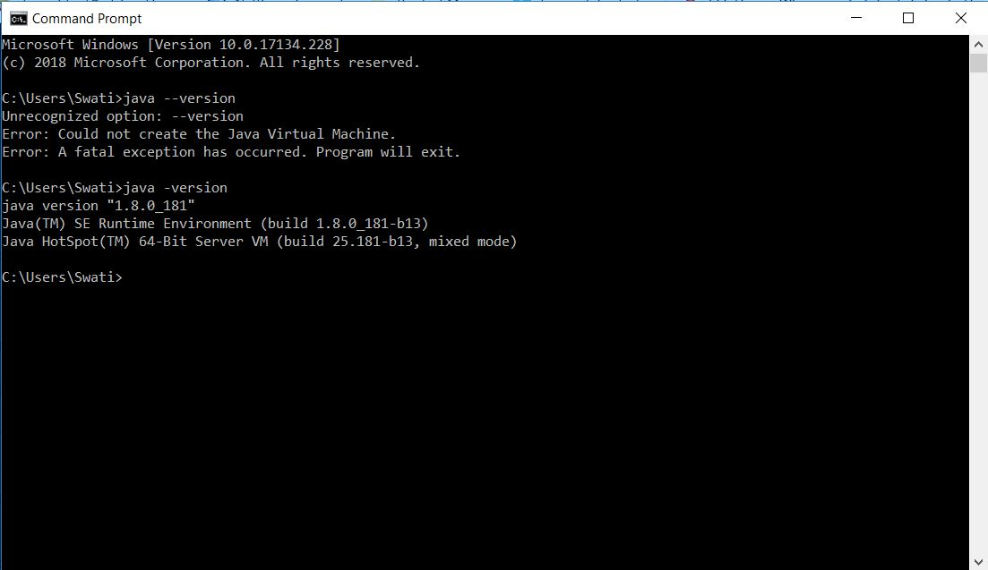

* Without java in system Maven will not work.

**Apache Maven Installation**

* Google search -> Maven download
* Click on first link of download Apache Maven -> Apache Maven Project
* Scroll down
* Our architecture is Windows so download, binary and not source
* Click -> binary zip archive

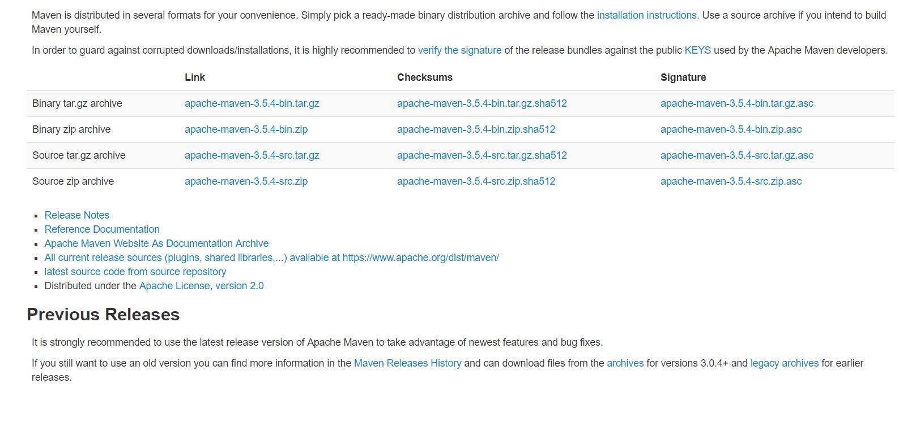

* After downloading, extract it and copy its url add environmental variables

Both In system variables {M2_HOME = location of your Maven

M2=%M2_HOME%\bin (binary files location of Maven)}

Environment variable setup

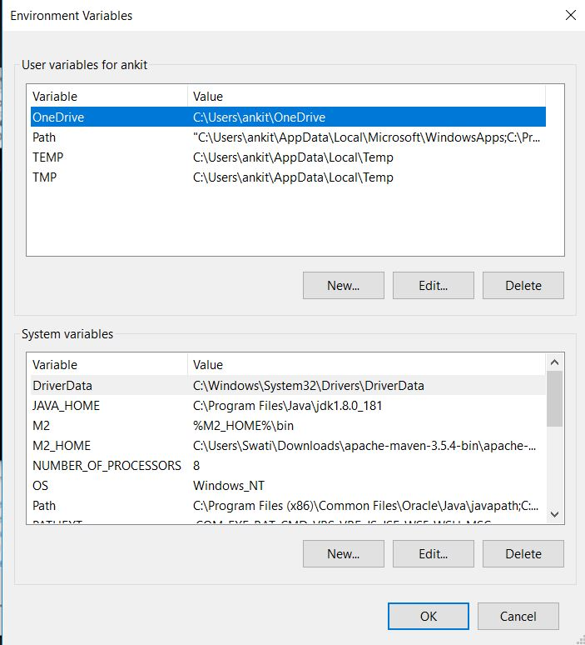

* MAVEN_HOME ->windows
* MAVEN_OPTS = -XMS 256M -XMX512m (min-max)

We have to assign some size of data for maven to run, that’s why we mention 256 and 512 here.

* %M2% -> Click path and edit

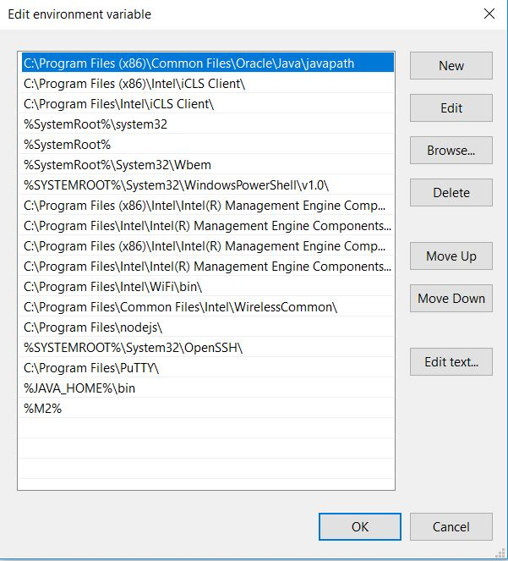

* Click new and add this.
* Click OK in all dialog boxes
* MAVEN_OPTS are not required for now

**How to check if maven is properly installed**

* Cmd -> mvn –version

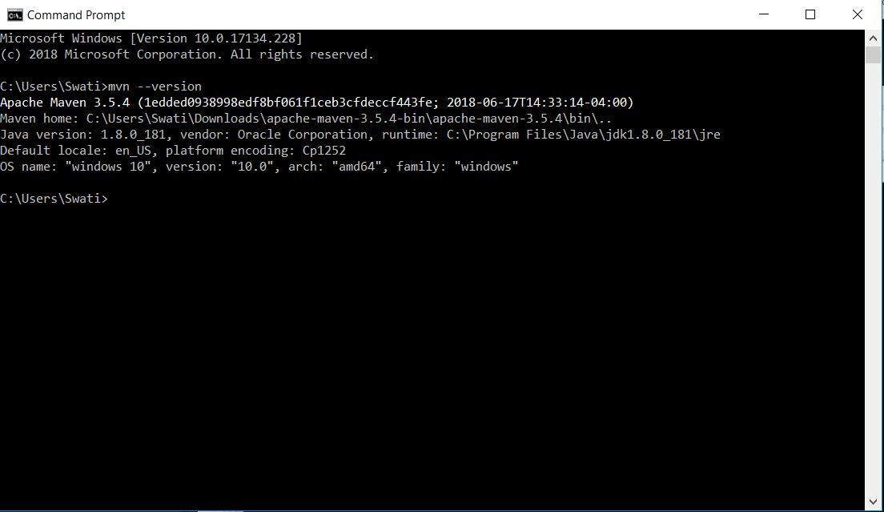

* It will give the version 3.5.4 which is mentioned in the path for M2_HOME by us.

**Maven core concepts**

It uses POM. POM file is an xml representation of project files. All POM files have mandatory fields.

* groupId - id of projects’ group. In an organization this project name will be unique.
* Artefact Id – id of project, name of project
* Version – version of the project

Packaging – defines the style of your project- ear or war file

Plugins may change

**Elements of POM file**

* **Dependencies** – Specifies the dependencies of a project. Dependencies are used for a particular command, eg., we need to test something, we need dependencies for performing the test.
* **Repositories** – Specifies alternative resources for Maven
* **Plugin repositories/plugin** – materializing build plugins
* **Build** – shows how to build the project
* **Reports** – what reports to be generated for project documentation
* **Templates** – when you want to start writing code, already preconfigured code is there
* . to check availability templates in Maven - to check project archetype, go to project in git bash and run mvn archetype:generate
* It will ask number, artifactId, version, etc

Can we create our own templates?

Yes

To create a java archetype ->

Mvn archetype:generate -DgroupId=com.digi.app -DartifactId=maven-app -DarchetypeArtifactId=maven-archetype-quickstart -DinteractiveMode=false

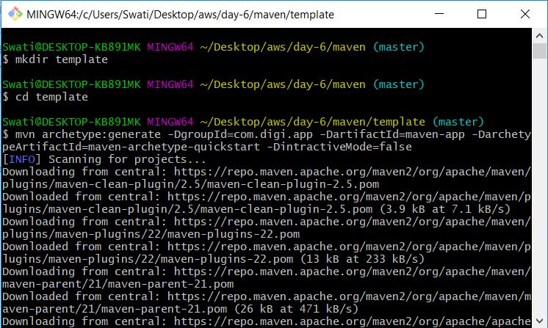

You’ll get new files in your folder after this when the build is success.

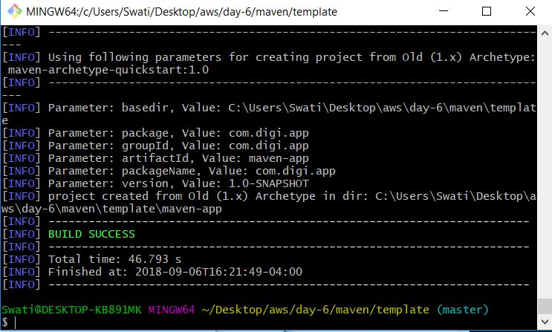

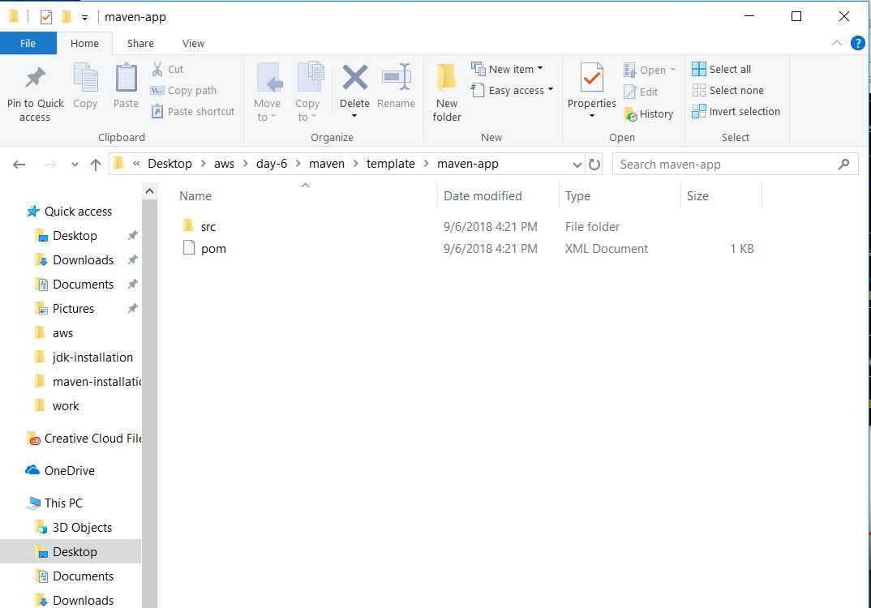

App.java file also gets added. When a developer gives an application to you, you will keep that file in place of App.java file here.

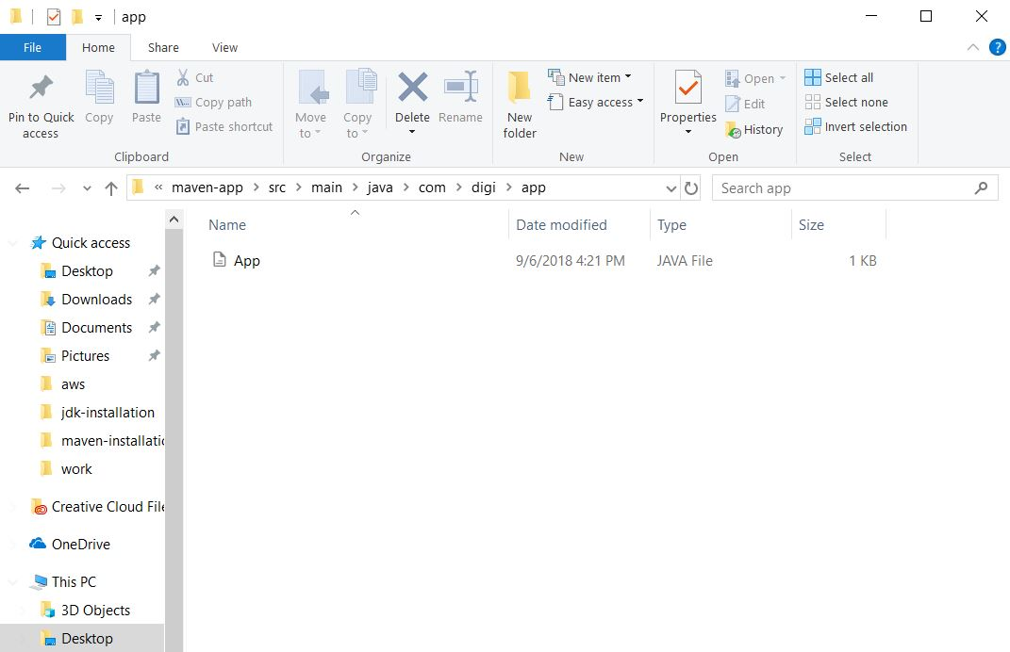

Command for that ->

mvn clean – also deletes target and src folders. Go to desired folder and use this command

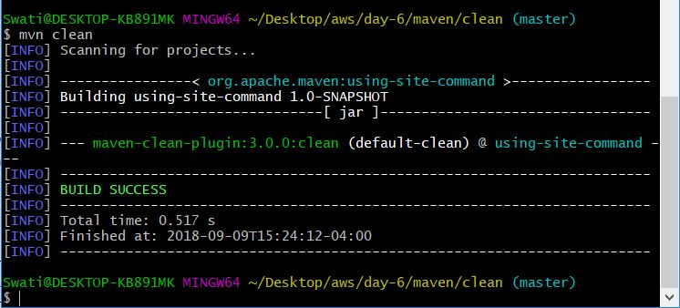

mvn install

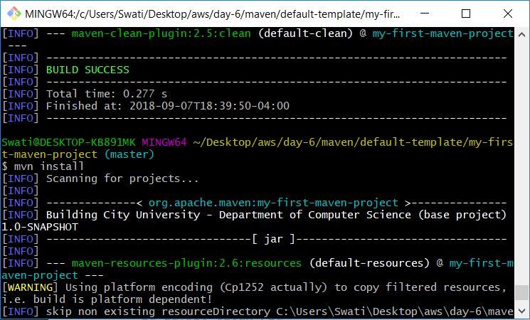

mvn test

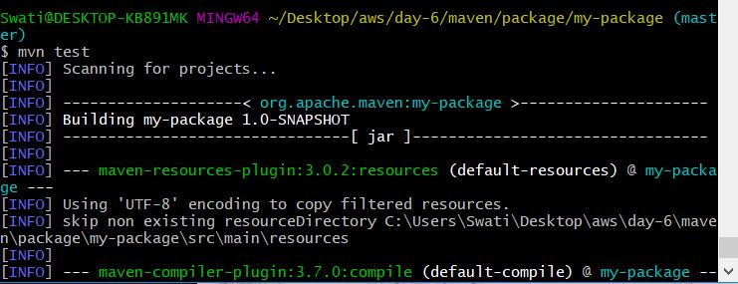

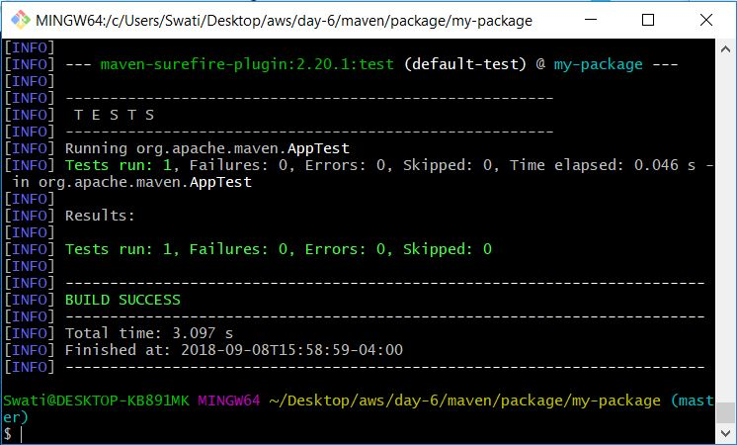

mvn validate – to validate the code

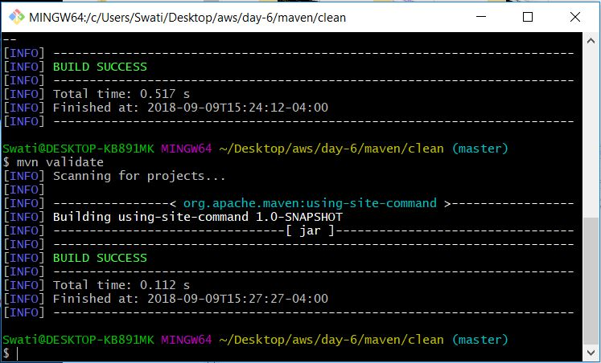

When you install jdk, jre will automatically come.

jre – java runtime environment – it is used to run the code related to java.

To check if jdk is installed successfully, use java -version command in cmd. It will display version number and what package of jdk has been installed on your system.

Maven opts is used to set the size.

Maven is POM based – to build a project you’ll be using various build tools.

If you use mvn archetype:generate, you’ll see the number of templates there. They are given by default by Apache.

**Default directory layout**

Folders – src – main – java ….App.java

App.java holds java source code.

Folders – src -test …. App.test.java – whatever data used for testing purpose for java application

**Maven build and test project**

* Go to folder – Maven/package – Make sure java file is there
* Open git bash
* Mvn clean package – to create an executable jar file – packaging of it will create a jar file inside a newly created target folder.
* That file is done
* If we scrool up we’ll see – project (org.apache.maven):project group(my-package)
* It is performing clean command
* If already target folder is there, it will delete and create a new one.
* It will first clean the target and then package our product and give a jar file as output.
* Maven compiles the src code file and compiles the code file
* If we do mvn test, if junit is there in POM file, only then it will perform the test.
* We can edit the POM as per our requirement.

Build life cycle consists of a sequence of build phases. When we run Maven, we pass a command to Maven, that command is the name of a build life cycle or phase or goal.

Maven dependencies – 1st goal – Maven checks the dependency which are required for the project. They are java libraries that project uses.

Build plugins – to provide extra goals to your build phase. If you want to perform extra actions, they can be included here.

Build profile – If you need to build your project in different ways. Developer, QA profile, production profile. You can do the changes in the POM.xml file.

When Maven builds a software project, it follows a build life cycle. It’s divided into the following:

1. Phases – eg., in POM.xml, in-order and all
2. Goals

**Maven life cycle** – well defined sequence of phases which define the order in which the goals are to be executed.

Phase/stage in a lifecycle

* Validate
* Compile
* Test-compiles projects unit test – junit test
* Package-jar r war package
* Integration test
* Verify
* Install
* deploy

**Maven Build Life Cycle**

1. **Default** – handles compiling and packaging of your project
2. **Clean** – handles everything related to removing temporary files from output directory, including previous jar files
3. **Site** – handles everything related to generating documentation.

They are all executed independently of each other in a sequence.

**How to share jar/war files**:

**Manually**-Sharing directly with people using Git

**Automatically**-using Jenkins

2) Site Life Cycle->

a) site - for the fresh documentation purpose and to create reports

b) site – deploy

**Running Maven** ->

We do it by executing mvn command in the command prompt. When executing the mvn command, we’ll pass the name of a build life cycle, it includes phases and goals like, mvn clean, mn package, etc.

mvn install command – This command executes the build phase called install part of the default build life cycle which builds the project and copies the package jar file into the local maven repository.

In running Maven, we can execute multiple build life cycles or phases by passing more than one argument to the mvn command, like mvn clean package, mvn clean install, etc.

Local repository – After whatever we execute, that gets added in the local repository in .m2 folder.

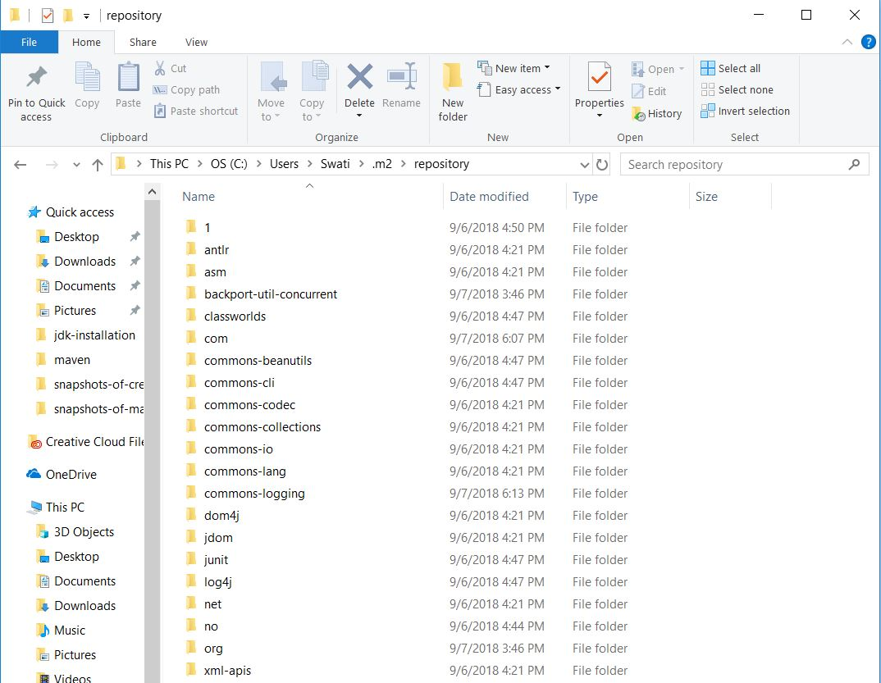

Whenever you uninstall Maven, you remove .m2 folder also from your system.

Build Plugins -> They add extra features to your project. Plugins in general provide a set of goals. When we work with Jenkins, we’ll work with different plugins always. Maven is a plugin exhibition framework where every task is done by plugins. Maven plugins are generally used for creating jar files, war files and compiler code file, unit testing of code, creating project documentation and reports.

Common plugins:

Clean - to clean up the target after the build and deletes the target’s directory.

Compiler – it compiles the java source file.

Surefire – it will run the junit test cases. It will create the test reports for that.

jar file – it builds a jar file from the current project.

war file - it builds a war file from the current project.

java doc – generates java doc for the project

ANTrun – run is a set of ANT task from any phase mentioned in the build. ANT is also one build tool which is used for different projects.

Open a folder and copy its POM.xml file. Go to Maven folder and paste that POM.xml file here. Open git bash. Give the command mvn clean.

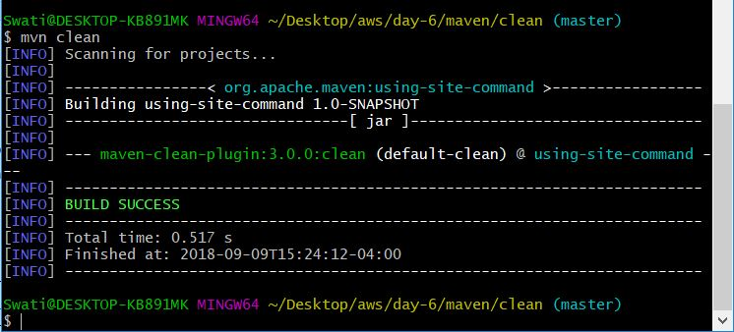

After it executes successfully give the command, mvn install



Copy src folder from another folder-eg, maven/validate/using-validate-command and paste it in clean folder inside maven.

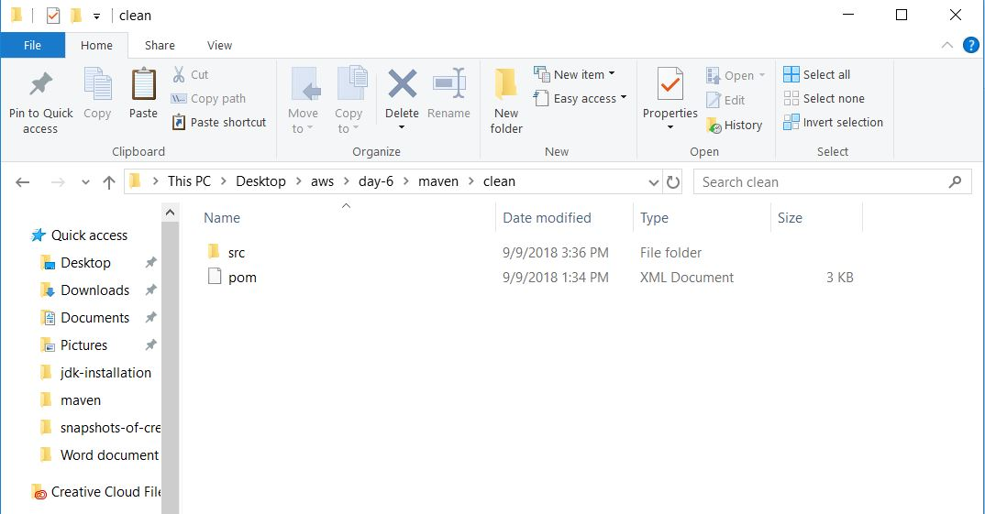

Give the command, mvn install in clean directory, and it will automatically create a target folder in clean folder.

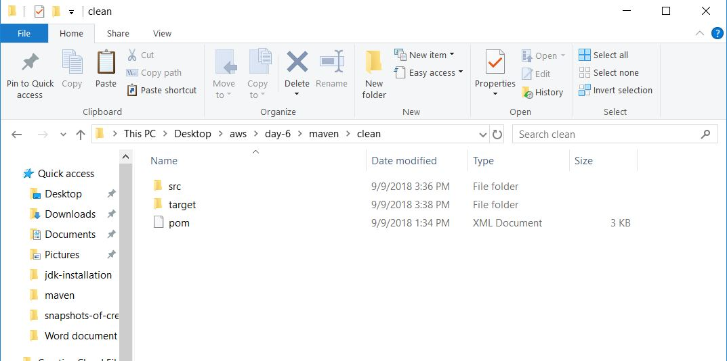

Give mvn package, a default jar file gets created.

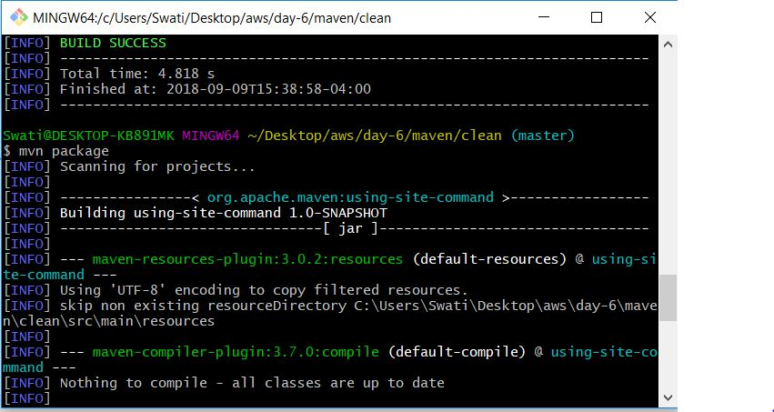

mvn compile command ->

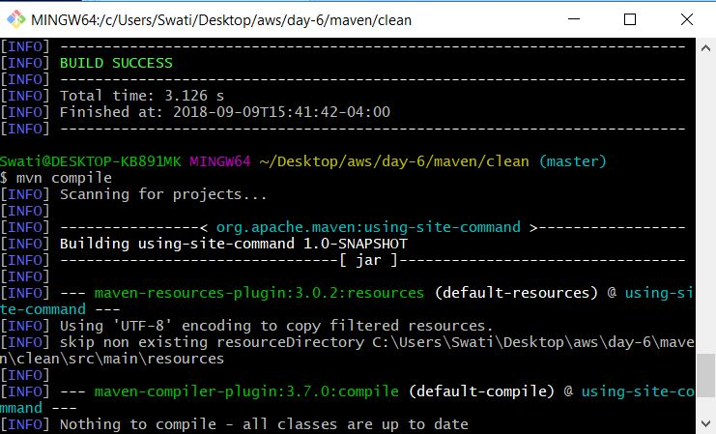

Go to a folder, check its App.java file. Right click and open the App.java file using notepad. You’ll see it’s going to print “Hello World!”

How to deploy it manually

Tomcat Installation ->

In google search, type Tomcat Download. There you click the 1st link on Apache Tomcat

Choose 8.0.53 version

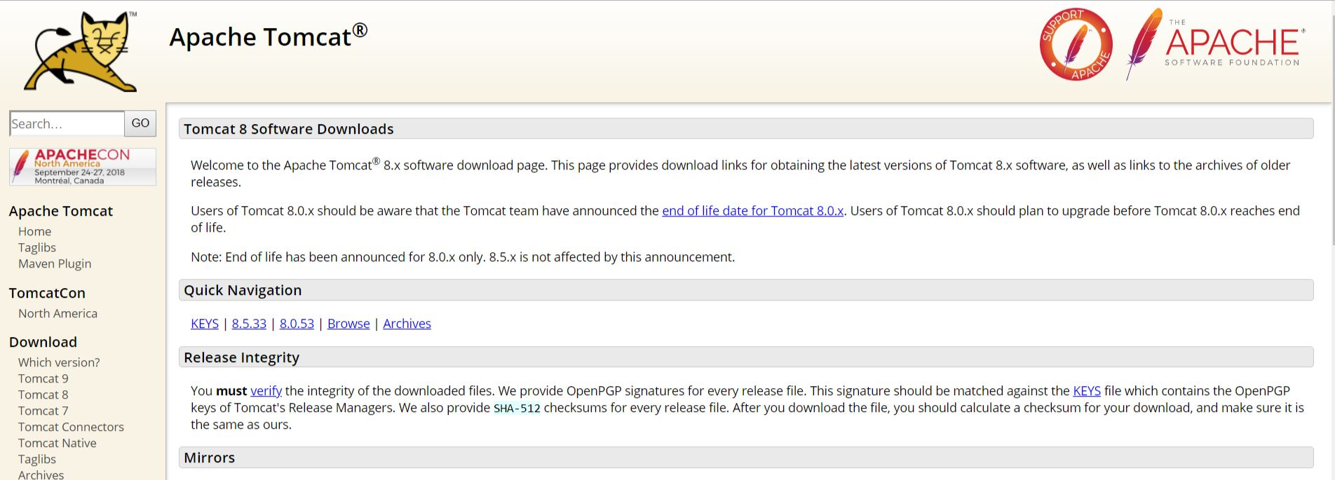

Choose 64-bit Windows zip in Core. Click and it will start downloading

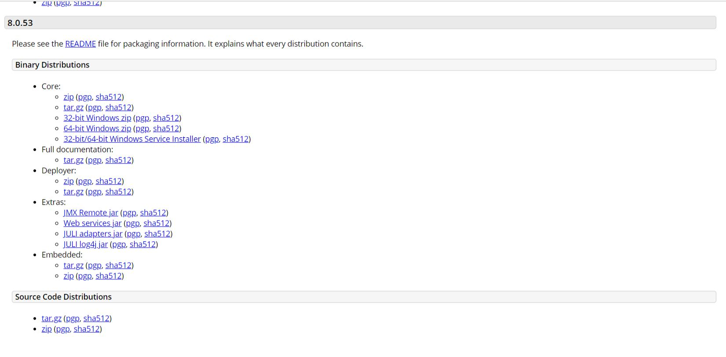

Once, it downloads, extract it.

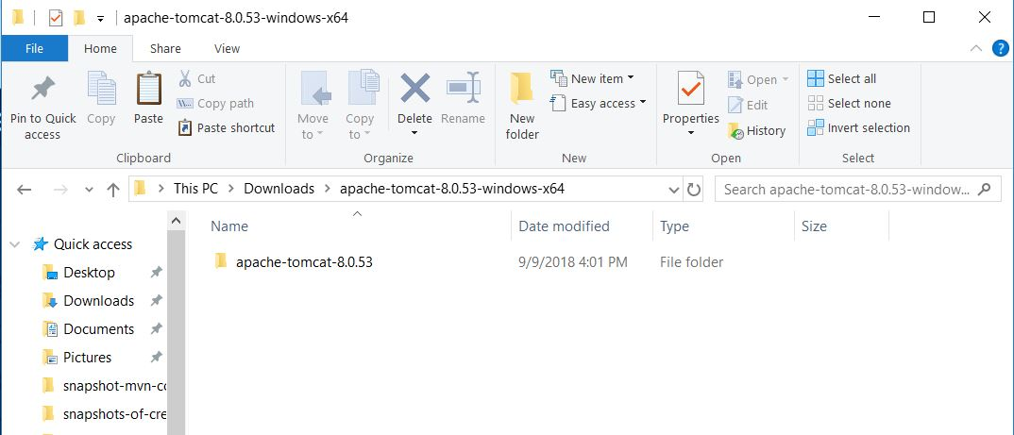

If we click our installed folder of Tomcat, we’ll see many folders. Open conf (Configuration) folder, we’ll see many files like server, etc. In server, the connectivity port number can be changed. Open uptimfile in notepad, the default connector port number mentioned is 8080. If you change anything that is applied. Change it to 8085. Jenkins will also come with that port number, that’s why we have changed this one

We can also see a webapps folder, whatever jar/war file be created can be placed or pasted here.

Method to start Tomcat

Go to bin in the Tomcat’s folder. Here you’ll see startup and shutdown files.

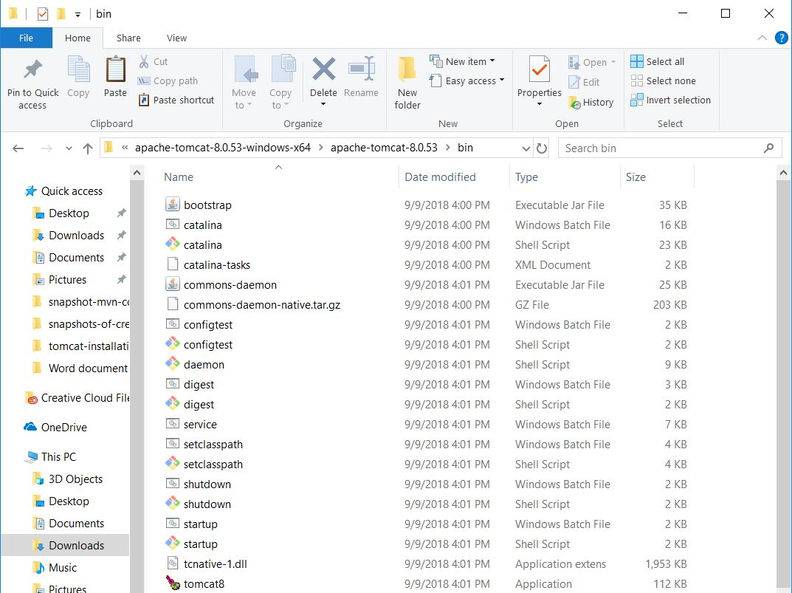

We’ll see startup.ssh file. It is for windows Batch file and shell script. But we use shell scripting in Linux. So, we’ll use startup in Windows Batch file. Double click on startup, and it will get started. A new terminal will get opened, let it execute some commands.

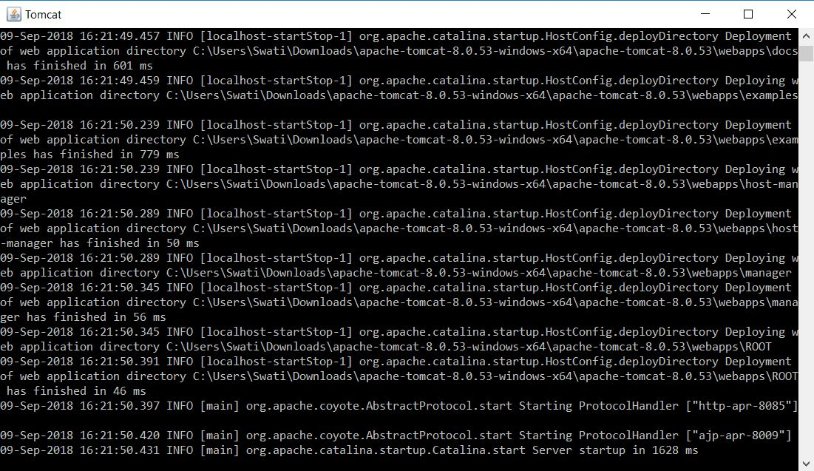

After it finishes executing, Go to browser and type localhost:8085.

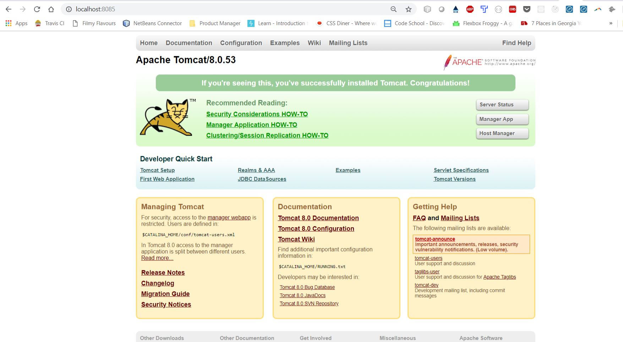

You’ll get the above page, if the Tomcat has started.

How to use Tomcat.

Click on Manager App button, you’ll be asked to sign in. Click cancel.

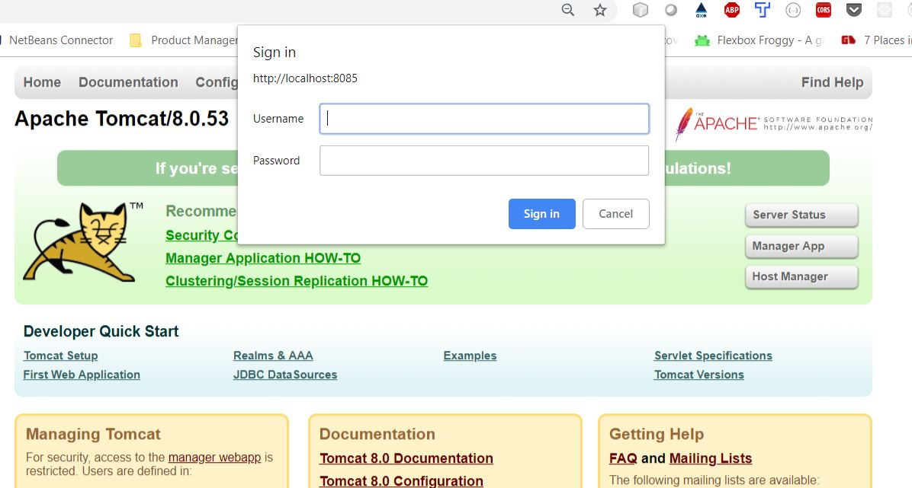

When you click cancel, you’ll be taken to the following page.

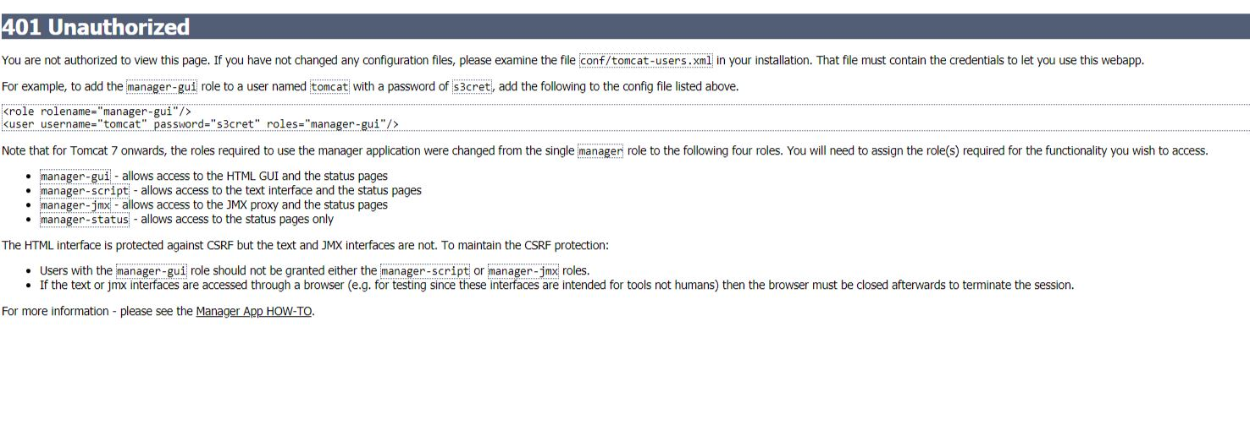

Copy the contents of the first box mentioned here (highlighted in blue below)

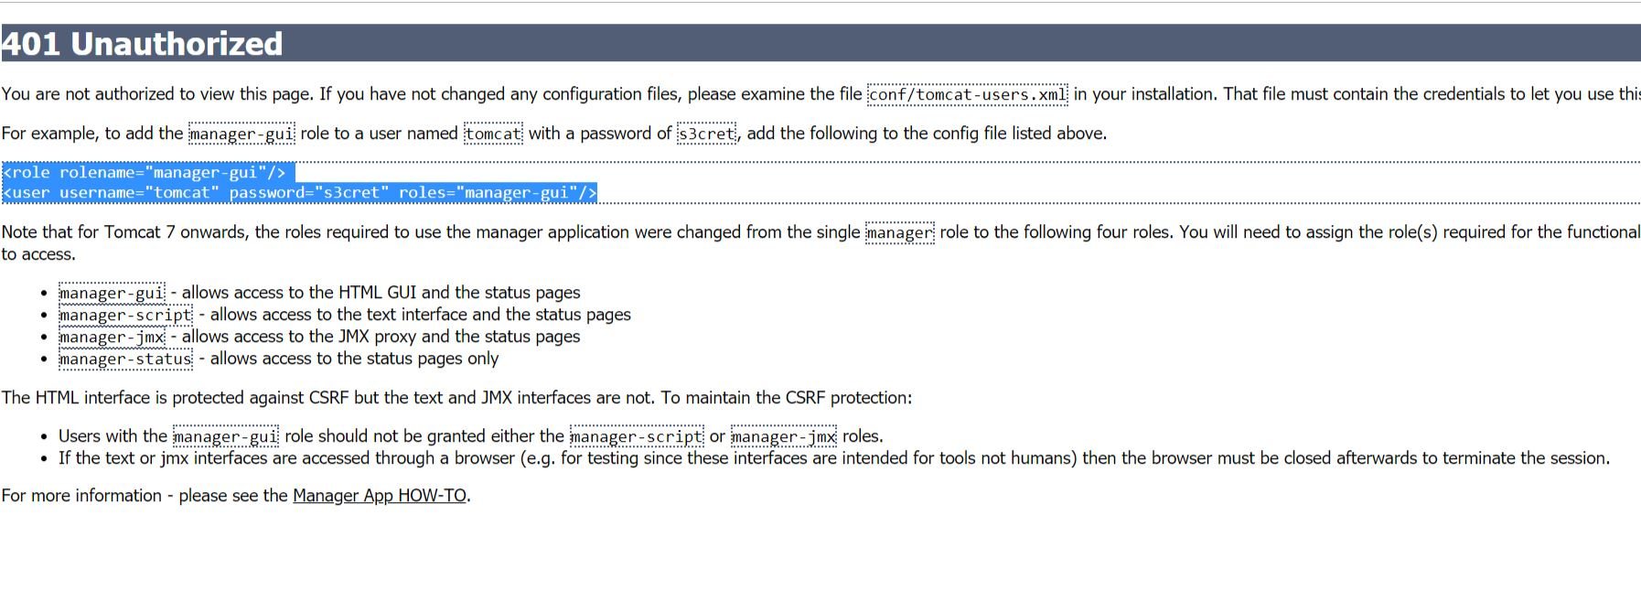

Go to Tomcat folder, conf folder, tomcat-users file(XML document). Open it using notepad and paste those contents at the end before closing the tag(written in blue at the end of the clip)

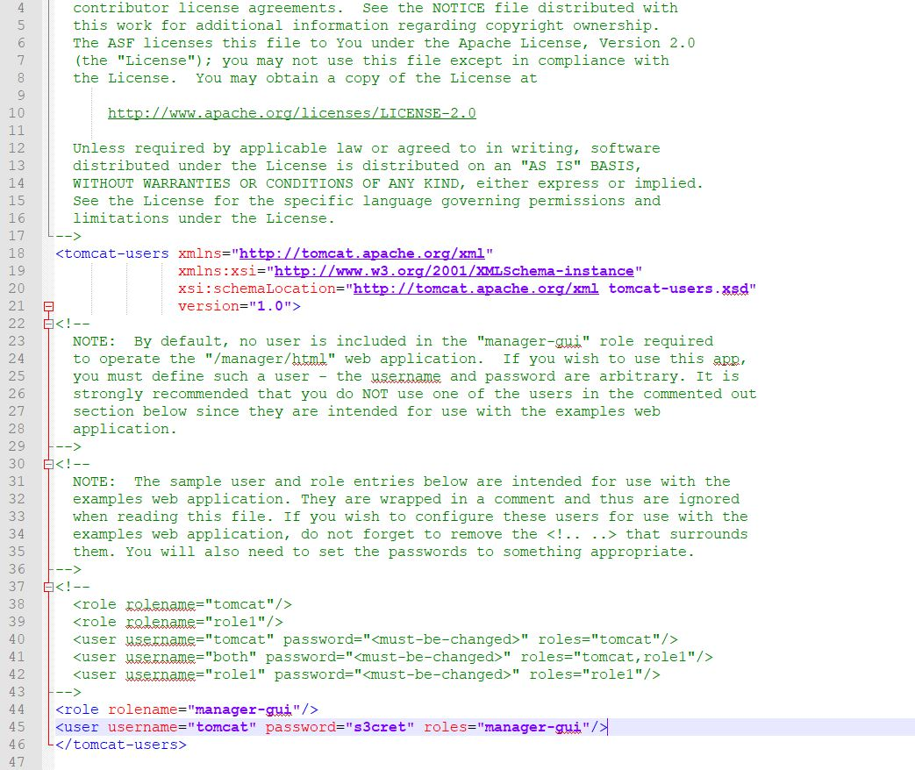

We can change the password here to tomcat.

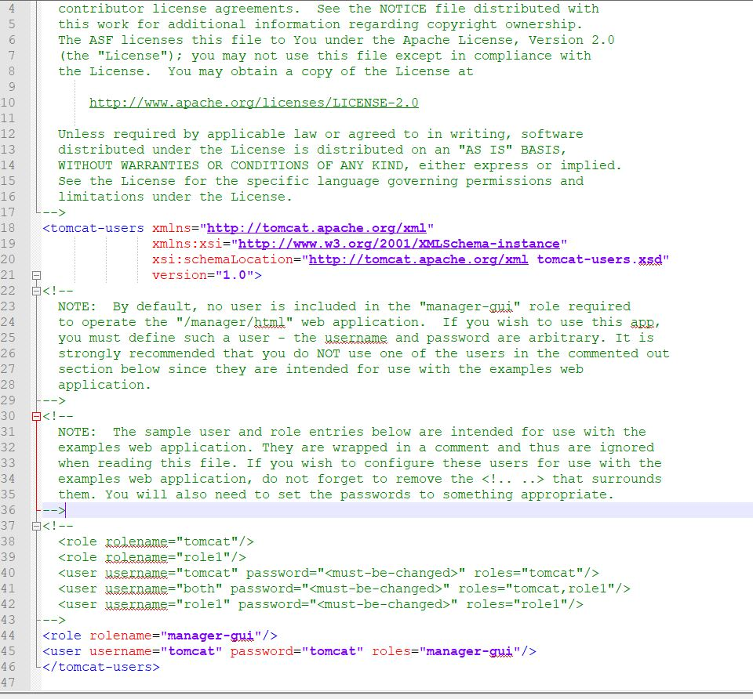

We need to shutdown and startup again so that we can sign in with the username and password we just got. Double click shutdown and then startup in bin folder for it to start.

Now when we sign in by click manager app, and add the particulars ->

Username: tomcat

Password: tomcat

And enter

We will successfully login to manager app. We’ll see the Tomcat server.

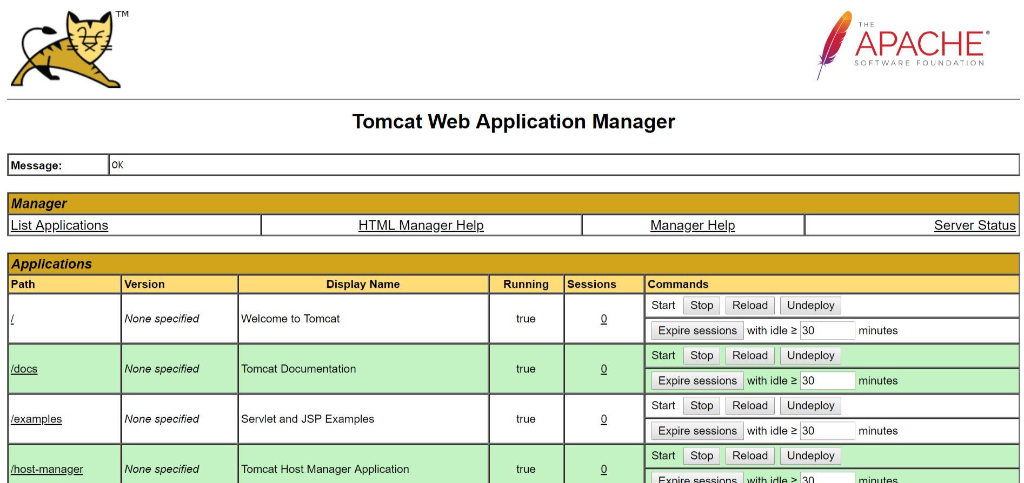

When we create our war file, that war file we have to get here.

Copy a Jenkins.war file and paste it in webapps inside tomcat. You’ll see Jenkins will be added in the table above but it will not start on its own. Start it by clicking on start in front of Jenkins row in the above table and you’ll see that it started.

You can also browse and choose the war files here itself on a click of a button, but it will take a long time to process because the file size will be big. So, directly pasting it in webapps is a better option.

Jenkins started but how can we access it?

Go to localhost:8080. It is a default port for Jenkins. If it doesn’t start like this, go to Jenkins in the table, click on it and it will start.

**How to start Jenkins manually**

Open a directory in git bash, like I have created a Jenkins folder and open it in gitbash. Give the command –> java -jar jenkins.war. Once you give this command, it will start extracting the jar file.

war file is a complete application

Jar file is a supporting application for your entire project. When you are developing an operating system, you will go with 8.1, 8.2. At that time you need some supporting jar files like individual features which you are going to add to your project.

Once this war file is there, it will extract all the files from the war.

Advantage of Jenkins ->

Whatever the data you work with here, it will be securely stored even if you are applying any updates on that.

Press ctrl + C to stop Jenkins

Nexus

Nexus is a repository, remote repository

Use of Nexus

Your clients will be accessing your application from there. They can download the files you give there.

Add nexus.war file also to the webapps folder in Tomcat.

When we have a war file and we need to deploy that piece of war file/software for the next stage of environment, so you have to deploy that and according to that you also have to give it to repositories. So, we are looking at both Tomcat and nexus repositories.

**Types of Servers**

1. Web Servers – They will have container andweb services -eg., Apache OHS, Iplanet, HIS
2. Application Servers - They also contain web services, containers, along with business container and jns container. Eg., Weblogic, Websphere, Jboss, Tomcat, Glassfish

Difference between Web server and HTTP protocol

1. Web server handles HTTP protocols
2. Application servers handle any number of protocols
3. Web servers are mostly designed to serve static content
4. Application servers are used to run business logic or dynamically changing/generating presentation code
5. Web servers is a Web based application
6. Application servers are web based and enterprise based applications
7. Web servers provide only web container, like, servlet container plus jsp container,eg, Oracle Application Server, Jboss, Weblogic, etc.
8. Application server provides web container, ejb container, jms container. Eg., Apache OHS, IAS, Iplanet, etc.

**Tomcat server** – It is an open-source server, platform independent, the most trusted vendor is Apache. Apache is a vendor for this.

**Pre-requisites to use Tomcat**

* You can use it in any voice
* It takes only 1GB of RAM.
* To install it, we need to install Java jdk.

**Tomcat directory structure**

**Webapps** – This is an application deployable directory. It is used to place the deployable piece of software.

**Bin folder** – We are using to start and shutdown scripts of Tomcat.

**Logs** – You’ll find the logs here. It consists of :

Catalina ot-server code log file

Catalina host – access information about the server

**Conf** – It consists of the following:

Server– You can change the port number

Tomcat-users – This will be helpful when we want to access the manager app given in Tomcat homepage

**Temp - temporary**

**Work**

After starting the Tomcat in localhost:8085

**Methods of deployments**

1. **Console/Tomcat manager deployment –** Deploying through Tomcat homepage
2. **Direct/ Hot deployment –** Deploying by adding war files to webapps manually and starting ssh

**Nexus Repository –** Itis a repository for your company**.** You can host your own repositories but also can use it as a proxy for public repositories. With such a proxy the time to receive an artifact is reduced and it saves bandwidth. Nexus allows you to host your private build artifacts.

In Tomcat, after starting it and click on it. A new page will open, and You’ll see releases and snapshots folder in it, among others.

**How we can assign Nexus in a build life cycle**

**Step 1 ->** Make a folder named Nexus Example in Maven folder

**Step 2 ->** This comes in the mavens-profile concept. Copy contents of a maven profile in this folder, eg., go to a folder which had distribution management and in its POM.xml file. Copy that folders contents along with POM.xml file into Nexus Example folder. I don’t have distribution management and snapshot repository in any of my POM.xml files, so I’ll just type it in my POM.xml copied from other folders.

I’ll copy the contents of the validate file and paste in nexus-example folder which I created and type distribution management and snapshot repository in my POM.xml file.

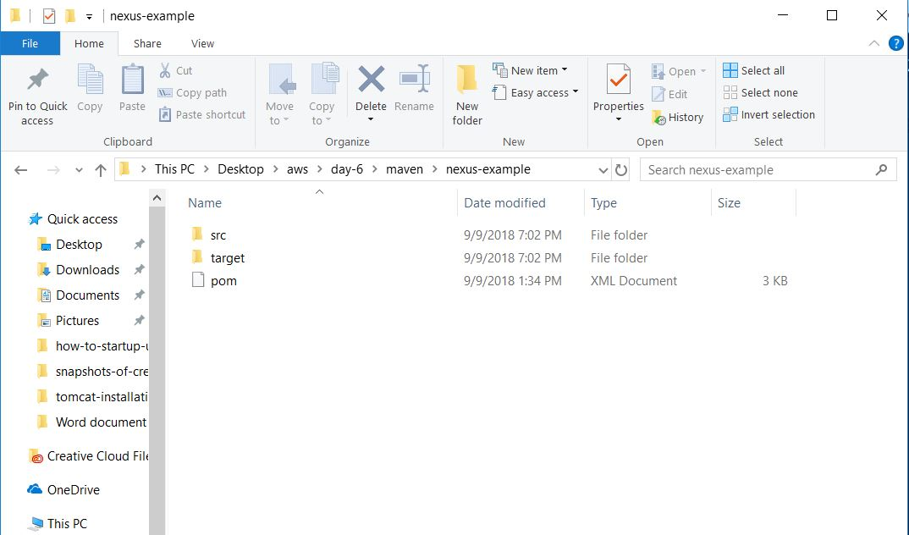

**Step 3 ->** Open Nexus-Example in Git Bash and use the command mvn clean

**Step 4 ->** How we can work with theDistribution management.

* Open POM.xml
* You’ll see one is Repository and the other is Snapshot Repository.
* You’ll see 2 urls (one in each) – first one would be releases and the other snapshot. Just as we have folders in Nexus page we started in the browser. Copy the url given in the browser of releases and snapshots and paste those urls in the POM.xml replacing the original urls.

**Step 5 ->** Run the command mvn validate to validate the code.

**Step 4 ->** mvn install

**Step 5 ->** mvn deploy

**Step 6 ->** Once, it’s done to check the health, click snapshot analyze in the nexus which is started in the browser. Once you click on the snapshots and releases url, the directory will get downloaded.

**Step 7 ->** shutdown in tomcat/bin.

**Continuous Integration**

CI is the process of automating the build and testing of code every time a team member commits changes to version control (Git) tool. Jenkins is a CI.

**Jenkins Installation**

1. go to jenkins-ci.org
2. click download
3. Select long term support release which is a stable build. Select windows there.
4. Double click and extract it. You’ll get jenkins.war file in program file(x86)/Jenkins
5. Copy this jenkins.war file in Day-6 folder. I have not added it there but simply open gitbash from Jenkins original path itself - C:\Program Files (x86)\Jenkins
6. Git bash this folder.
7. Run this command: java -jar jenkins.war – This is a command to start Jenkins.

If it doesn’t start on the default port, change the port to 8081 by giving the command:

java -jar jenkins.war --httpPort=8081

In my case, it wasn’t running, so I have changed the port to 8081.

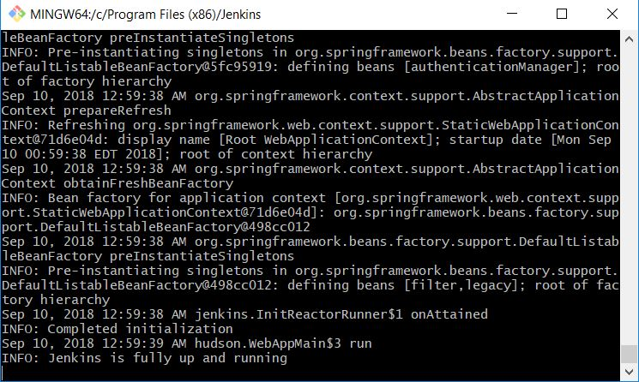

Open Jenkins on port 8081 and go to path to find the Administrator password- C:\Users\Swati\.jenkins\secrets\initialAdminPassword

1. Open initial Admin Password with notepad and copy the password from there.
2. Paste that password in the Administrator password and click continue. When you click continue it will take the default plugins.

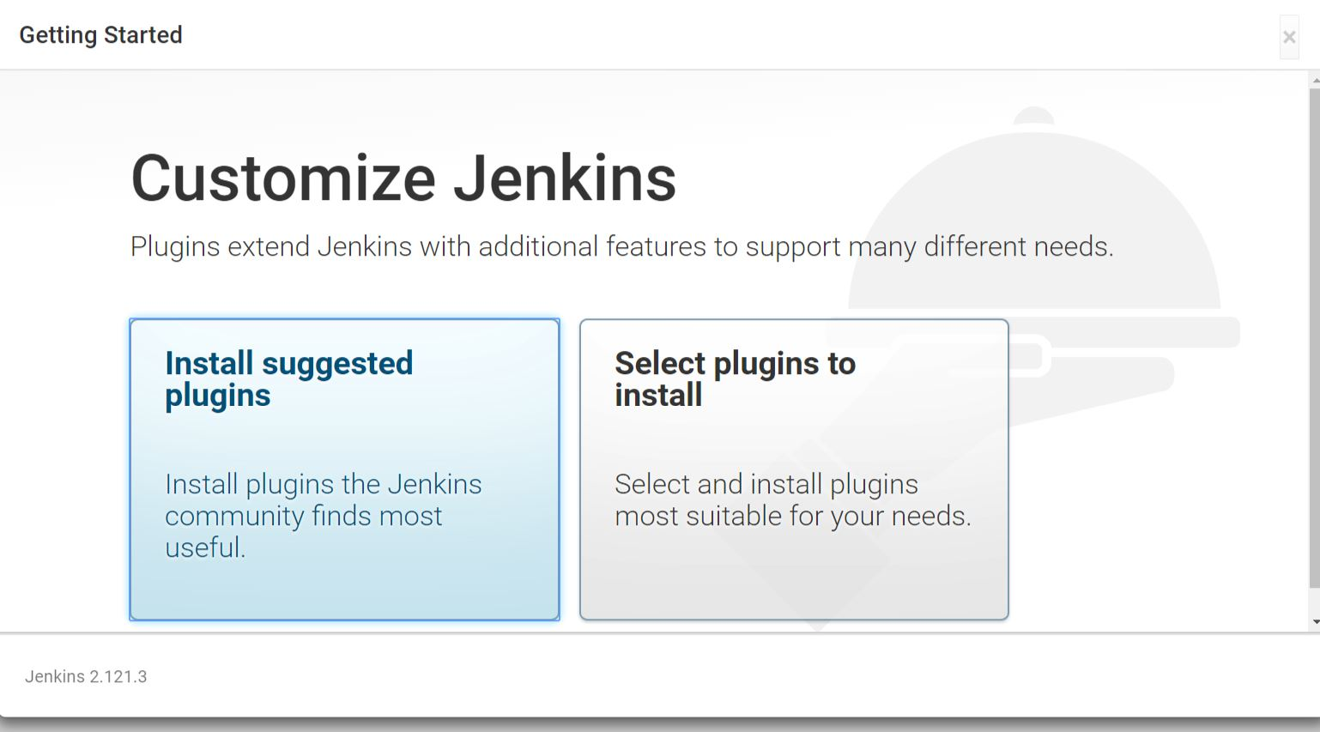

1. Select install suggested plugins. Multiple plugins will be downloaded.

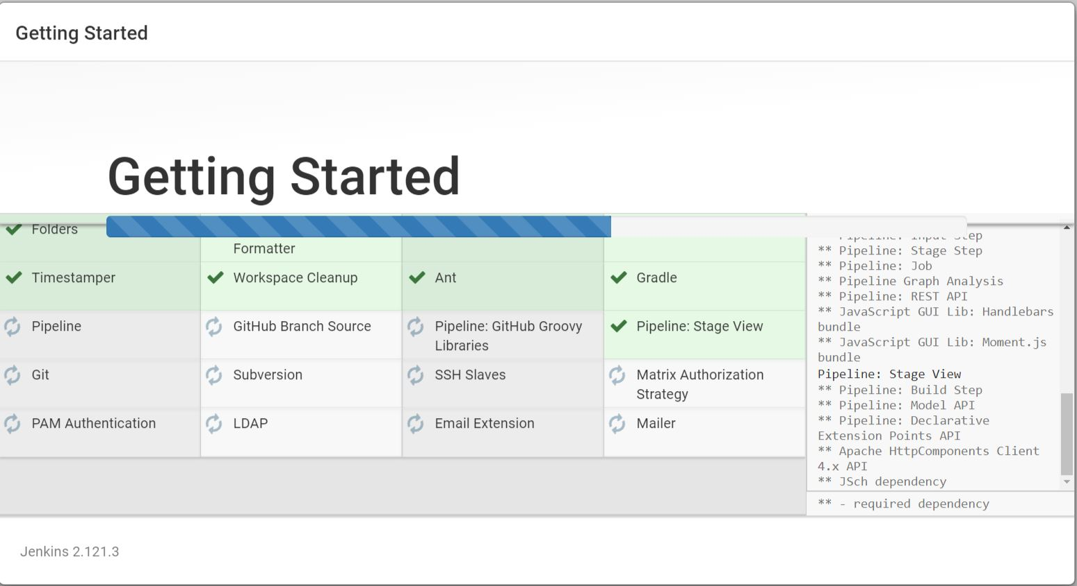

1. Once all the plugins are installed it will ask the Admin user particulars

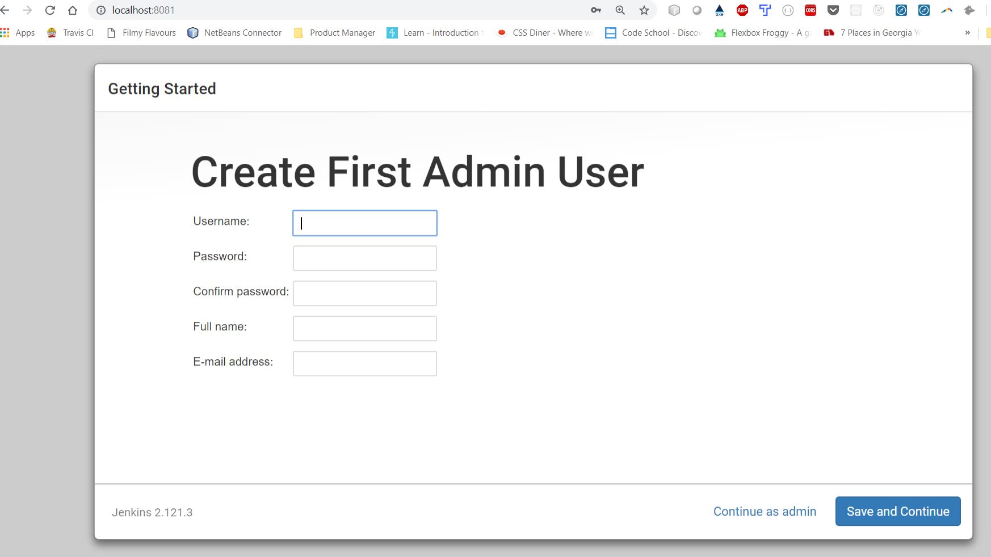

1. After filling, click save and continue.

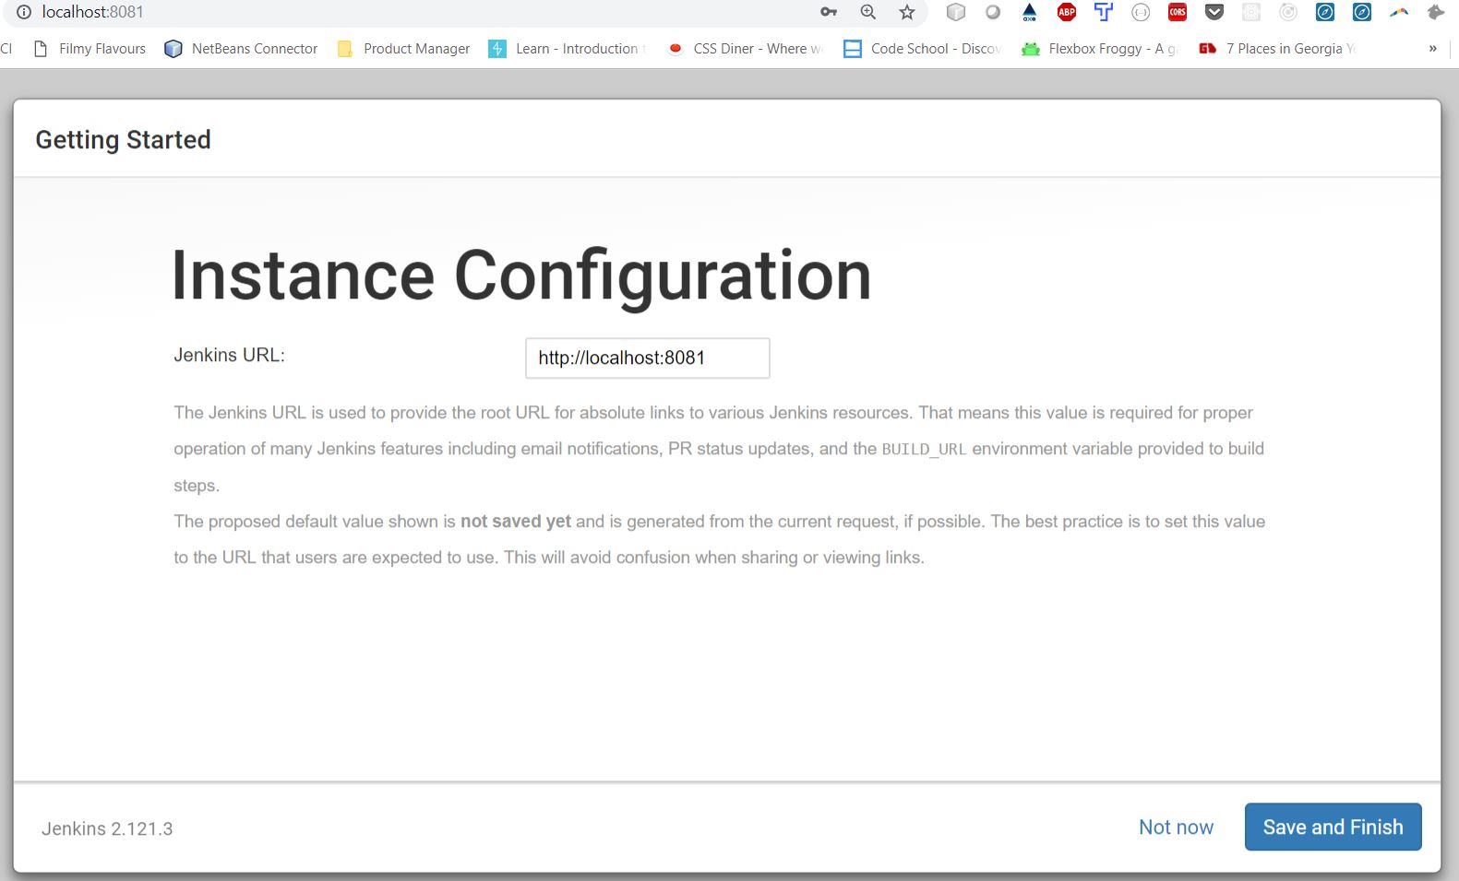

1. Click save and finish.

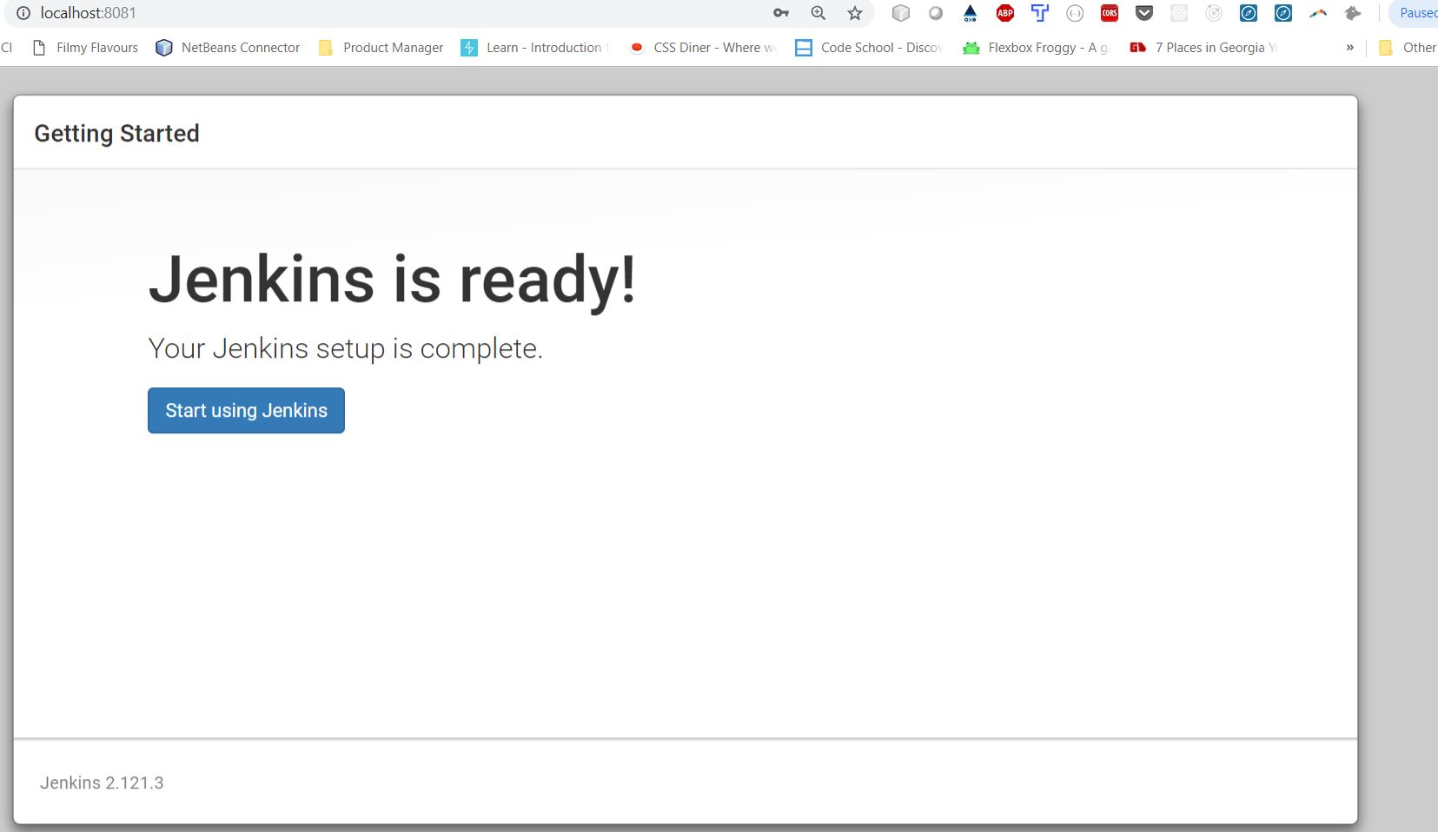

1. Click start using Jenkins
2. If it doesn’t start after this. Again give the java -jar jenkins.war --httpPort=8081

Jenkins command in the git bash and refresh the browser after getting the statement in git bash- Jenkins is fully up and running.

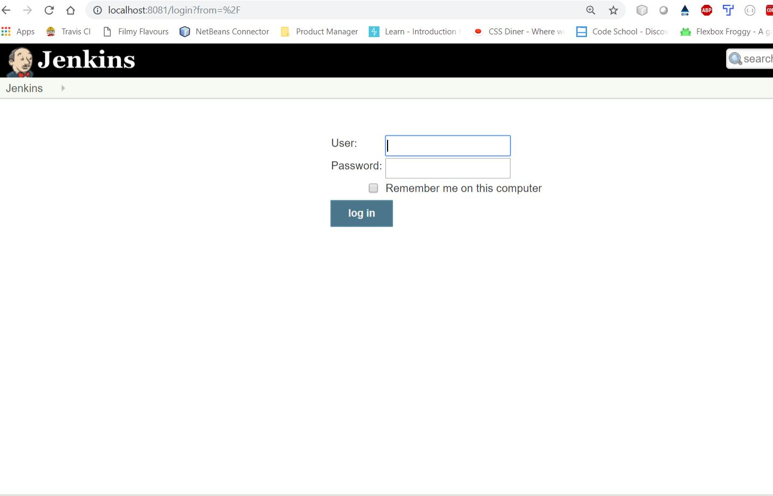

1. Fill the particulars and click log in.

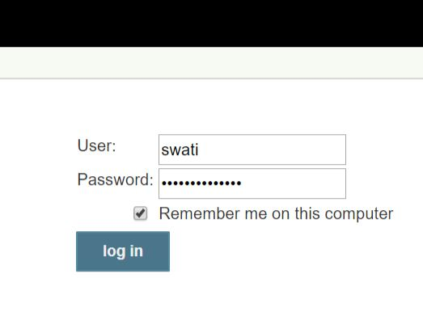

1. You’ll be led to Jenkin’s dashboard

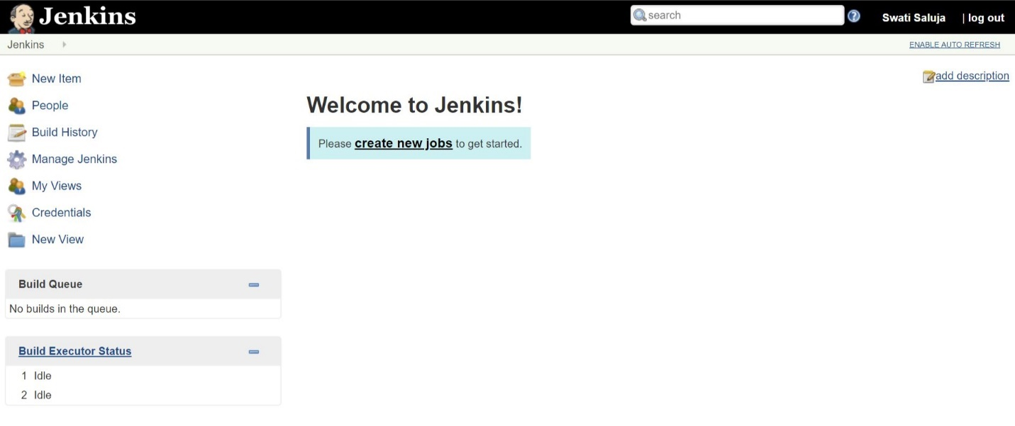

**How to create a Jenkin’s job and work with it**

* Click new item or click create new jobs.
* Enter item name – Myfirstjob
* Select Freestyle project

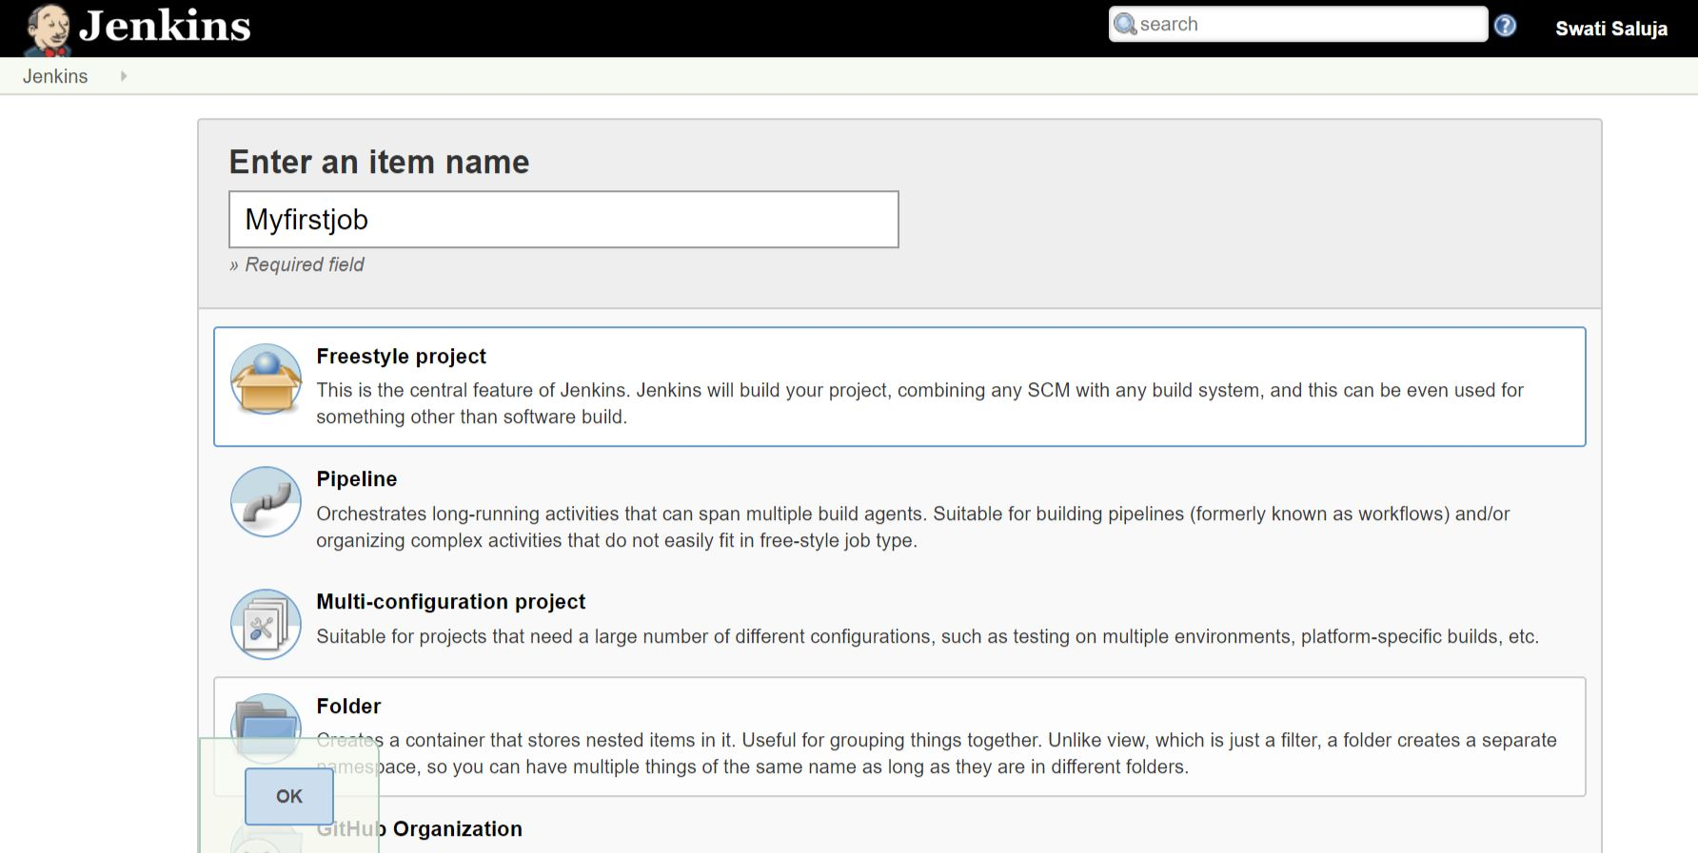

* Click OK. You’ll be redirected to the page you’ll integrate the tools.
* Go to Build. Select Execute shell.
* Write the command, eg., #Display the memory usage of the system

free -m

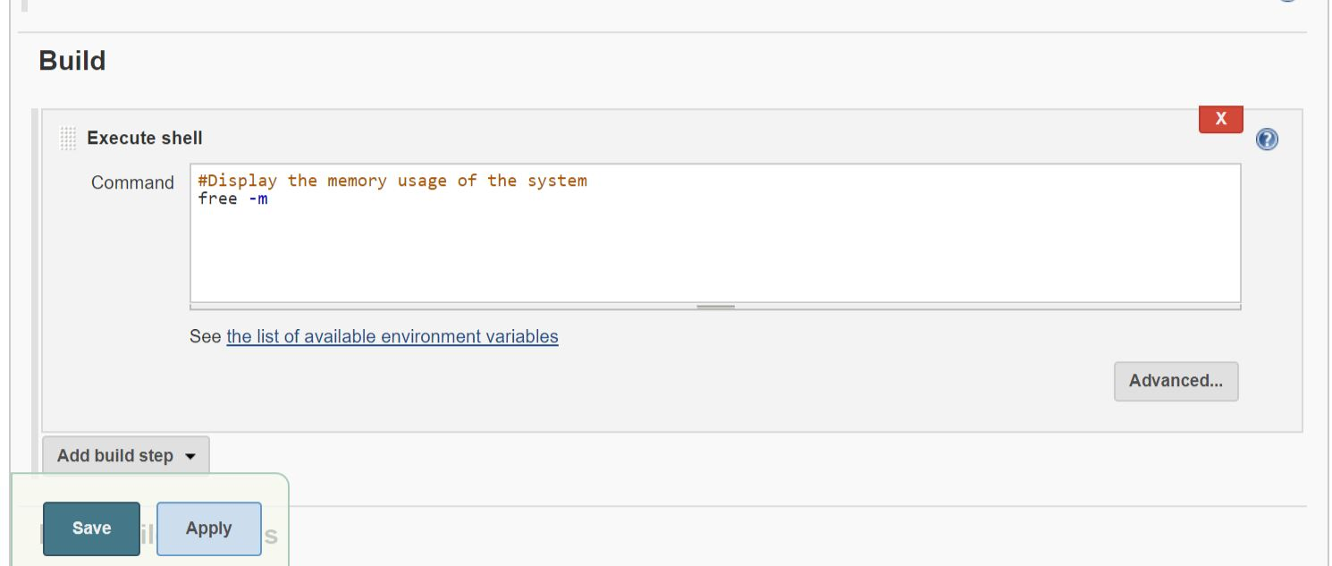

* Click save and one job is created.
* You’ll be redirected to a new page. Click on build now.

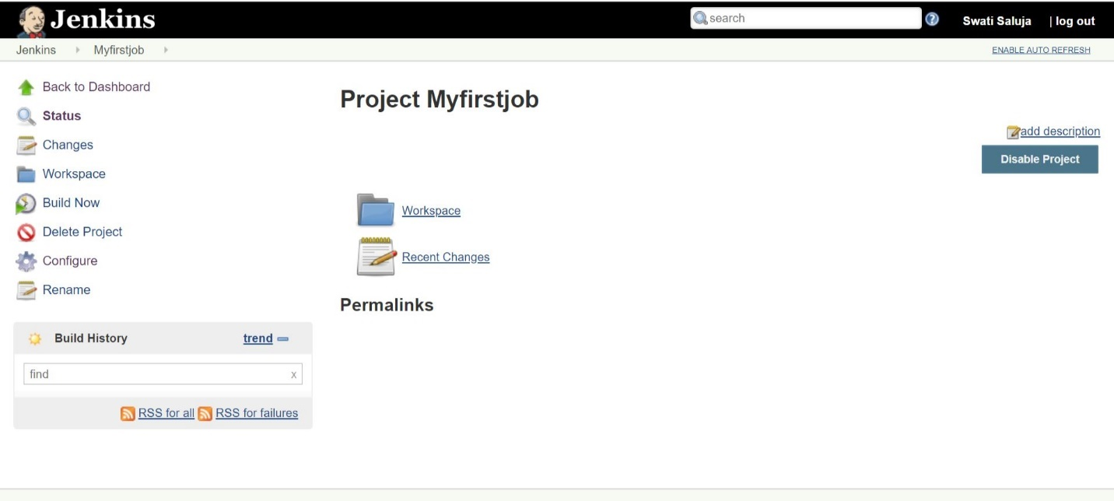

* It will create a build below.

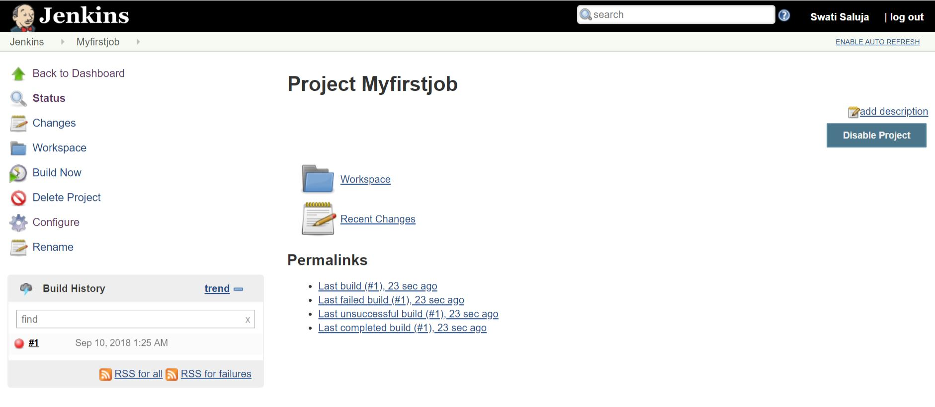

* Click on that build #1 and you’ll be redirected to a new page with its details.

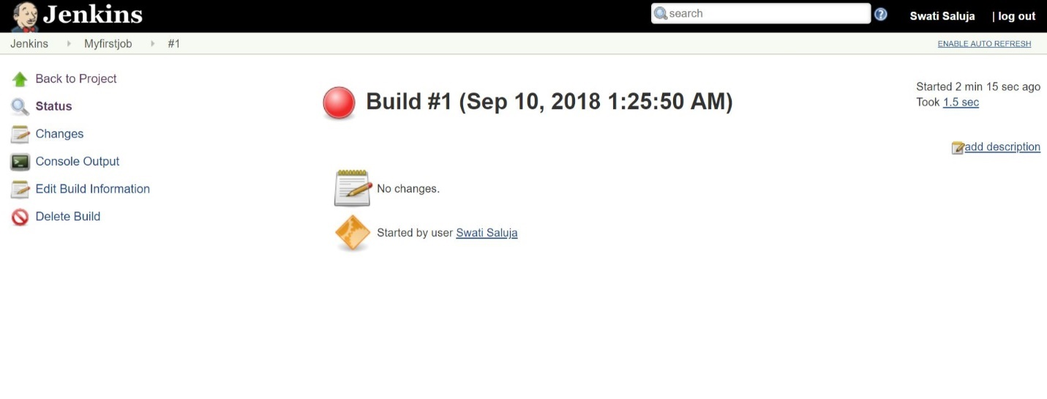

* This ball on top should be in blue, instead of red.
* Again go back, and try a different command, df -h and click apply and then save.

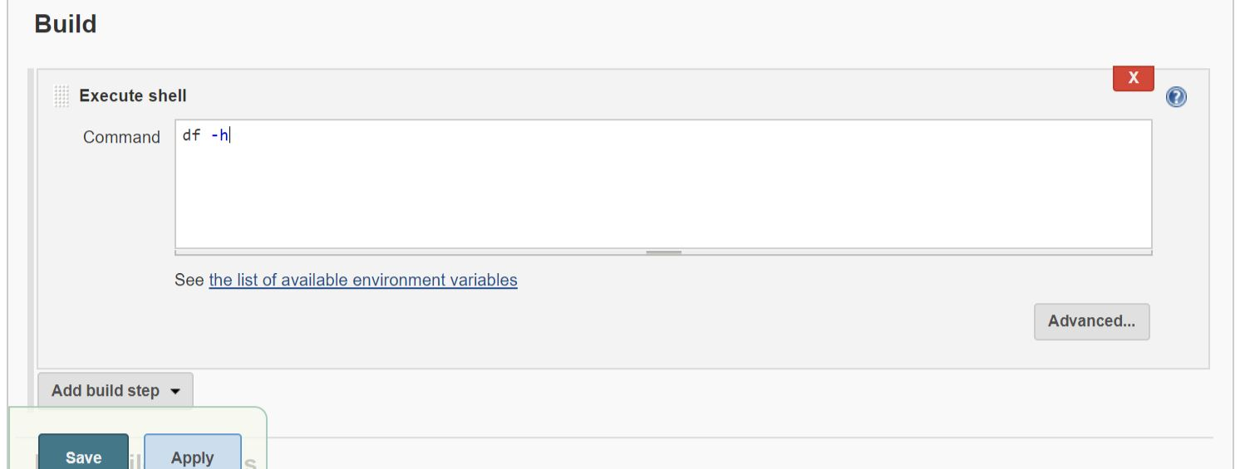

* We can see, it worked this time as the ball has turned blue.

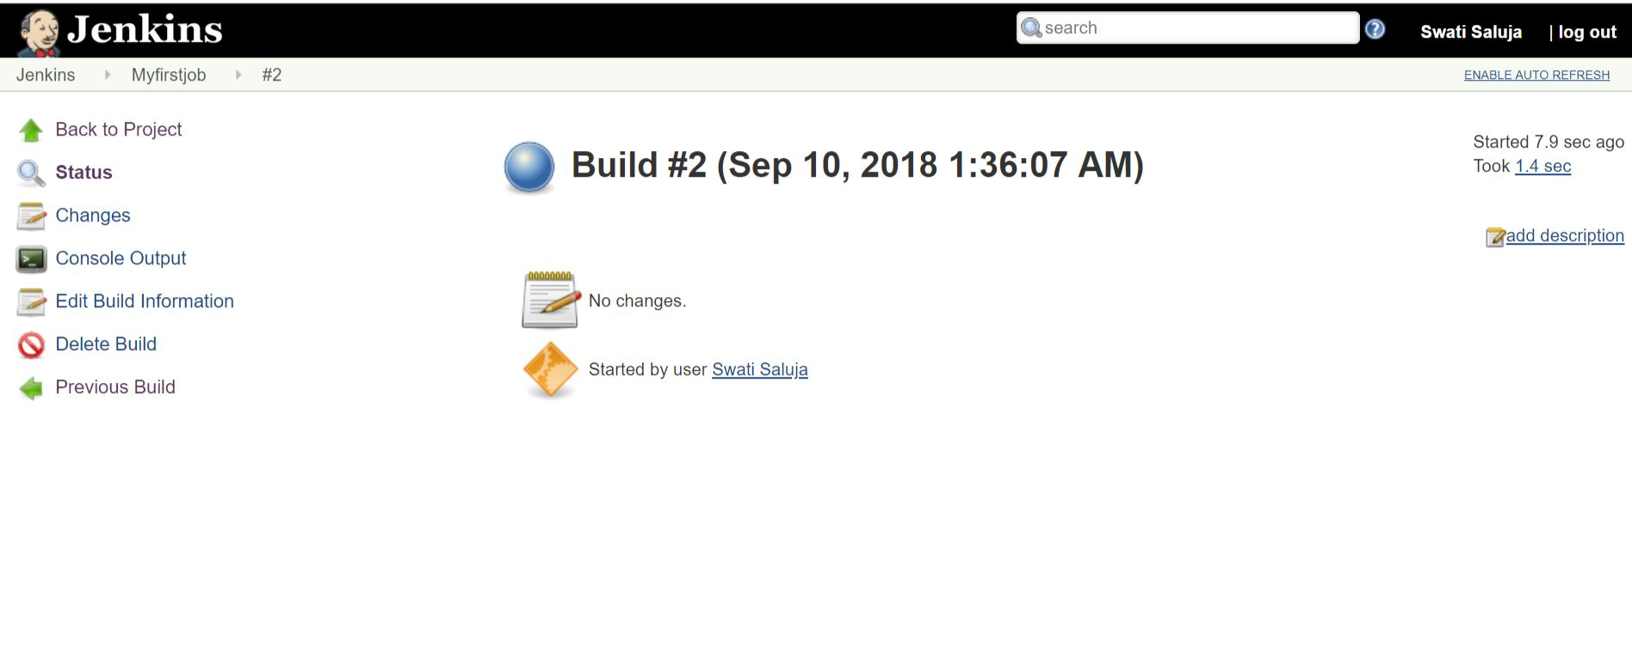

* df -h command is used to check the system storage, memory, etc.
* Click on console output

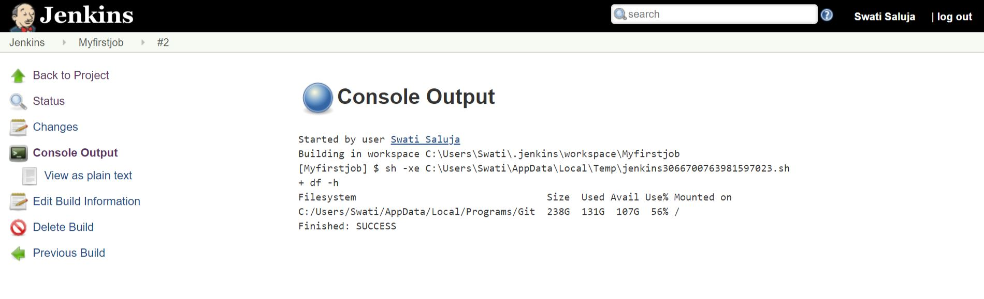

* It gives you the path for the workspace folder where it has been created. Myfirstjob folder is created.

Using the export command you can change its path.

* This is the way a simple job is created.

If you want to restart Jenkins, whichever page you are on just add /restart at the end in the url, eg., localhost:8081/manage/restart.

If you want to shutdown Jenkins, whichever page you are on just add /restart at the end in the url, eg., localhost:8081/manage/shutdown or /stop.

You can even start Jenkins directly by putting the port:8085 in the browser->getting Tomcat server, clicking on Jenkins there and opening it.

**Features of Jenkins**

* **Open source:** Lot of contribution all around the world on daily basis. They are updating plugins on the daily basis. It has latest and greatest features that developers are integrating into it regularly. This community have written a ton of plugins that can perform a variety of tasks, like, integration with external tools, we can work with version control system like Git, svn, build plugins, like, maven, ANT, notification plugins-chat, email, sms, cloud plugins – creating a cloud infrastructure, deploy, cloud services, testing plugins - code analysis, unit test cases, static code analysis.
* **Extensible:** Its main power is in its extensibility that we can achieve by installing plugins into it.

**Understand features of Jenkins mentioned in Jenkins homepage**

Go to Jenkins homepage. Click Manage Jenkins and check out different links on that page.

**About Jenkins** will give the information about the plugins used via third-party, etc.

**Manage old data** helps to work on old version of Jenkins by writing that version.

**Configure system –** If the new version has come up and we are still using the older version, and we install the new version, your old files will not go anywhere. Click here and you’ll get redirected to a new page.

Home directory tells about our workspace and files

System message - we can write anything directly

Number of executors – number of individual executors

Labels – if the build label is same, it will perform the tasl

Quiet period – After each stage it will go to sleep for the time mentioned here and go to the next stage/execute the next one.

SCM checkout retry count – once you are giving a number here, it will check the code has executed within that time or not, if not it will pull that code from the resources. Recommended will be 0.

Extended email notifications – search gmail smtp details in google search. You’ll get port number as 465, etc., fill those details here.

After completing click apply and save.

**Global Tool Configuration –** Hereyou’ll add your system credentials - location of file installations like, jdk, gradle, etc.

Click on add JDK – Name -jdk8

Version -select Java SE Development Kit 8u 181

Check I agree

If you check install automatically, automatically it will install. If you uncheck it, it will ask for JAVA_HOME. JAVA_HOME is in C:\Program Files\Java\jdk1.8.0_181. Copy this path and paste in the place given for JAVA_HOME.

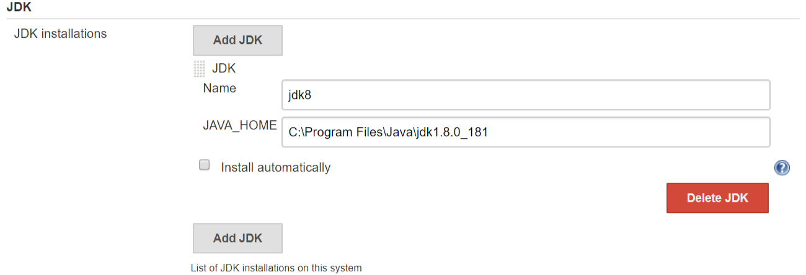

Add Git – give the path - C:\Users\Swati\AppData\Local\Programs\Git\cmd\git.exe. If you don’t know the path open cmd and give the command where git.

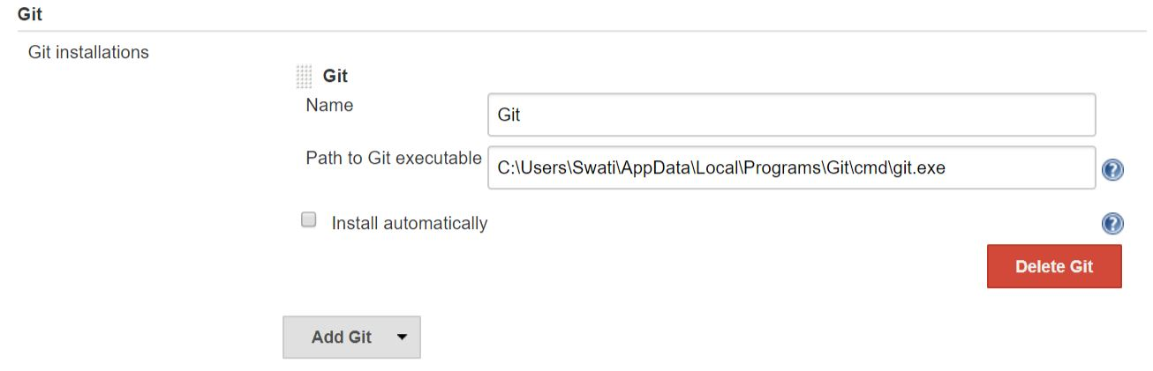

Add Maven – Name: Maven3.5.4

Unclick install automatically and give the path of MAVEN_HOME: C:\Users\Swati\Downloads\apache-maven-3.5.4-bin\apache-maven-3.5.4

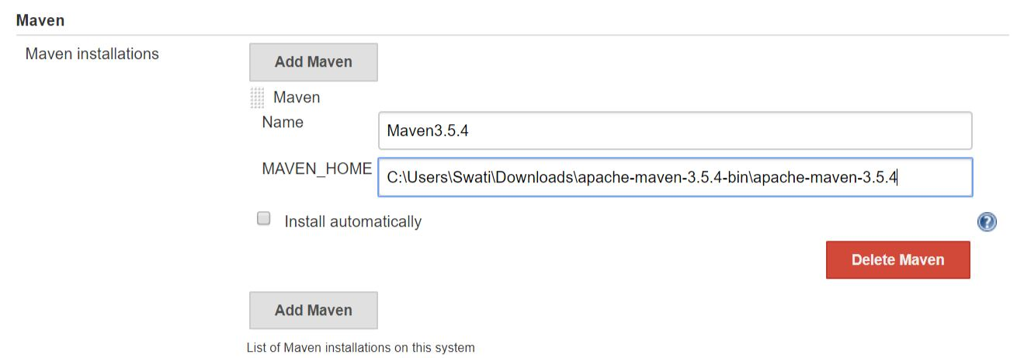

Click apply and save

**Manage Plugins –**

Tabs mentioned on top:

Updates: If any plugins need updates, it will intimate you here.

Available – Click available. If you want to check whether the plugin you require is available, you can search in the filter, eg., deploy. So, all plugins related to it will be displayed. Then you can check the ones you want. Click install without restart. You’ll get redirected to a new page and it will start installing.

Installed – Whatever plugins you have installed on your server will be displayed here.

Advanced – You can create a plugin on your own here.

**Configure Global Security** -

If we uncheck enable security, no one will get the permission, even the credentials will not be shown.

Access Control-

Authorization: Anyone can do anything meaning Anybody can login and anybody can change your builds

Matrix-based security – Before using this, you need to add the users.

How to add users –

Go to Manage Jenkins – Click Manage Users – click Create User

Add credentials

Username: user1

Password: user1

Confirm password:user1

Full name: user1

Email:user1@gmail.com

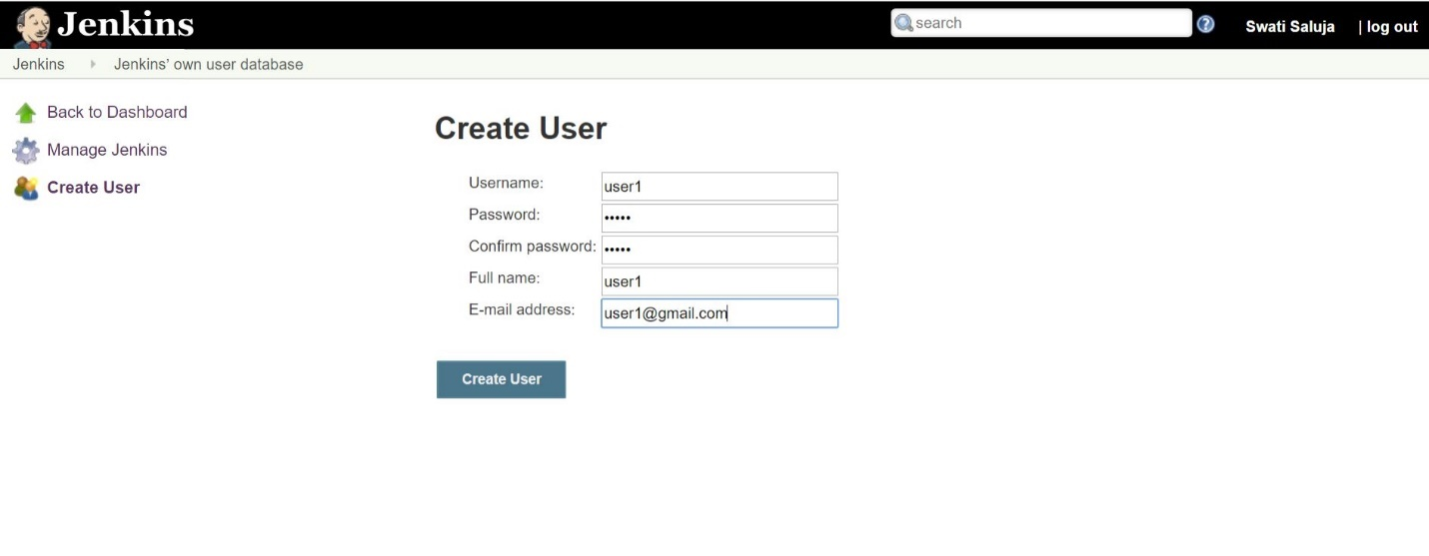

Click create user

User1 is created

In the same way, create 2 more users.

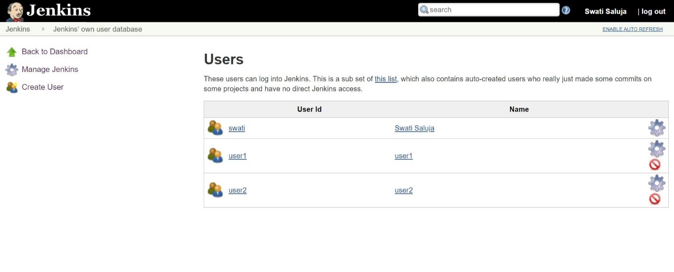

If we check on the symbols on right, the grey one above is for settings. If we click on it, we’ll be asked about the details of the users. Email is asked there to know who is changing the build or creating the jobs.

If we click on the red symbol, automatically the user will get deleted.

Back in Matrix-based security – you are going to give the permissions from here.

Click add a user or group – user1and click OK.

As per your requirement, you choose the features you want in your job by that user. When you give a user, you need to check all the boxes on the extreme right. If you won’t check them, you will not get the login access. Again you have to uninstall you Jenkins and re-install it.

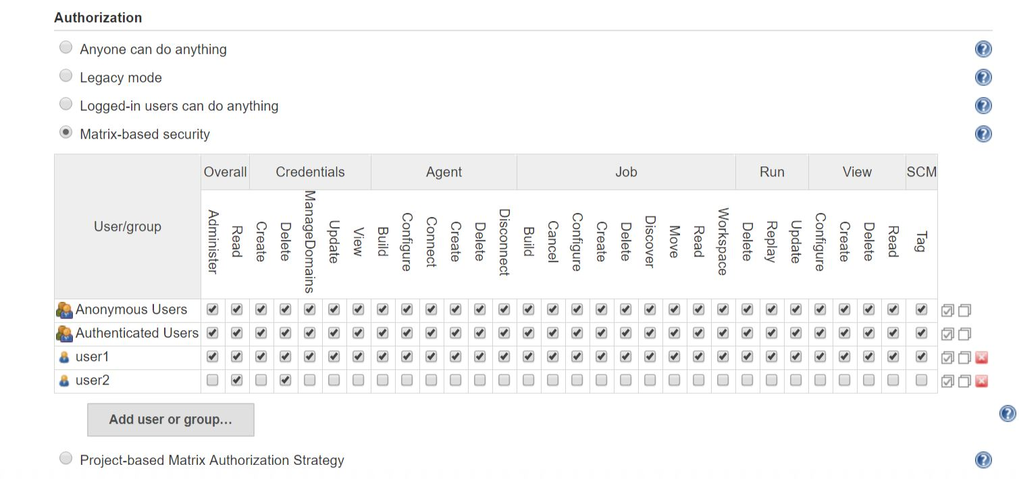

Apply and save

**Reload Configuration from Disk** – If you have an update and you want to install it in your system but you are already working on a job, automatically all your working directories and files will be directly connected. It happens with the help of the reload configuration from disk.

**System Information** – Java versions and all we are using and whatever we have installed, its information is here. It’s used for troubleshooting purpose.

**System Log** – When Jenkins is started and closed, the plugins you have used, the builds, success. It will keep an eye on each and every movement of what’s happening in Jenkins.

**Load Statistics** - It shows the current jobs running.

**How to work with sample Git project**

**Step 1 ->** Open a repository in Github. – my-first-maven-project

**Step 2 ->** We want to create a build activity related to this project**.**

**Step 3 ->** Go to Jenkins, click New Item to create new job.

**Step 4 ->** Enter an item name – Sample Maven

**Step 5 ->** Click Freestyle project – We use it because It supports all projects. Click OK

**Step 6 ->** Description – Simple Java Project, Click Github project

**Step 7 ->** Go to Github repo, clone the url of that repo

**Step 8 ->** Paste it in project url mentioned in Jenkins job we are creating.

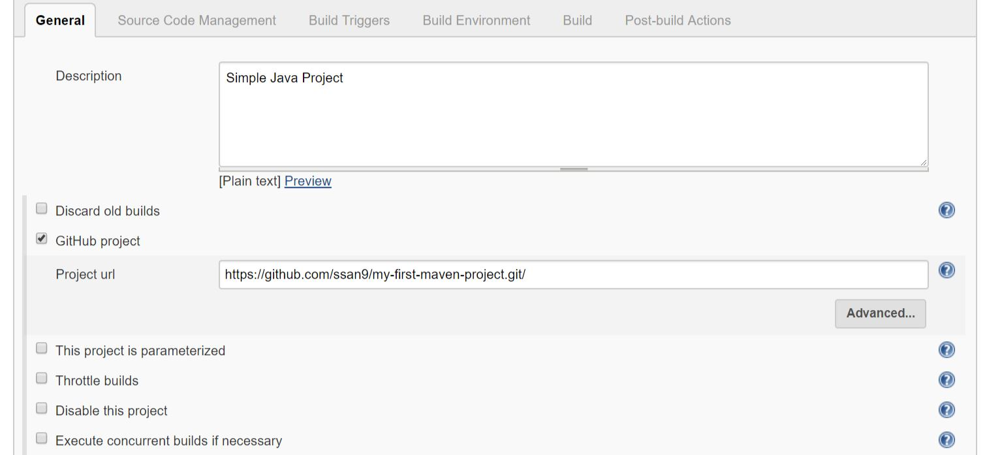

**Step 9 ->** In Source Code Management choose Git

**Step 10 ->** Repository Url – paste the cloned url here

**Step 11 ->** choose none in git credentials

**Step 12 ->** If you want to add, click add, Jenkins ->

Domain: Global credentials(unrestricted)

Kind: Username with password

Scope: choose Global(Jenkins, nodes, items, all child items, etc.)

Username: Swati

Password: **********

Click add, automatically it will get added. We can see it below none if we click it in git credentials.

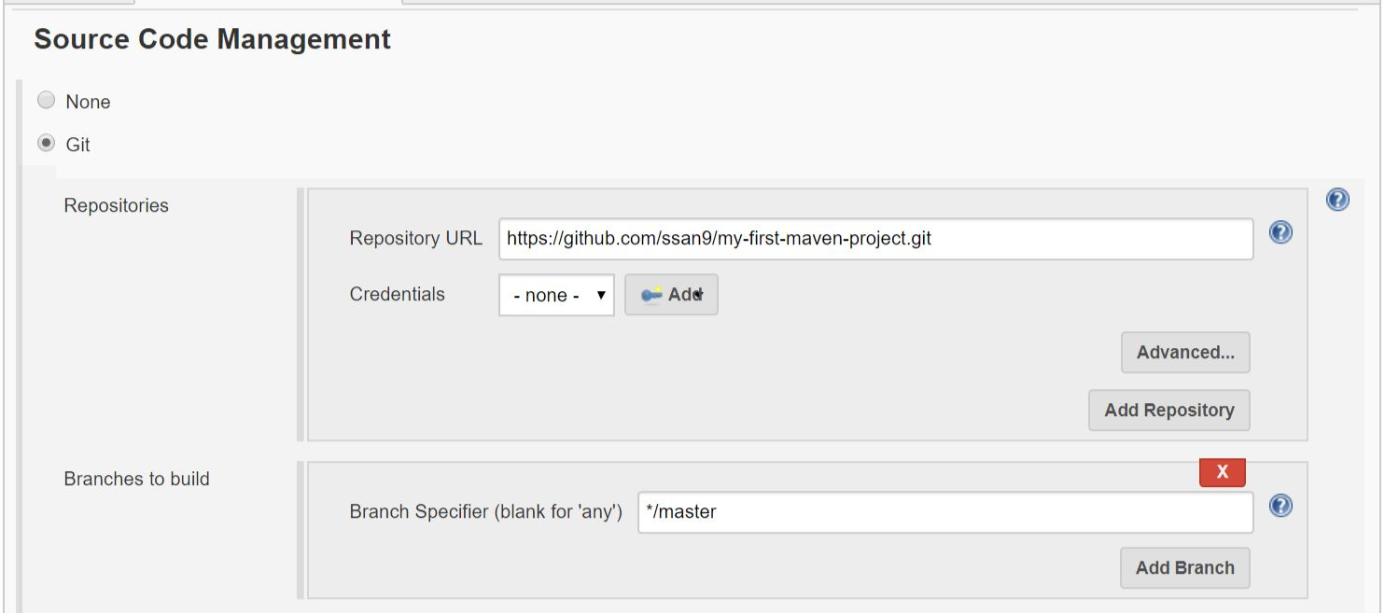

**Build Triggers –**

Build periodically **-** It means it will have formats**.** If you click on the ? mark you will see everything. We can give something like 2**** in the schedule for every 2 minutes. We will uncheck it.

Poll SCM **–** Whenever changes are there automatically it will run. Here also you can give a time in the schedule. 2****. It denotes every 2 minutes

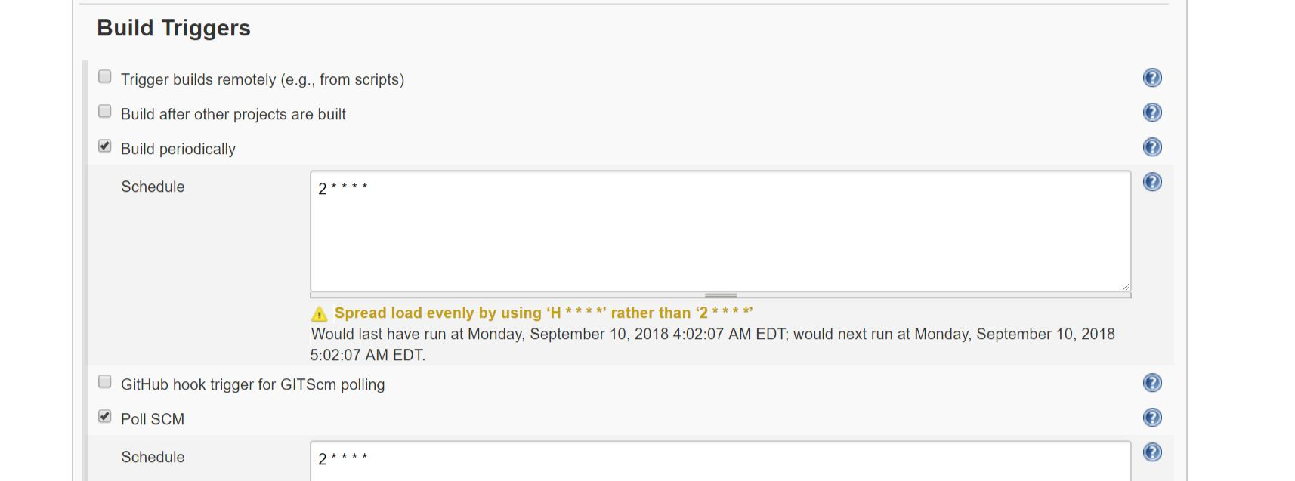

Note: Remove Build periodically from here. Only keep Poll SCM

**Build environment** –

Delete workspace before build starts – It will delete any pre-existing war files, etc. before performing the build.

**Build**

Click add build step

Choose invoke top-level maven targets:

Maven version – Maven3.5.4

Goals – test or validate . If you don’t know the goals, click on the ? mark on the right and look at the goals you can use. We are using validate right now.

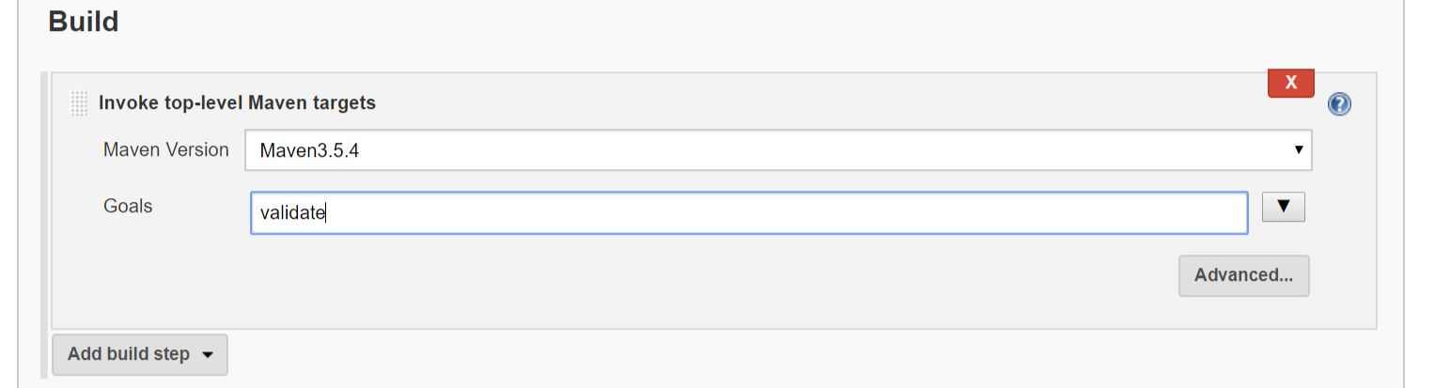

Apply and save

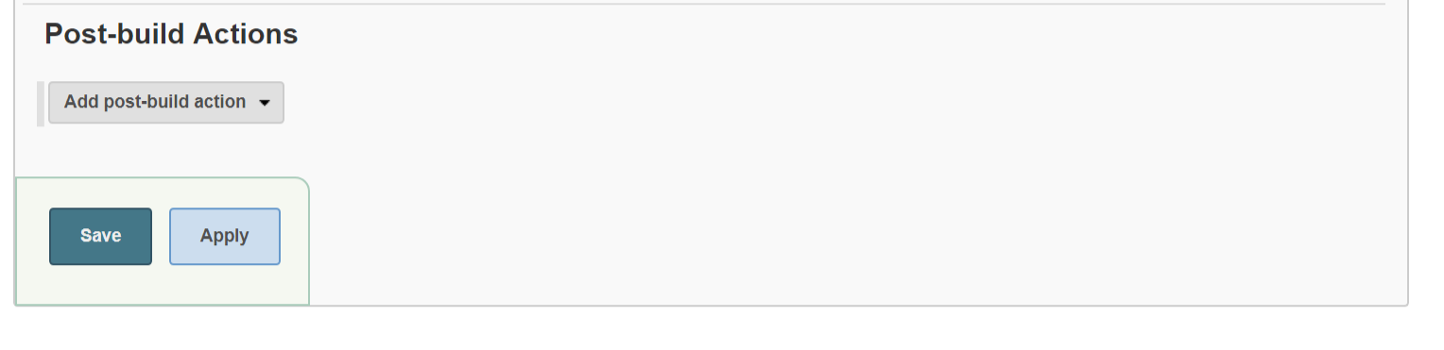

**Step 13 ->** Click Build Now and click on #1 below

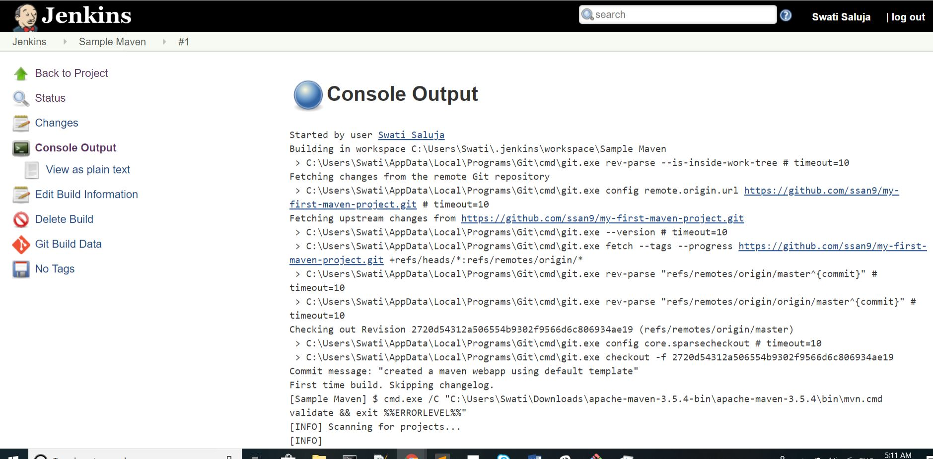

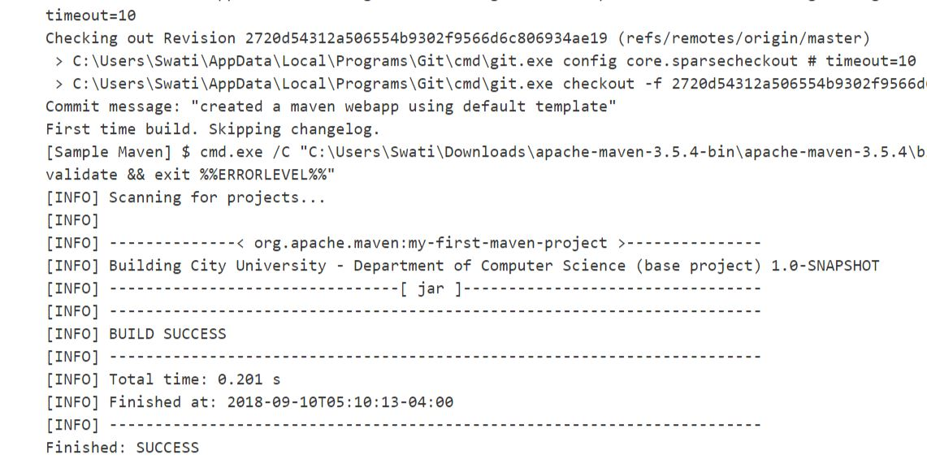

**Step 14 ->** Go to the repository on Github and open src folder, keep going inside until you reach App.java/Main.java. Open it. Click edit.

Change "Hello World!" to "Hello World! Welcome to Digiinfotek"

Click commit changes. The build automatically starts on Jenkins and is a success. It’s happened because of poll SCM.

**Node Configuration**

* Go to Jenkins
* Manage Jenkins
* Manage Nodes – Click New Node
* Node Name: Node1. Check Permanent agent. Click ok
* Fill the particulars in the following format:

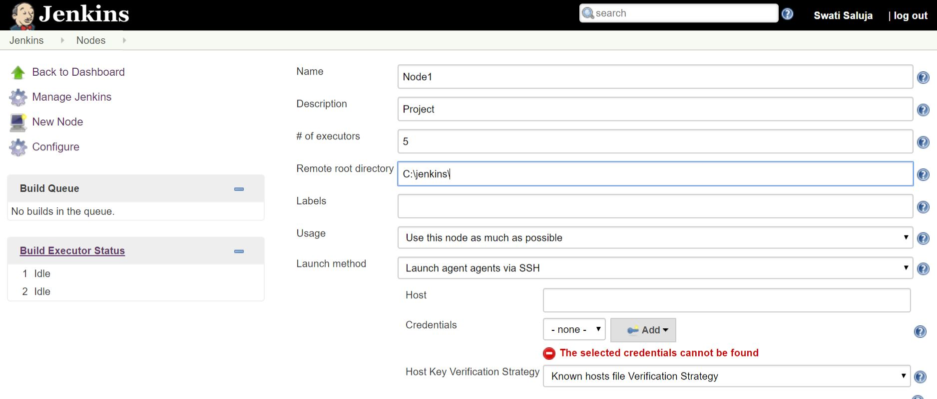

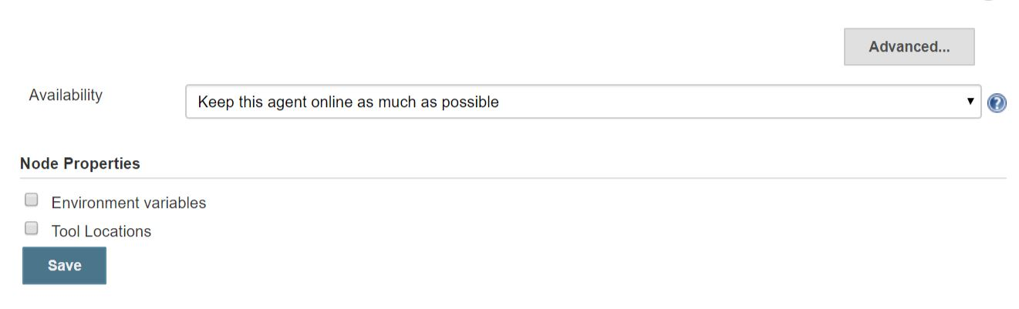

Click save

Click Node1. Click logs and see if it’s a success.

**Shell Scripting**

It is a group of unix commands and shell keywords. It is used to handle different types of text files in the form of .cvs, .dat, .html, .var, .jar, .conf, .c, .sql, etc.

**Use of Shell Scripting**

* It helps in job scheduling
* To create new unix commands – reusability

**Different types of shells interpreter**

* Bourne shell $sh
* korn shell $ksh
* c shell $csh
* bash shell $sh or bsh
* zshell $zsh

**Flavor name** **Default shell name**

Linux, Macintosh Bash shell

Sco-unix, Sun solaris, HP-UX Bourne shell

IMB-AIX korn shell

IRIX c shell

**Shell commands**

Start an instance on AWS and then open Putty

Login as : ec2-user

Sudo I – we are in home now

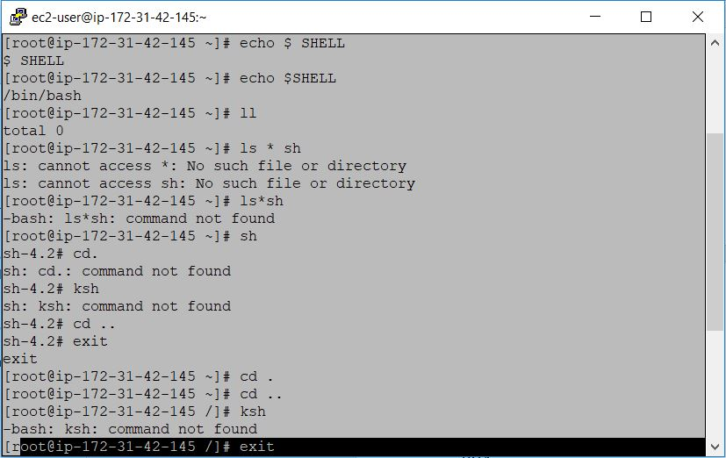

Echo $Shell – we are using bash shell

If you want to go to ksh, simply give the command ksh

cd. cd .. ksh

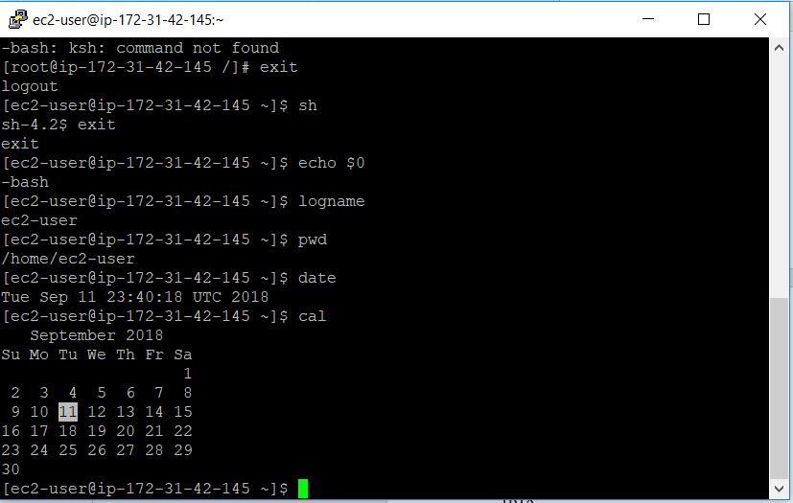

echo $0 – to see the current shell

logname – to display the current username

pwd – to see the working directory

date

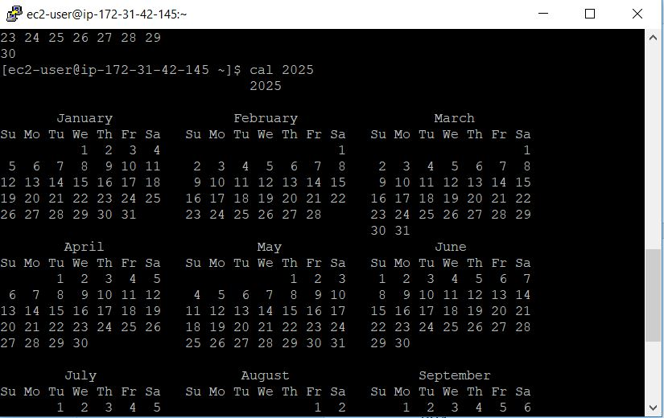

uname – display operating system name

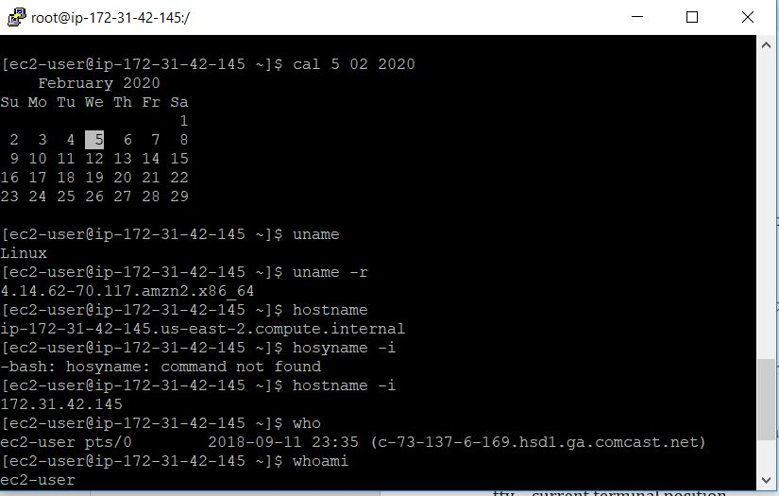

uname r – display kernel version

hostname -i – to get IP address

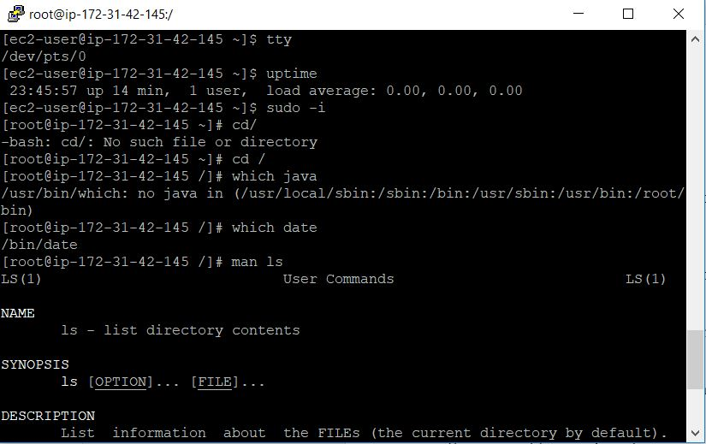

tty – current terminal position

uptime – to check services

cd / - to get out of root user back into ec2 user

which java

which date

man ls

How to write the shell script?

vi shell! sh - to open file

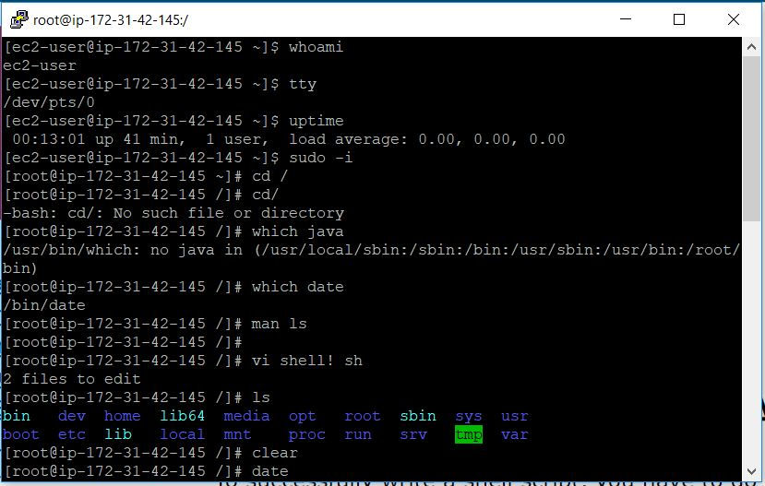

clear

date

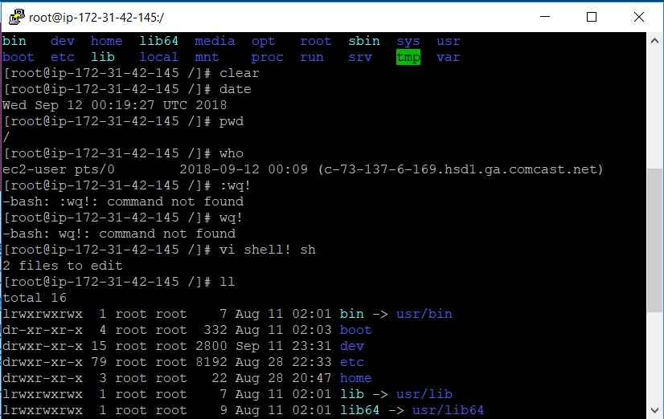

pwd

who

esc (+) :wq! – save and quit

ll

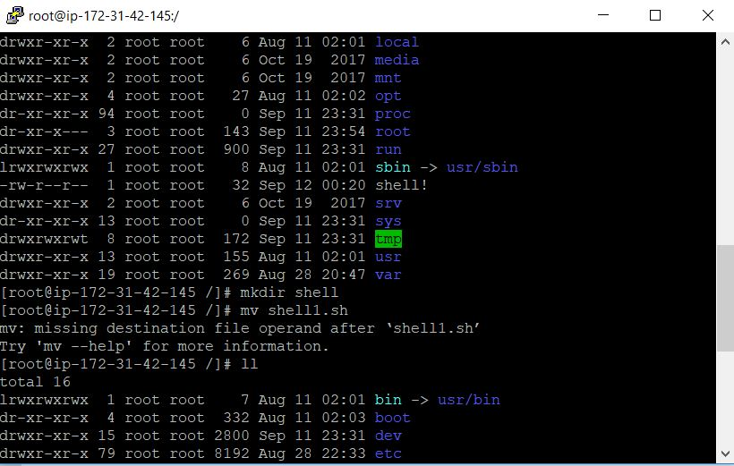

mkdir shell

mv shell1.sh

ll

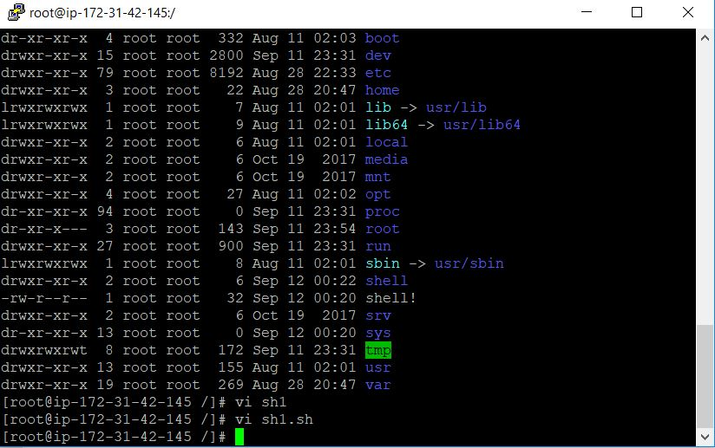

cd shell!

ll

vi sh1.sh

clear

date

pwd

who

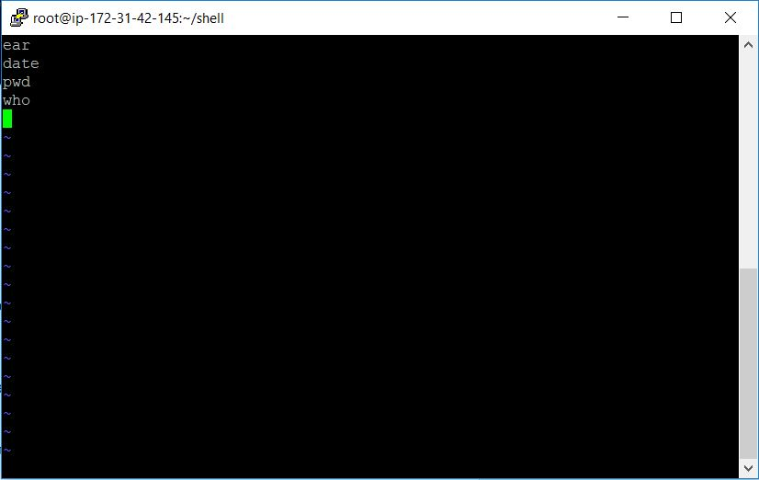

esc (+) :wq!

chmod +x sh1.sh

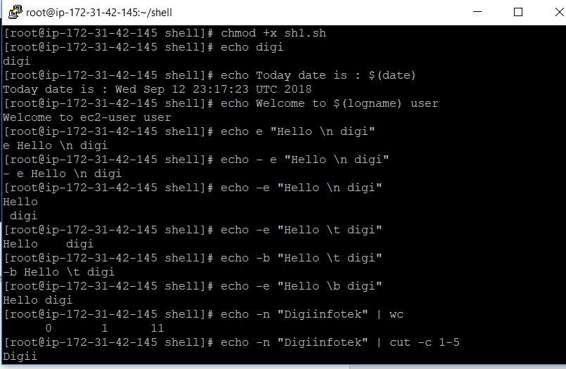

echo – It is a shell keyword used to write data on the output screen

echo digi

echo Today is : $(date)

echo Welcome to $(logname) user

echo -e “Hello \t digi” – e is the escape character

echo -e “Hello \b digi”

echo -e “Hello \n digi”

echo -n “Digiinfotek” | wc – wc means word count

echo -n “Digiinfotek” | cut -c 1-5 – give first 5

echo -n “Digiinfotek” | cut -c 5

echo -n “Digiinfotek” | rev – to reverse

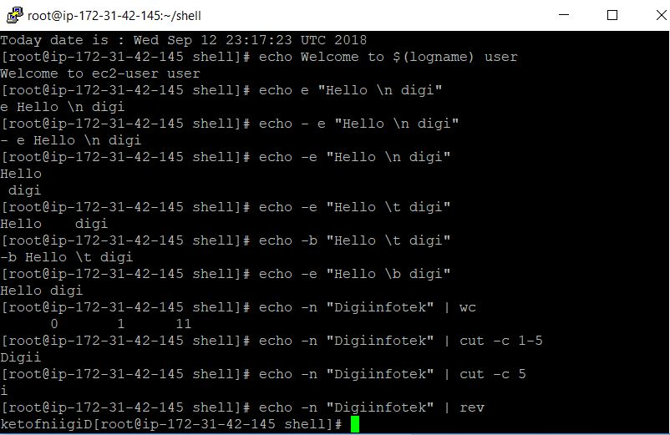

**Variables**

1. User defined variables
2. System defined variables or environment variables

**User defined variables**

1. Local variables
2. Constant variables
3. Global variables

In shell scripting, data types are not used. Everything is used as shell scripting.

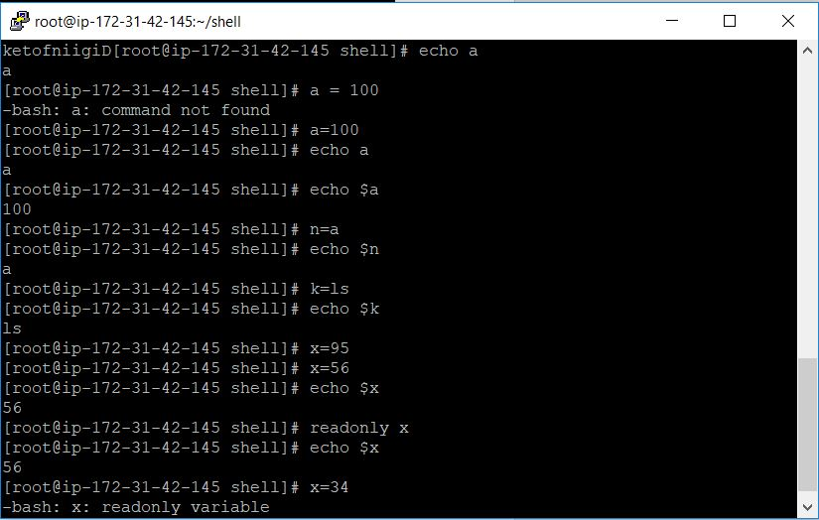

read -s -p “Enter your password: “

p – shows the data you receive

s – you will not see what you get but the data you give will be taken

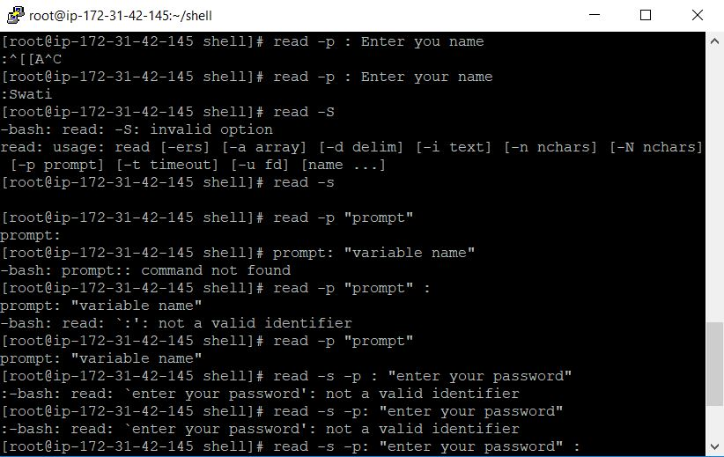

operators

1. Additional operators -> +, -, *, /, %
2. Relational operators -> -lt, -le, -gt, -ge, -eq, -ne

<, >, +, !

1. Logical operators -> -a (logical and)

-o (logical or)

! (logical not)

1. Assignment operator -> =

a=10

b=5

echo $(($a+$b))

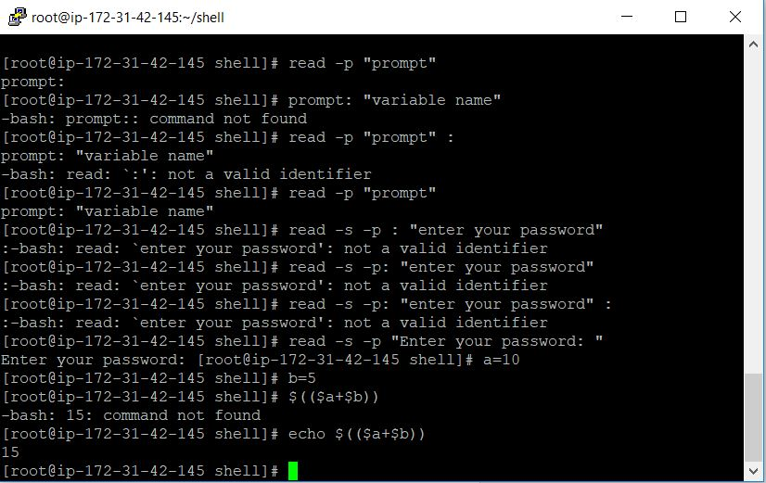

Control

1. if … else

if [condition]

then

…

…

else

…

…

fi

1. if … elif

if [condition]

then

…

…

elif [condition 2]

…

…

elif [consition n]

…

…

Else

…

…

fi

1. Nested if … else …

if [condition1]

then

…

…

if [condition 2]

then

…

…

else

…

…

fi

…

else

…

…

fi

Case statement

Case variable n

pattern 1)

…

…

pattern 2)

…

…

… give n number of patterns and close the program using

Esac

1. while loop

while [consition]

do

…

done

…

…

**AWS**

**IAM – Identity and Access Management**

It is a webserver which enables you to manage users an user permissions

**Use**

When multiple people are working on Maven and you want to give permissions (products by AWS), etc. you can centrally manage the users’. Security credentials that user’s access are provided by IAM.

Steps ->

* Go to services
* Type IAM -Manage action and …
* Click on it – Welcome to Identity and Access Management
* Create few users – on navigation pane click users
* Click add user
* Username – developer1
* Access type
* Programmatic access – developers tool they use they will be promoted. The options given here
* Click AWS Management Console access
* Console password – choose auto
* Click on Require password reset
* Click on permission
* You’ll be re-directed to a new page, click Set permission

We can provide policies to a group, If I want to add a user to a group, we should follow the steps:

* Create group
* Group name –> Cloud_Group
* To create a policy for the group, I can check from the policies mentioned here
* Click Administrator access
* Click create group -> one group is added
* Clock on this group, create and click review
* Click create user – user will get created
* Clock download .csv – excel file will be downloaded, you can see the credentials of that file. Password will be auto generated by the AWS server. This we can send to the developer.
* The AIM we’ll be creating. Go to IAM again, you’ll see a change on its page because of the user we created.
* Click on security credentials.

Multi-factor authentication – kind of security to your account -enhance security. The password it gives with that you can make your system more secure.